# BRAHMS & TCHAIKOVSKY

## Thursday 7 December 2023 Barbican Concert Hall

**Johannes Brahms** Piano Concerto No 1  
*Interval*  
**Pyotr Ilyich Tchaikovsky** Symphony No 6, ‘Pathétique’

**Gianandrea Noseda** conductor

**Simon Trpčeski** piano

**London Symphony Orchestra**

Tchaikovsky Symphony No 6 recorded for future release on LSO Live

# Welcome

Welcome to this LSO concert, the second of three in December with Gianandrea Noseda, LSO Principal Guest Conductor, whom we are delighted to have joining us again in our   
Barbican home

It is a pleasure to welcome back pianist Simon Trpčeski, a long-standing friend of the Orchestra, who has performed with the LSO both at our Barbican home and on tour multiple times since his debut in 2006. Tonight we hear Johannes Brahms’ First Piano Concerto, a passionate work written early in the composer’s life. We look forward to his performance of Brahms’ Second Piano Concerto on Sunday.

After the interval, Gianandrea Noseda continues his cycle of Pyotr Ilyich Tchaikovsky’s symphonies with the Sixth, ‘Pathétique’, a deeply personal work written close to the end of the composer’s life. This performance of the Symphony is being recorded for future release on our record label, LSO Live.

We are delighted this evening to host the LSO Advisory Council – our thanks to them for all they do to support the Orchestra in so many ways. Many thanks also to Classic FM for recommending this concert to their listeners. I hope you enjoy the performance and that you will be able to join us again soon.

This weekend Gianandrea Noseda, continues his Sergei Prokofiev symphony cycle with the Fourth. Looking ahead to the new year, we are thrilled to present two monumental choral works in January: Leoš Janáček’s dramatic opera, *Jenůfa*, conducted by Sir Simon Rattle, Conductor Emeritus; and Felix Mendelssohn’s *Elijah*, conducted by Sir Antonio Pappano, Chief Conductor Designate. We hope to see you there.

**Dame Kathryn McDowell DBE DL  
Managing Director**

# Piano Concerto No 1 in D minor Op 15

## Johannes Brahms

1 Maestoso  
2 Adagio   
3 Rondo: Allegro non troppo

Programme note by Stephen Johnson

‘My Concerto has had here a brilliant and decisive failure.’ Johannes Brahms was writing to his friend, the virtuoso violinist and composer Joseph Joachim, the morning after the Leipzig premiere of his First Piano Concerto in January 1859. He wasn’t exaggerating. A performance in Hanover a few days earlier had been received politely, though without enthusiasm. But this performance, in Germany’s unofficial musical capital, could not have been less like the breakthrough the 25-year-old composer had been hoping for.

In the same letter to Joachim, Brahms described the audience’s reaction to both his music and his playing (Brahms himself played the solo part): ‘At the conclusion three pairs of hands were brought together very slowly, whereupon a perfectly distinct hissing from all sides forbade any such demonstration. There is nothing more to say about this episode, for not a soul has said a word to me about the work!’

To what can we attribute the reaction? People simply weren’t prepared for what Brahms was offering them. Here was a piano concerto conceived in much grander terms than most contemporary symphonies. Not since Ludwig van Beethoven had anyone attempted anything on this scale in concerto form. And while the piano writing may have been hugely challenging, it wasn’t the kind of glamorous display piece that mid-19th century audiences had come to expect. The orchestral contribution was much weightier than normal in a concerto, and the harmonic language must have seemed exceptionally dissonant to its first hearers. In place of the usual scintillating acrobatic solo cadenzas, Brahms had provided a series of intensely serious dramatic monologues for the piano.

It wasn’t that Brahms had set out with the intention of writing something difficult. Even as a young composer, he showed little interest in novelty for its own sake. For an explanation we have to look at the First Piano Concerto’s history. Initially Brahms hadn’t intended to write a concerto at all. His first plans were for a symphony – a massively ambitious orchestral work that would justify the composer Robert Schumann’s prophecy that Brahms would become Germany’s leading symphonist. A four-movement sketch was nearly completed in 1854. But Brahms was plagued by doubts and insecurities: was this an orchestral work at all, or might it be more effective as a sonata for two pianos?

Eventually the last two movements of the sketch were discarded, and the theme for the original slow Scherzo   
became the starting point for the movement ‘Denn alles Fleisch es ist wie Gras’ (For all flesh is as grass) from his German Requiem (completed in 1868). Brahms realised that combining piano and orchestra in a concerto of symphonic proportions might be the ideal compromise. The first movement of the sketch was reworked with Joachim’s assistance, and a new slow movement and finale were composed. But something of the original conception remained. Brahms could have called the result ‘Symphony for Piano and Orchestra’. It wouldn’t have been completely unprecedented: Hector Berlioz had composed a large-scale symphony with a prominent solo part as early as 1834, *Harold in Italy*. But, unlike Berlioz, Brahms provided no literary programme to aid understanding of his new piece. However dramatic and emotionally intense the music may be, it could be understood and explained only on its own abstract terms. No wonder audiences baulked.

The opening of the Concerto can startle audiences even today, more than 150 years after it was written. A fortissimo (very loud) growl from timpani, low horns and low strings introduces a darkly impassioned first theme, its harmonies clashing with the sustained deep bass D. According to Joachim, it reflects Brahms’ feelings on hearing that his mentor Robert Schumann had tried to throw himself into the River Rhine. This theme sets the tone for the whole first movement. The piano’s first entry is gentler, more soothing; indeed, for a while, the soloist seems to offer consolation in the face of the orchestra’s onslaughts. But the piano is drawn deeper and deeper into the conflict, until it is pitted against the orchestra in the return of that first theme, the harmonies clashing more strikingly than ever. The ending of the first movement is as stormy as the beginning.

The slow second movement is mostly peaceful and otherworldly. When Brahms sketched out the orchestra’s first theme, he wrote above it the words ‘Benedictus qui venit in nomine Domini’ (Blessed is he who comes in the name of the Lord). Brahms was no believer; in fact, the text suggests another link with Schumann – whom Brahms nicknamed ‘Mynheer Domini’ (Honoured Master) – that has led some to interpret the movement as a wordless requiem for the older composer (the words appear in the text of the Latin Requiem mass). Brahms said nothing further on this subject, though the hushed ending could certainly be heard as a prayer   
for the repose of a soul.

The finale returns to action, beginning with a muscular theme that looks back to the first movement – and perhaps further still, to the finale of Johann Sebastian Bach’s Triple Harpsichord Concerto BWV 1063 (written approximately 1735–45). The sense of struggle from the first movement returns, but at the crucial moment, an ardent piano solo turns the key from D minor to major, and from grim conflict to defiant hope.

# Johannes Brahms

## 1833 (Germany) to 1897 (Austria)

Composer profile by Andrew Mellor

Johannes Brahms was born in Hamburg, a north German city known for its Lutheran sobriety and seriousness. His father played the double bass in an orchestra and his mother was a seamstress. Brahms was neither privileged nor poor, and developed a strong work ethic. He seemed destined to pursue a career as a pianist, but composing gradually took over. ‘Gradually’ being the operative word. Brahms was conscientious and severely self-critical, predicaments exacerbated by the timing of his birth – very much in the shadow of Ludwig van Beethoven, dead for six years but still music’s towering genius figure. Aged 40, Brahms had completed only four orchestral scores and sketched the first of four symphonies (it would take him two decades to finish). Despite his struggles, he would prove the natural successor to Beethoven in the arenas of symphonic and chamber music.

Other influences proved vital. Robert and Clara Schumann became important companions and advisers. The multi-voiced weave of ‘past’ music by Johann Sebastian Bach would increasingly shape Brahms’ view of music’s future. Early in his career as a jobbing pianist, Brahms was introduced to Hungarian gypsy music by the violinist Ede Reményi. That music cut a gregarious path through the composer’s default musical severity. Its influence can be seen in the finales of the Violin Concerto, Second String Quartet, Second String Quintet and the First Piano Quartet, as well as in the String Sextet in G major, the second movement of the Clarinet Quintet, and various songs.

Like Beethoven, Brahms was a lifelong bachelor, despite a possible desired romance with Clara Schumann. He enjoyed simple pleasures, among them his daily walk to The Red Hedgehog tavern in his adopted home of Vienna, hands clasped behind his back. Despite his reputation as brusque and sarcastic, Brahms was unusually generous.

# Symphony No 6 in B minor Op 74, ‘Pathétique’

## Pyotr Ilyich Tchaikovsky

1 Adagio – Allegro non troppo  
2 Allegro con grazia  
3 Allegro molto vivace  
4 Finale: Adagio lamentoso

Programme notes by Andrew Huth

When 19th-century composers wrote minor-key symphonies, they generally followed the ‘darkness-to-light’ model set by Ludwig van Beethoven; even if the finale ended in a dark minor key (like Johannes Brahms’ Fourth Symphony) it would normally be a fast, passionate movement, more defiant than tragic. The quiet, despairing ending of Pyotr Ilyich Tchaikovsky’s Sixth Symphony was unprecedented. This Symphony is the record of a deeply personal experience, expressed with a power that leaves one in no doubt either of Tchaikovsky’s musical mastery or the intensity of his feelings, but it is certainly not music for people who are embarrassed by the expression of strong emotions.

In the autumn of 1892, Tchaikovsky sketched a new symphony but soon put it aside, feeling that something was wrong. He realised that he had been writing out of habit, without any deep commitment, and it was an altogether different sort of symphony that he needed to compose. The sketches were recycled into his Third Piano Concerto, and by the following February the new work was well underway. He completed the orchestration on the last day of August and immediately wrote to his brother Anatoly: ‘I’m very proud of the Symphony, and I think it’s the best of my works.’ He conducted the first performance on 28 October 1893 in St Petersburg. The response was polite, but apparently not enthusiastic. Tchaikovsky, who was usually extremely sensitive to audiences’ reactions, was not upset on this occasion: ‘It’s not that it displeased, but it produced some bewilderment. As far as I myself am concerned, I take more pride in it than in any other of my works,’ he wrote to his publisher.

When composing it, Tchaikovsky had admitted that it was a symphony ‘with a programme, but with a programme of a kind which remains an enigma to all – let them guess it who can’. We cannot know exactly what Tchaikovsky had in mind; he never wanted to ‘explain’ his music in any other terms, and when the work was performed it was simply billed as: Sixth Symphony, B minor. On the morning after the first performance, about to send the score for engraving, Tchaikovsky could not make up his mind whether to give it a title at all. He didn’t like the idea of either ‘Tragic Symphony’ or ‘Programme Symphony’, and it was his brother Modest who suggested a title in French: ‘Pathétique’. It sounds odd in English, with its suggestion of weakness or inadequacy. In French or in Russian (‘Pateticheskaya’) the word is more serious, implying the expression of deep feeling and suffering.

The first movement of the ‘Pathétique’, from its opening bassoon crawling up from the depths to its hushed ending, includes a wide variety of musical images. As always in Tchaikovsky, it is the lyrical idea that propels the music; and the economy of texture, rhythmic vitality and clarity of instrumentation ensure that these images strike the listener with immediate force. It is a drama of contrasts, of personal passion struggling against hostile forces.

There is lightness and some sort of happiness in the two inner movements, though it is not untroubled. The second movement is calm and urbane, redolent of the world of Tchaikovsky’s ballets. It sounds like a waltz, although it is not written in a triple-time waltz metre but with a strangely unsettled five beats to the bar. The following march is as brilliant and thrilling as anything Tchaikovsky wrote, but for all its frantic activity, there is a deliberate lack of melodic focus: it takes a long time for the march rhythms and orchestral ferment to settle down and reveal an actual tune. In both these inner movements, there appears the figure of a downward scale which is heard so often in Tchaikovsky’s music, and which he associated with Fate. Tchaikovsky believed that the power of Fate ruled his life, and once grimly described it as ‘the fatal force which prevents our hopes of happiness from being realised, and which watches jealously to see that our bliss and happiness are never complete and unclouded … it is inescapable and it can never be overcome’.

This descending ‘Fate’ figure shapes both themes of the Finale. On its first appearance, the second of these themes begins consolingly in the major mode and rises to a climax of passionate protest – perhaps a last desperate attempt to find love and happiness. On its reappearance, it sinks lower and lower, ebbing away into darkness and silence.

Five days after conducting the ‘Pathétique’, Tchaikovsky was taken ill, and he died four days later. The official version of events was that he drank a glass of unboiled water, always a rash thing to do in St Petersburg at this time, and contracted cholera. There were vague rumours of suicide, and in the 1970s a strange story emerged from Russia, passed down over 80 years by word of mouth, that Tchaikovsky had been summoned to a ‘court of honour’ composed of ex-students of the St Petersburg School of Jurisprudence, where he had studied as a young man. This court, apparently, presented Tchaikovsky with the grim alternatives of public exposure of an affair he had been having with a young nobleman, followed by disgrace and probable criminal proceedings, or suicide. For all its implausibilities and the absence of any corroborating evidence, it’s a story to grab on to for those who would like to hear the Sixth Symphony as a premonition of a conveniently dramatic ending to an unhappy life.

Whatever the truth of the events surrounding Tchaikovsky’s death, though, there is no evidence at all of suicidal thoughts during the time he planned and composed the Sixth Symphony. The obvious pride he took in it suggests, on the contrary, a rare period when his art was able to compensate for the loneliness of his life, when the perfect musical expression of his own character allowed him greater peace of mind than he had enjoyed for many years. All the same, it is hard to hear the bleak ending of the Symphony without wondering whether he was right about Fate.

# Pyotr Ilyich Tchaikovsky

## 1840 to 1893 (Russia)

Composer profile by Andrew Stewart

Pyotr Ilyich Tchaikovsky was born in Kamsko-Votkinsk in the Vyatka province of Russia on 7 May 1840. His father was a mining engineer, his mother of French extraction. In 1848 the family moved to the imperial capital, St Petersburg, where Tchaikovsky was enrolled at the School of Jurisprudence. He overcame his grief at his mother’s death in 1854 by composing and performing, and music remained a diversion from his job – as a clerk at the Ministry of Justice – until he enrolled as a full-time student at the St Petersburg Conservatory in 1863.

His First Symphony was warmly received at its St Petersburg premiere in 1868. *Swan Lake*, the first of Tchaikovsky’s three great ballet scores, was written in 1876 for Moscow’s Bolshoi Theatre. Between 1869 and the year of his death, Tchaikovsky composed over 100 songs, cast mainly in the impassioned Romance style and textually preoccupied with the frustration and despair associated with love, conditions that characterised his personal relationships.

Tchaikovsky’s hasty decision to marry an almost unknown admirer in 1877 proved a disaster, his homosexuality combining strongly with his sense of entrapment. By now he had completed his Fourth Symphony, was about to finish his opera *Eugene Onegin*, and had attracted the considerable financial and moral support of Nadezhda von Meck, an affluent widow. She helped him through his personal crisis and, in 1878, he returned to composition with the Violin Concerto.

During the late 1880s and early 1890s, Tchaikovsky produced many of his greatest pieces, including the ballets *The Sleeping Beauty* and *The Nutcracker*, the Fifth Symphony, the string sextet *Souvenirs de Florence* and the operas *The Queen of Spades* and *Iolanta*. The composer himself claimed that his Sixth Symphony represented his best work. He died on 6 November 1893, nine days after its premiere.

# Gianandrea Noseda

## Principal Guest Conductor

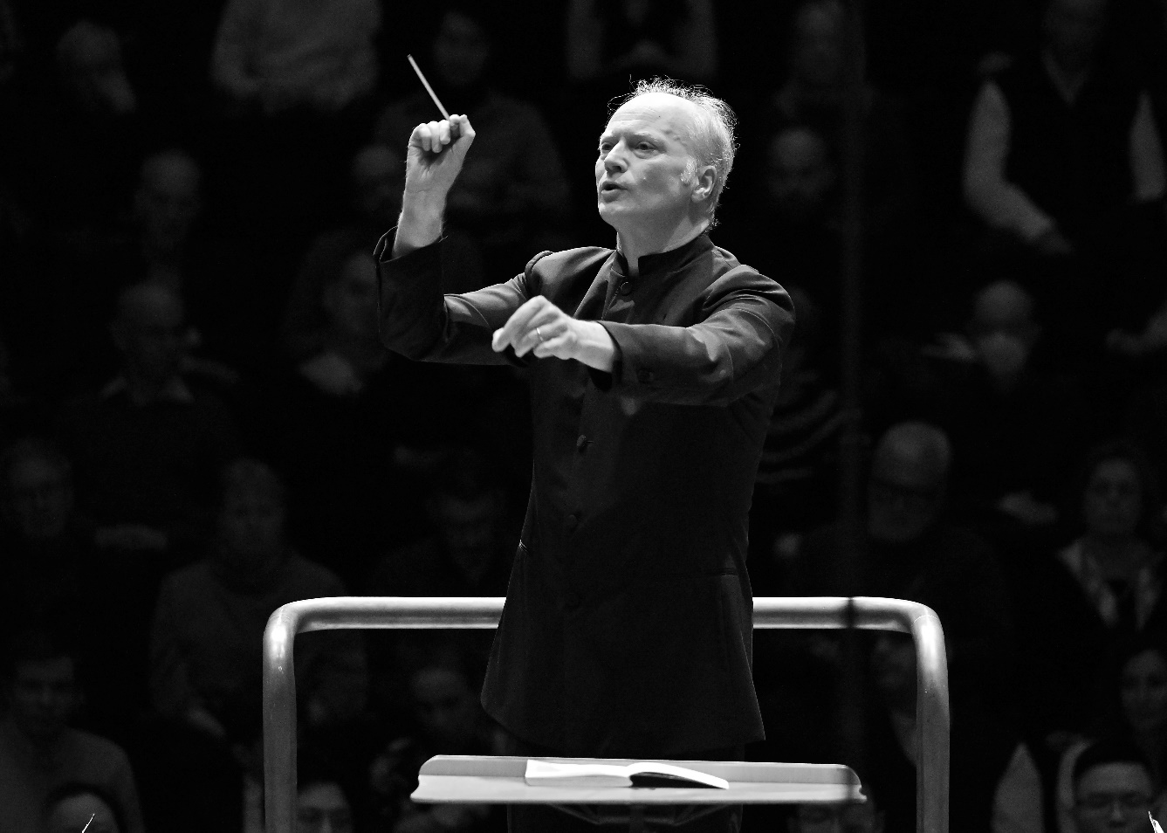

Gianandrea Noseda is one of the world’s most sought-after conductors, equally recognised for his artistry in the concert hall and the opera house. The 2023/24 season marks his eighth season as Principal Guest Conductor of the London Symphony Orchestra, and seventh season as Music Director of the National Symphony Orchestra.

In addition to his performances at the Barbican and LSO St Luke’s, Noseda has toured with the LSO to the United States, China, Europe and Edinburgh. His recordings on LSO Live include Britten’s War Requiem, Mussorgsky’s *Pictures at an Exhibition*, Verdi’s Requiem, and ongoing multi-year recording projects of the complete symphonic cycles of Prokofiev, Shostakovich and Tchaikovsky.

Noseda’s leadership at the NSO has reinvigorated the orchestra, which makes its home at the Kennedy Center in Washington D C. The renewed recognition has garnered invitations to Carnegie Hall, international concert halls, and led to streaming projects and a record label distributed by LSO Live. The NSO’s recent recordings include the complete Sinfonias by Pulitzer Prize-winning Washington D C native George Walker and a Beethoven symphony cycle.

Noseda became General Music Director of the Zurich Opera House in September 2021. A milestone there will be his first performances of Wagner’s *Ring* cycle in May 2024. In February 2023, he was recognized as ‘Best Conductor’ by the German OPER! AWARDS.

From 2007 to 2018, Noseda served as Music Director of the Teatro Regio Torino, where his leadership marked a golden era. He has conducted leading international orchestras, opera houses and festivals, and had significant roles at the BBC Philharmonic (Chief Conductor), Israel Philharmonic Orchestra (Principal Guest Conductor), Mariinsky Theatre (Principal Guest Conductor), Orchestra Sinfonica Nazionale della RAI (Principal Guest Conductor), Pittsburgh Symphony Orchestra (Victor de Sabata Chair), Rotterdam Philharmonic (Principal Guest Conductor) and Stresa Festival (Artistic Director).

Noseda has made over 80 recordings for various labels, including Deutsche Grammophon and Chandos where recordings included works of neglected Italian composers on his *Musica Italiana* series.

Noseda has a strong commitment to working with young artists. In 2019, he was appointed the founding Music Director of the Tsinandali Festival and Pan-Caucasian Youth Orchestra in the village of Tsinandali, Georgia.

A native of Milan, Noseda is Commendatore al Merito della Repubblica Italiana, marking his contribution to the artistic life of Italy. He has been honoured as Conductor of the Year by both Musical America (2015) and the International Opera Awards (2016). In 2023, he received the Puccini Award.

# Simon Trpčeski

## Piano

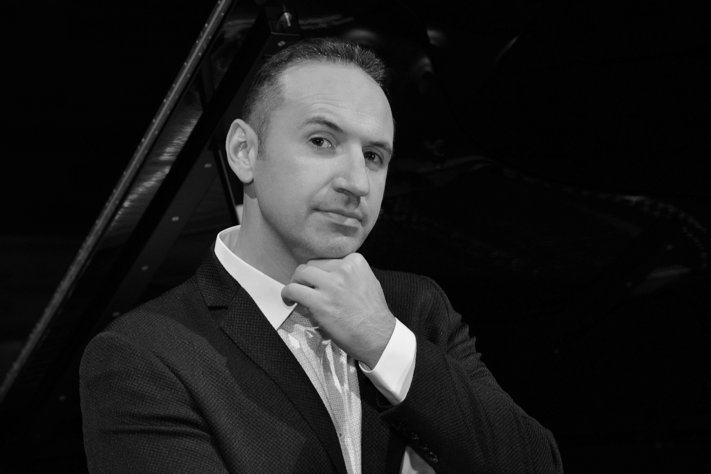

Simon Trpčeski has been praised not only for his powerful virtuosity and deeply expressive approach to music, but also for his charismatic stage presence. Launched onto the international scene more than 20 years ago as a BBC New Generation Artist, and enjoying an incredibly fast-paced career that encompasses no cultural or musical boundaries, Trpčeski has collaborated with over 100 orchestras on four continents, and performed on the most prestigious stages.  
  
The long list of prominent conductors Trpčeski has worked with includes Lorin Maazel, Vladimir Ashkenazy, Marin Alsop, Gustavo Dudamel, Cristian Măcelaru, Gianandrea Noseda, Vasily Petrenko, Charles Dutoit, Jakub Hrůša, Vladimir Jurowski, Susanna Mälkki, Andris Nelsons, Sir Antonio Pappano, Robert Spano, Michael Tilson Thomas, Gabriel Bebeşelea and David Zinman.

Trpčeski’s fruitful collaborations with EMI Classics, Avie Records, Wigmore Hall Live, Onyx Classics and, currently, Linn Records have resulted in a broad and award-winning discography which includes repertoire such as Serge Rachmaninoff’s complete works for piano and orchestra and Sergei Prokofiev’s piano concertos, as well as works by composers such as Francis Poulenc, Claude Debussy and Maurice Ravel. *Variations*, his latest solo album, was released in spring 2022 and features works by Johannes Brahms, Ludwig van Beethoven and Wolfgang Amadeus Mozart.

Born in Macedonia in 1979, Trpčeski is a graduate of the School of Music at the University of St Cyril and St Methodius in Skopje, where he studied with Boris Romanov. He is committed to strengthening the cultural image of his native country, and his chamber music project Makedonissmo is dedicated to introducing audiences worldwide to the rich traditional Macedonian folk roots, weaving into one unique sound world the Macedonian folk music tradition, and highly virtuoso, jazz-influenced riffs and harmonies. Since its successful launch in 2018, Makedonissimo has performed to audiences worldwide and released an album   
on Linn Records.

In 2009, Trpčeski received the Presidential Order of Merit for Macedonia and in 2011, he became the first ever recipient of the title ‘National Artist of Macedonia’. He was a BBC New Generation Artist 2001–03 and in 2003 was honoured with the Young Artist Award by the Royal Philharmonic Society.

# London Symphony Orchestra

## On Stage

Leader  
Carmine Lauri

First Violins  
Jérôme Benhaim   
Clare Duckworth   
Ginette Decuyper   
Maxine Kwok   
William Melvin   
Stefano Mengoli   
Elizabeth Pigram   
Claire Parfitt   
Laurent Quénelle   
Harriet Rayfield   
Morane Cohen-Lamberger   
Eleanor Fagg  
Caroline Frenkel  
Grace Lee  
Julia Rumley

Second Violins  
Julián Gil Rodríguez  
Thomas Norris  
Sarah Quinn  
Miya Väisänen   
Matthew Gardner

Naoko Keatley   
Alix Lagasse   
Belinda McFarlane   
Iwona Muszynska   
Csilla Pogány   
Andrew Pollock   
Paul Robson   
Louise Shackelton  
Anna Takeda

Violas  
Eivind Ringstad   
Gillianne Haddow  
Malcolm Johnston  
Matan Gilitchensky

Anna Bastow   
Thomas Beer  
Steve Doman   
Sofia Silva Sousa   
Robert Turner   
Michelle Bruil   
Clifton Harrison   
Alistair Scahill

Cellos  
Rebecca Gilliver  
Alastair Blayden  
Salvador Bolón   
Ève-Marie Caravassilis   
Daniel Gardner   
Laure Le Dantec   
Amanda Truelove   
Judith Fleet   
Henry Hargreaves  
Joanna Twaddle

Double Basses  
Lorraine Campet   
Patrick Laurence   
Thomas Goodman   
Joe Melvin   
Jani Pensola   
Chaemun Im   
Simon Oliver   
Adam Wynter

Flutes   
Gareth Davies  
Daniel Shao

Piccolo   
Sharon Williams

Oboes   
Timothy Rundle  
Rosie Jenkins

Clarinets   
Nicholas Rodwell  
Chi-Yu Mo

Bass Clarinet   
Kenny Keppel

Bassoons   
Rachel Gough  
Joost Bosdijk

Horns  
Timothy Jones  
Jonathan Maloney  
Daniel Curzon   
Andrew Sutton  
Eleanor Blakeney

Trumpets   
James Fountain  
Will O’Sullivan  
Katie Smith

Trombones   
Peter Moore  
Jonathan Hollick

Bass Trombone   
Paul Milner

Tuba   
Ben Thomson

Timpani   
Nigel Thomas

Percussion   
Neil Percy  
David Jackson