PROKOFIEV & BRAHMS

Sunday 10 December 2023
Barbican Concert Hall
Sergei Prokofiev Symphony No 4 (rev 1947)
Interval
Johannes Brahms Piano Concerto No 2

Gianandrea Noseda conductor
Simon Trpčeski piano
London Symphony Orchestra

LSO Friends’ Supported Concert

Prokofiev’s Symphony No 4 recorded for LSO Live

Concert recorded for broadcast on BBC Radio 3

Welcome
A warm welcome to this evening’s concert, our final performance of 2023 at the Barbican. Tonight Gianandrea Noseda, LSO Principal Guest Conductor, continues his cycle of Sergei Prokofiev’s symphonies with the Fourth, of which we perform the 1947 version.
We are delighted to welcome back pianist Simon Trpčeski, a long-standing friend of the Orchestra, who has performed with the LSO both at our Barbican home and on tour multiple times since his debut in 2006. Following on from his performance of Johannes Brahms’ First Piano Concerto on Thursday of this week, we hear the composer’s Second Piano Concerto, written 22 years later.
Tonight we say a special thank you to the LSO Friends, a group of over 400 music-lovers who are among our most committed champions throughout the year. We are thrilled to have many Friends in the audience tonight – thank you all for your support. If you are not yet a member of the LSO Friends, please do consider joining or sharing a close connection with the LSO through a gift membership, which you can learn more about on page 7.
This concert is being recorded for future broadcast on 13 February 2024 by our media partner BBC Radio 3, and the Symphony is being recorded for future release on our label, LSO Live.
I hope you enjoy the concert, and that you can join us again in the new year. We look forward to welcoming Sir Simon Rattle to the Barbican for the first time in his role as LSO Conductor Emeritus. He begins 2024 with two concert performances of Leoš Janáček’s dramatic opera, Jenůfa, featuring Asmik Grigorian singing the title role, with which she made her Royal Opera House debut in 2021, alongside a line-up of star soloists and the London Symphony Chorus.
Sincere thanks to all our audience members for your support of the LSO. I hope that the Orchestra’s music-making has brought you much joy in the past year, and I wish you a very happy festive season, and a bright New Year.

Dame Kathryn McDowell DBE DL
Managing Director

Symphony No 4

Sergei Prokofiev
1 Andante assai – Allegro eroico
2 Andante tranquillo
3 Moderato, quasi allegretto
4 Allegro risoluto
Programme note by David Nice

‘Recent wine in new bottles’ might well have been the verdict of conductor Serge Koussevitzky on taking delivery of a supposedly new work by Sergei Prokofiev, one in fact reworked from material for the ballet The Prodigal Son, for which he had paid $1000. As Prokofiev tells us in his diary for November 1930, he learned from Olga Naumova, Koussevitzky’s niece and secretary, that ‘the critics were muted, and evidently the public reaction was no more than average’ at the premiere of the original Fourth Symphony in the middle of that month.
The source for the Fourth Symphony had produced unquestionably fine music. By the beginning of 1929, Prokofiev was half way through composing what would turn out to be the last score for Serge Diaghilev’s Ballets Russes in Paris. With it, Prokofiev aimed to reflect the by then fashionable elemental storylines of a New Testament favourite – the parable of the Prodigal Son. At this point he had a bright idea: as his diary entry for 16 January puts it, ‘hey presto, I could concoct a Fourth Symphony out of the ballet’. He had no doubts about reworking stage material in symphonic form; after all, he had only just done the same for the first time with his Third Symphony, related more closely than he later admitted to his infernal opera The Fiery Angel.
By late March, however, he was resolved. When Vladimir Dukelsky, the young composer who was soon to make his name in America as Vernon Duke, objected that ‘to mix up dance music with pure symphonic material is completely incomprehensible’, Prokofiev retorted: ‘In principle, I agree with you. I’ve done this because in the ballet there remained some undeveloped material; and there were a few ideas which I couldn’t include in the ballet – and I thought it was a shame not to make use of them. My justification is that, as you know, when I played you the Symphony, you welcomed it, and it didn’t occur to you that this was the offspring of a ballet; but when I played the ballet to Diaghilev, who doesn’t know his symphonies, he was of the opinion that it’s my best ballet; and Diaghilev does know something about ballets!’
In the event, The Prodigal Son premiered that May with outlandish choreography by the young George Balanchine and striking sets by Georges Rouault. It had greater success than the Symphony, which Prokofiev completed, struggling a little with the finale, in the spring of 1930.
He remained attached to his ‘simple and clear’ work, so much so that in 1947, with the experience of two bigger works – the Fifth and Sixth Symphonies – he served it up as a much-expanded symphonic argument with a new opus number. Shedding its classical proportions and its relatively small forces but not the wealth of tuneful ideas so well suited to Prokofiev’s new audience, the Fourth now acquired armour plating in the shape of an even more lucid and determined ‘motto’ theme. Its clear outlines on unison woodwind fit naturally on to the more wayward, downward-stepping original introduction, newly composed in 1929 after Prokofiev had rejected material from the ballet.
The main Allegro (strangely marked ‘Eroico’–‘heroic’) comes from the second dance sequence of the Prodigal’s false friends and is twisted in to a more original new shape; its lyric contrast, a bucolic flute melody reviving memories of the ‘Classical’ First Symphony, is now flanked by pensive shapes much closer to the world of the tragic, introspective Sixth Symphony. It is as if Prokofiev the older, wiser composer is sadly footnoting his blither self; and in a much-extended development, the new motto caps piledriving activity with plenty of dissonances between its brassy fanfares. Aggression, rather than energy, remains the keynote of the movement.
The footnotes continue, sometimes with less obvious purpose, to extend the essentially unchanged inner movements. ‘What an Andante I could make from the themes which conclude the ballet’, declared Prokofiev in that first diary entry about the Symphony. Inevitably, the simple flute melody of the second movement has more emotional impact when it serves the Prodigal Son’s ultimate state of grace at the ballet’s end, but it remains a perfect inspiration. Its mixed companions here are a stalking theme in the bass, a plangent clarinet solo originally expressing the son’s remorse, a third melody for woodwind and the return of the Symphony’s introduction, ecstatic now on high-lying violins.
For the third movement, Prokofiev makes only cosmetic changes to the dance of the haughty siren who seduces the Prodigal, delicately embroidered and now placed in wistful parentheses. The finale cleverly stitches together the sharply accented music of the Prodigal’s impetuousness, the breezy theme of his youthful optimism – ushered in by the tuba before being subjected to all manner of ingenious variations – and a quirky march. But there is also unfinished business for the 1947 ‘motto’, excitingly propelled into the limelight by the trumpeting coda. The 1947 version of the Symphony No 4 ends with a triumph as ambiguous and as potentially terrifying as any Prokofiev ever wrote.

Piano Concerto No 2 in B-flat major Op 83

Johannes Brahms
1 Allegro non troppo
2 Allegro appassionato
3 Andante
4 Allegretto grazioso — Un poco più presto
Composer profile by Stephen Johnson

‘I have written a tiny, tiny piano concerto with a tiny, tiny wisp of a scherzo,’ wrote Johannes Brahms to his close confidante, Elisabeth von Herzogenberg, on 7 July 1881. Herzogenberg knew the composer well enough to take that kind of remark with several sacks of salt. So too did his friend, the surgeon Theodor Billroth, to whom Brahms posted the manuscript, with the accompanying message: ‘I am sending you a few small piano pieces.’ Billroth would only have had to glance at the score to realise that what Brahms had sent him was in fact unusually ambitious: a hybrid of concerto and symphony, laid out in four big movements (instead of the conventional three), all hugely challenging for the soloist, but with the orchestra as equal protagonist in a sustained, developing musical drama.
The idea of creating a four-movement concerto, with its
roots as firmly in the Beethovenian symphony as in the older composer’s grander concertos, had haunted Brahms at least since his early twenties. His First Piano Concerto (1854–58) actually began life as a symphony and Brahms only gradually gave up the idea of retaining the original slow Scherzo movement – its themes were later reprocessed in the movement ‘All flesh is as grass’ from the German Requiem. The Violin Concerto (1878) was also originally intended to have a Scherzo; that idea was soon dropped, but the material was clearly too good to be discarded, and before long it resurfaced in the Allegro appassionato of the Second Piano Concerto. Interestingly, that stormy movement is closer in style and spirit to Beethoven’s colossal symphonic scherzos than anything in Brahms’ four numbered symphonies. Brahms once complained of the difficulty of composing in Beethoven’s shadow: ‘You've no idea how hard it is with such a giant marching behind you!’ So it was crucial for Brahms to find a solution on his own terms – not by simply marching ahead of his predecessor, but by extending Beethoven’s triumphs into new territory. One can perhaps sense something of his pride in that achievement in the dedication of the Second Piano Concerto: here at last, Brahms had found something worthy to offer ‘to his beloved friend and teacher Eduard Marxsen’.
That said, there are passages in Brahms’ Second Piano Concerto where the listener is more likely to be reminded of the spirit of chamber music, not least at the very beginning, where the soloist quietly replies to and echoes the theme presented by a solo horn. But then the piano begins a long forceful solo, building up tension before handing the baton over to the orchestra for an extended symphonic passage. From this grows a first movement that is not only rich in contrast and imagination, but compellingly organic. Many composers would have been happy to go on from that to a meditative, lyrical slow movement. But Brahms intensifies the drama with his stirring scherzo second movement – the dark, impassioned minor-key outer sections framing a blazing major-key trio section.

Now follows the slow movement. It begins with a long, exquisite melody for solo cello, to which the pianist eventually adds their own reflective commentary. Stormier music follows, but the true heart of the movement comes in a slower pianissimo (very quiet) passage just before the return of the cello theme, in which the piano seems to float dreamily through languid, slow-moving clarinet and string figures. It is about as far removed from the turbulence of the second movement as could be imagined – a superb dramatic foil.
It’s hard to imagine conventional concerto triumphalism after a movement like this, so instead Brahms crowns his symphony-concerto with an unusually light-footed, playful finale: even in the melancholy of the second theme (woodwind alternating with strings) there are glimpses of an ironic smile. At last the tempo quickens and the Concerto ends with a display of relaxed, witty brilliance that is unique in Brahms. The ghost of the giant Beethoven has been faced, exorcised and finally forgotten.

Sergei Prokofiev

1891 (Ukraine) to 1953 (Russia)
Composer profile by Andrew Mellor

Sergei Prokofiev was born in Imperial Russia, now Ukraine, and died in Soviet Russia. He was raised by doting parents who took their son to operas and ballets in Moscow and St Petersburg. Aged nine, the young Prokofiev wrote text and music for his own opera, The Giant. He would soon be studying composition with Rimsky-Korsakov at the St Petersburg Conservatory, from where he graduated as a pianist and conductor, playing his own spiky Piano Concerto No 1.

The young Prokofiev kicked against the nationalistic conservatism at home and ventured west to Germany, France and America. There, he honed an acerbic and distinctive musical voice. But the Soviet regime knew it could lure the politically naive Prokofiev back, and eventually succeeded. In 1936, he settled permanently back in Russia, having all but abandoned his Spanish wife and their two sons.

To some extent, the return suited Prokofiev’s musical objectives to be clear, useful and evocative. He wrote music for children (most famously Peter and the Wolf), for aggrandising political events and for Soviet films – none of which forced him to fundamentally change his direct and muscular musical style, nor to move away from symphonies and operas.

In 1948, however, Prokofiev was denounced by Stalin’s government for writing ‘formalist’ music that failed to reflect the experience of the working classes. The composer took the charge seriously, admitting that the task of ‘finding a melody instantly understandable even to the uninitiated listener’ had led him unwittingly into unnecessary complication. Prokofiev pressed on, but the condemnation had damaged him. And Stalin had one last rebuke in store. The two men died on the same day, meaning Prokofiev’s passing was all but ignored.

Johannes Brahms

1833 (Germany) to 1897 (Austria)
Composer profile by Andrew Mellor

Johannes Brahms was born in Hamburg, a north German city known for its Lutheran sobriety and seriousness. His father played the double bass in an orchestra and his mother was a seamstress. Brahms was neither privileged nor poor, and developed a strong work ethic. He seemed destined to pursue a career as a pianist, but composing gradually took over. ‘Gradually’ being the operative word. Brahms was conscientious and severely self-critical, predicaments exacerbated by the timing of his birth – very much in the shadow of Ludwig van Beethoven, dead for six years but still music’s towering genius figure. Aged 40, Brahms had completed only four orchestral scores and sketched the first of four symphonies (it would take him two decades to finish). Despite his struggles, he would prove the natural successor to Beethoven in the arenas of symphonic and chamber music.

Other influences proved vital. Robert and Clara Schumann became important companions and advisers. The multi-voiced weave of ‘past’ music by Johann Sebastian Bach would increasingly shape Brahms’ view of music’s future. Early in his career as a jobbing pianist, Brahms was introduced to Hungarian gypsy music by the violinist Ede Reményi. That music cut a gregarious path through the composer’s default musical severity. Its influence can be seen in the finales of the Violin Concerto, Second String Quartet, Second String Quintet and the First Piano Quartet, as well as in the String Sextet in G major, the second movement of the Clarinet Quintet, and various songs.

Like Beethoven, Brahms was a lifelong bachelor, despite a possible desired romance with Clara Schumann. He enjoyed simple pleasures, among them his daily walk to the tavern, The Red Hedgehog, in his adopted home of Vienna, hands clasped behind his back. Despite his reputation as brusque and sarcastic, Brahms was unusually generous.

Gianandrea Noseda

Principal Guest Conductor
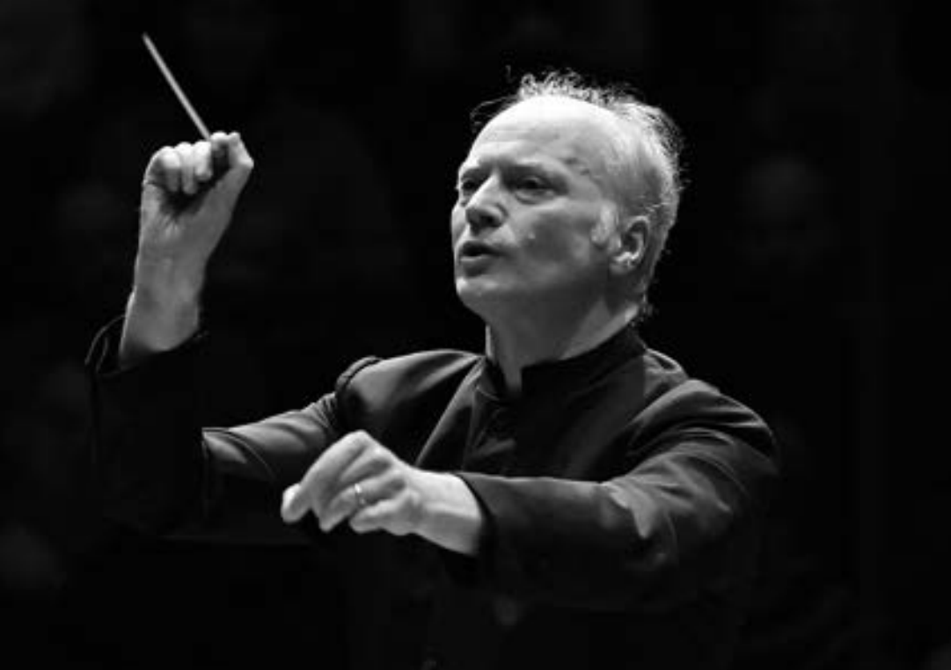
Gianandrea Noseda is one of the world’s most sought-after conductors, equally recognised for his artistry in the concert hall and the opera house. The 2023/24 season marks his eighth season as Principal Guest Conductor of the London Symphony Orchestra, and seventh season as Music Director of the National Symphony Orchestra.
In addition to his performances at the Barbican and LSO St Luke’s, Noseda has toured with the LSO to the United States, China, Europe and Edinburgh. His recordings on LSO Live include Britten’s War Requiem, Mussorgsky’s Pictures at an Exhibition, Verdi’s Requiem, and ongoing multi-year recording projects of the complete symphonic cycles of Prokofiev, Shostakovich and Tchaikovsky.
Noseda’s leadership at the NSO has reinvigorated the orchestra, which makes its home at the Kennedy Center in Washington D C. The renewed recognition has garnered invitations to Carnegie Hall, international concert halls, and led to streaming projects and a record label distributed by LSO Live. The NSO’s recent recordings include the complete Sinfonias by Pulitzer Prize-winning Washington D C native George Walker and a Beethoven symphony cycle.
Noseda became General Music Director of the Zurich Opera House in September 2021. A milestone there will be his first performances of Wagner’s Ring cycle in May 2024. In February 2023, he was recognised as ‘Best Conductor’ by the German OPER! AWARDS.
From 2007 to 2018, Noseda served as Music Director of the Teatro Regio Torino, where his leadership marked a golden era. He has conducted leading international orchestras, opera houses and festivals, and had significant roles at the BBC Philharmonic (Chief Conductor), Israel Philharmonic Orchestra (Principal Guest Conductor), Mariinsky Theatre (Principal Guest Conductor), Orchestra Sinfonica Nazionale della RAI (Principal Guest Conductor), Pittsburgh Symphony Orchestra (Victor de Sabata Chair), Rotterdam Philharmonic (Principal Guest Conductor) and Stresa Festival (Artistic Director).
Noseda has made over 80 recordings for various labels, including Deutsche Grammophon and Chandos where recordings included works of neglected Italian composers on his Musica Italiana series.
Noseda has a strong commitment to working with young artists. In 2019, he was appointed the founding Music Director of the Tsinandali Festival and Pan-Caucasian Youth Orchestra in the village of Tsinandali, Georgia.
A native of Milan, Noseda is Commendatore al Merito della Repubblica Italiana, marking his contribution to the artistic life of Italy. He has been honoured as Conductor of the Year by both Musical America (2015) and the International Opera Awards (2016). In 2023, he received the Puccini Award.

Simon Trpčeski

Piano
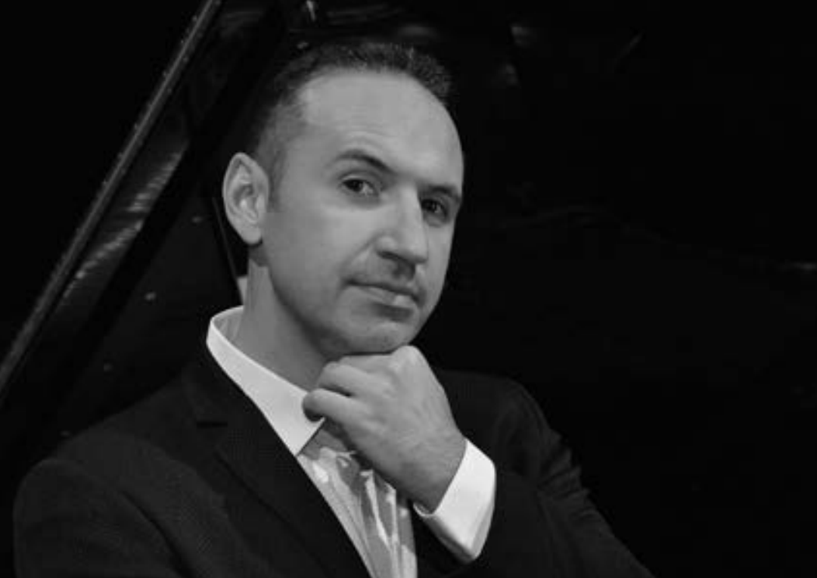

Simon Trpčeski has been praised not only for his powerful virtuosity and deeply expressive approach to music, but also for his charismatic stage presence. Launched onto the international scene more than 20 years ago as a BBC New Generation Artist, and enjoying an incredibly fast-paced career that encompasses no cultural or musical boundaries, Trpčeski has collaborated with over 100 orchestras on four continents, and performed on the most prestigious stages.
The long list of prominent conductors Trpčeski has worked with includes Lorin Maazel, Vladimir Ashkenazy, Marin Alsop, Gustavo Dudamel, Cristian Măcelaru, Gianandrea Noseda, Vasily Petrenko, Charles Dutoit, Jakub Hrůša, Vladimir Jurowski, Susanna Mälkki, Andris Nelsons, Sir Antonio Pappano, Robert Spano, Michael Tilson Thomas, Gabriel Bebeşelea and David Zinman.
Trpčeski’s fruitful collaborations with EMI Classics, Avie Records, Wigmore Hall Live, Onyx Classics and, currently, Linn Records have resulted in a broad and award-winning discography which includes repertoire such as Serge Rachmaninoff’s complete works for piano and orchestra and Sergei Prokofiev’s piano concertos, as well as works by composers such as Francis Poulenc, Claude Debussy and Maurice Ravel. Variations, his latest solo album, was released in spring 2022 and features works by Johannes Brahms, Ludwig van Beethoven and Wolfgang Amadeus Mozart.
Born in Macedonia in 1979, Trpčeski is a graduate of the School of Music at the University of St Cyril and St Methodius in Skopje, where he studied with Boris Romanov. He is committed to strengthening the cultural image of his native country, and his chamber music project Makedonissmo is dedicated to introducing audiences worldwide to the rich traditional Macedonian folk roots, weaving into one unique sound world the Macedonian folk music tradition, and highly virtuoso, jazz-influenced riffs and harmonies. Since its successful launch in 2018, Makedonissimo has performed to audiences worldwide and released an album
on Linn Records.
In 2009, Trpčeski received the Presidential Order of Merit for Macedonia and in 2011, he became the first ever recipient of the title ‘National Artist of Macedonia’. He was a BBC New Generation Artist 2001–03 and in 2003 was honoured with the Young Artist Award by the Royal Philharmonic Society.

London Symphony Orchestra
Leader
Carmine Lauri

First Violins
Jérôme Benhaim
Clare Duckworth
Ginette Decuyper
Maxine Kwok
William Melvin
Stefano Mengoli
Claire Parfitt
Elizabeth Pigram
Laurent Quénelle
Harriet Rayfield
Sylvain Vasseur
Richard Blayden
Morane Cohen-Lamberger
Julia Rumley
Helena Smart

Second Violins
Julián Gil Rodríguez
Thomas Norris
Sarah Quinn
Miya Väisänen
Matthew Gardner
Naoko Keatley
Alix Lagasse
Belinda McFarlane
Iwona Muszynska
Csilla Pogány
Andrew Pollock
Paul Robson
Louise Shackelton
Anna Takeda

Violas
Eivind Ringstad
Gillianne Haddow
Malcolm Johnston
Matan Gilitchensky
Thomas Beer
Germán Clavijo
Steve Doman
Julia O’Riordan
Robert Turner
Nancy Johnson
Elisabeth Varlow
Anna Dorothea Vogel
Cellos
Rebecca Gilliver
Alastair Blayden
Salvador Bolón
Ève-Marie Caravassilis
Daniel Gardner
Laure Le Dantec
Amanda Truelove
Judith Fleet
Miwa Rosso
Joanna Twaddle

Double Basses
Lorraine Campet
Patrick Laurence
Joe Melvin
Jani Pensola
Chaemun Im
Simon Oliver
Hugh Sparrow
Adam Wynter
Flutes
Gareth Davies
Daniel Shao

Piccolo
Sharon Williams

Oboes
Olivier Stankiewicz
Rosie Jenkins

Cor Anglais
Emily Cockbill

Clarinets
James Burke
Chi-Yu Mo
Andrew Harper

Bass Clarinet
Ferran Garcerà Perelló
Bassoons
Daniel Jemison
Joost Bosdijk

Contra Bassoon
Martin Field

Horns
Timothy Jones
Jonathan Maloney
Olivia Gandee
Finlay Bain
Eleanor Blakeney

Trumpets
James Fountain
David Carstairs
Kaitlin Wild

Trombones
Peter Moore
Jonathan Hollick
Bass Trombone
Paul Milner

Tuba
Ben Thomson

Timpani
Patrick King

Percussion
Neil Percy
David Jackson
Sam Walton

Harp
Bryn Lewis

Piano
Elizabeth Burley

