# Jenůfa

## Thursday 11 & Sunday 14 January Barbican

**Leoš Janáček** Jenůfa

*concert performance; sung in Czech with English surtitles*

**Sir Simon Rattl**e conductor

**Agneta Eichenholz** Jenůfa

**Katarina Karnéus** Kostelnička

**Nicky Spence** Števa  
**Aleš Briscein** Laca  
**Carole Wilson** Grandmother Buryjovka

**Jan Martiník** Foreman / Mayor  
**Hanna Hipp**  Mayor’s Wife  
**Evelin Novak** Karolka

**Claire Barnett-Jones** Herdswoman / Barena  
**Erika Baikof** Jano

**London Symphony Chorus  
Simon Halsey** chorus master

**London Symphony Orchestra**

Generously supported by The Jeremy and John Sacher Charitable Trust and the LSO Opera Giving Circle

Recorded for future broadcast from 8 February on Marquee TV

Recorded for future release on LSO Live

# Welcome

Happy New Year, and a warm welcome to these LSO performances at the Barbican. We are delighted to welcome back Sir Simon Rattle, now in his role as LSO Conductor Emeritus. For these concerts, he continues his exploration of the glorious operas of Czech composer Leoš Janáček with two concert performances of *Jenůfa*. These much-anticipated performances follow on from the production of *The Cunning Little Vixen* in 2019, which has been released on our record label, LSO Live, and concert performances of *Katya Kabanova* in 2023, which will be released on LSO Live in February of this year.

Alongside Agneta Eichenholz making her LSO debut in the title role, we welcome Katarina Karnéus as Kostelnička, Jenůfa’s guilt-ridden stepmother; Nicky Spence as Števa, Jenůfa’s true love; Carole Wilson as Grandmother Buryjovka; Erika Baikoff as Jano; and Evelin Novak as Karolka. We also welcome Aleš Briscein as Laca, Števa’s half-brother, along with Jan Martiník, Claire Barnett-Jones, Hanna Hipp and the London Symphony Chorus.

These concerts are generously supported by The Jeremy and John Sacher Charitable Trust, and the LSO Opera Giving Circle, to whom we are very grateful. You can find out more about the Opera Giving Circle at lso.co.uk/operacircle.

The performances are being recorded for future release on our record label, LSO Live, and the performance on 11 January is being recorded for broadcast by our partner Marquee TV, available online from 8 February.

I hope that you enjoy the concert and that you   
will be able to join us again soon. At the end of   
this month, Sir Antonio Pappano, LSO Chief Conductor Designate, returns to the Barbican to conduct two performances of Felix Mendelssohn’s monumental oratorio, *Elijah*, and we look forward to welcoming soloists Masabane Cecilia Rangwanasha, Dame Sarah Connolly, Allan Clayton and Gerald Finley, and the London Symphony Chorus. We hope to see you there.

**Dame Kathryn McDowell DBE DL  
Managing Director**

# Jenůfa

## Leoš Janáček

Music by Leoš Janáček  
Czech libretto by Gabriela Preissová

English translation by Simon Rees  
Surtitles operated by Damien Kennedy  
Notes and synopsis by Nigel Simeone

PREISSOVÁ’S PLAY  
In November 1890, the Prague National Theatre staged Gabriela Preissová’s play *Her Stepdaughter*. Though it was enthusiastically received by the public, critics condemned its ‘gratuitous violence’ and it closed after five performances. A shocked Preissová wrote to a Prague newspaper explaining that, far from being gratuitous, her play was based on ‘two real-life incidents, much idealised! In the first, a lad wounded a girl in the face … because he loved her himself. In the second, a woman helped her stepdaughter get rid of a love-child (the girl threw the baby into the sewer), but I did not want two murderesses. Jenůfa falls through love, but she has enough goodness and strength to live a better life.’

When composer Leoš Janáček approached Preissová for permission to make an operatic adaptation of her play, she worried that it might not be suitable. But he talked her round, partly because Preissová had enjoyed their earlier collaboration on a one-act opera, *The Beginning of a Romance*. At the 1904 Brno premiere of Janáček’s *Jenůfa* (known in Czech-speaking countries as *Její pastorkyňa* – ‘Her Stepdaughter’), any doubts Preissová may have had were swept aside. After the Prague production of *Jenůfa* in 1916, the opera went on to receive international success. It had been a long wait. When Janáček started composing *Jenůfa*, he had just turned 40. By the time of its triumph in Prague, he was 62.

COMPOSING Jenůfa  
Janáček began *Jenůfa* in 1894, the year in which Marie Stejskalová arrived as the Janáčeks’ housekeeper. She recalled him composing whenever time allowed, often working through the night: ‘Sometimes it seemed to me that the master was battling with *Jenůfa*, as if he went into his study not to compose it, but to fight with it.’

After completing Act I, Janáček put the opera aside for four years to work on other projects, including an enormous collection of Moravian folk music. He resumed in 1901, finishing Act II in July 1902. Janáček’s daughter Olga was at that time gravely ill, as Stejskalová recalled (with a fascinating comparison between Janáček and the character of Kostelnička): ‘The more Oluška [Olga] became ill, the more obsessed she became with her father’s new opera. ... He put his pain over Oluška into his work, and the suffering of his daughter into Jenůfa’s suffering. And that tough love of Kostelnička – that’s him. There is much of his own character in that part.’

Composing Act III coincided with Olga’s final illness. She often sat with Janáček while he worked and asked him to play through the whole opera a few days before she died (on   
26 February 1903). According to Stejskalová, when Janáček got to the end, Olga said: ‘It’s beautiful. What a pity I will never see it.’ Janáček’s dedication on the score of *Jenůfa*reads: ‘To the memory of Olga Janáčková’.

Jenůfa’s Premiere  
The first performance of *Jenůfa* was given in Brno on 21 January 1904. Despite an orchestra that was smaller than Janáček envisaged (and missing several instruments, including the harp and cor anglais), it was a great local success. As soon as it was finished, Janáček sent the score to the Prague National Theatre. It was swiftly rejected, partly due to the theatre’s conductor Karel Kovařovic, who had never forgiven Janáček for a brutal review of his own opera *The Bridegrooms* in 1887. Janáček tried to interest other conductors in *Jenůfa*: in December 1904, Gustav Mahler wrote from the Vienna Court Opera that he would ‘certainly be interested in getting to know the work’, but asked for a German translation, which wasn’t available at the time.

There matters rested for several years. From 1906 to 1907, Janáček made a thorough revision of *Jenůfa*, bringing it to its definitive form. Finding a publisher turned out to be surprisingly easy. In December 1907, at a meeting of the Brno Friends of Art Club, Janáček suggested the Club could inaugurate its musical publications with *Jenůfa*. Everything was quickly agreed and finished copies were ready in March 1908.

Janáček’s Definitive Version  
But even with the vocal score in print, four years after its premiere, *Jenůfa* had still had no productions outside Brno. After years of frustration, Janáček became disheartened over efforts to have *Jenůfa* performed in Prague. But his supporters persisted, and eventually Kovařovic agreed to put it on at the Prague National Theatre, on the condition that it was done with his own reorchestration. Initially, at least, Janáček had no objection, and when Universal Edition took on the score in 1917, it was published with all of Kovařovic’s changes. This was how *Jenůfa* was heard in the world’s great opera houses until the 1980s, when John Tyrrell and Charles Mackerras prepared a new edition based on Janáček’s own definitive version. Since then, the opera has emerged as the composer himself intended: its music more rugged and muscular, and closer to the sound-world of his later operatic masterpieces such as *Katya Kabanova* (1921).

Given its setting in a Moravian village, it is natural that Janáček included some folk elements in his score, notably the Recruits’ Chorus in Act I and the dance-song of the Village Girls in Act III. These are both invented tunes, inspired by Janáček’s study of Moravian folk music, but not actual quotations from folksongs.

Other musical features are of greater significance: in *Jenůfa*, Janáček developed a style of vocal writing in which characters are sharply differentiated by the music they are given to sing (their phrases sometimes derived from Janáček’s study of speech patterns). In particular, the radiant lyricism of the protagonist Jenůfa’s music is set in sharp relief against the prickly and belligerent writing for Kostelnička. The larger-scale musical argument is articulated in the orchestra, often with arresting instrumental colours (starting with the clattering xylophone at the beginning) and driven by short, repeating ostinato figures.

Janáček’s other great achievement in this opera is his perfecting of dramatic pacing: Act II, in particular, has almost terrifying intensity. He was to achieve even tauter dramatic compression in some of his later operas, but *Jenůfa* remains a work where its characters’ passions are laid bare in a miraculous combination of tragic power and lyrical ardour.

# Synopsis

ACT I: THE BURYJA MILL, LATE AFTERNOON  
We hear the clacking of the mill wheel, represented by a xylophone. Jenůfa is anxious to know if her beloved Števa has been conscripted: she is carrying his child and her secret will soon be known. She is relieved that he has not been called up, so will be able to marry her before the pregnancy becomes obvious. Meanwhile, Laca – Števa’s jealous half-brother – secretly loves Jenůfa. Števa staggers in drunk with a group of recruits and they break into a rowdy dance. This incurs the disapproval of Jenůfa’s stepmother, Kostelnička (literally meaning the ‘village sacristan’) who tells Števa he can only marry Jenůfa if he abstains from drinking for a year. Jenůfa begs Števa to marry her as soon as possible and he tells her he loves her ‘rosy-apple cheeks’. Grandmother Buryja sends Števa away to sleep off his drink and Laca taunts Jenůfa with flowers that Števa had been given by one of his female admirers. Jenůfa remains steadfast. Laca tries to kiss her, she repels him and, consumed with jealous rage, he slashes her cheek with a knife.

ACT II: The Kostelnička’s house, five months later, WinterKostelnička has hidden Jenůfa at home, where she has given birth to a boy. Jenůfa loves the child, but Kostelnička cannot bear the shame. She gives Jenůfa a sleeping potion and sends for Števa. Kostelnička tells him about the baby and begs him to marry Jenůfa. Števa refuses as he is now engaged to Karolka, the Mayor’s daughter. Kostelnička then turns to Laca, who is only too happy to marry Jenůfa, but he is distressed to hear about the baby. Kostelnička believes lying to be her only option: she tells Laca that the child has died. Much worse, she turns her lie into a shocking reality, drowning the baby in the freezing water of the millstream. Jenůfa wakes up as she returns and Kostelnička tells her she has been in a fever for two days, during which time the baby has died. Laca returns and offers to marry Jenůfa, insisting that he loves her, and she agrees to become his wife. Gripped by guilt and remorse, Kostelnička has a terrifying vision at the height of a storm, seeing the hand of death forcing open the door of her house.

*20-MINUTE INTERVAL AFTER ACT II*

ACT III: TWO MONTHS LATER, SPRINGIt is Jenůfa and Laca’s wedding day. The Mayor and his wife pay their respects. Laca tells Jenůfa that he has put the past behind him and invited Števa and his bride-to-be, Karolka. The village girls sing and Grandmother Buryjovka blesses the couple. Just as Kostelnička is about to bless them, there is a commotion: a baby’s body has been found in the thawing river. From the clothes he was wearing, Jenůfa realises that this must be her child. The villagers turn on Jenůfa, accusing her of killing the baby, but Kostelnička steps forward and confesses to her crime. As Kostelnička is led away to face her punishment, Jenůfa calls upon the wedding guests to forgive her stepmother. Jenůfa tells Laca that he is free to go, but he promises to stay with her forever. Moved by his devotion, Jenůfa concludes that God has blessed their union.

# Cast

Jenůfa

Agneta Eichenholz  
The opera’s protagonist, pregnant with her cousin Števa’s child, and stepdaughter of Kostelnička.

Kostelnička

Katarina Karnéus  
Jenůfa’s stepmother, the village sacristan, a pillar of the community and Grandmother Buryjovka’s daughter-in-law.

Števa

Nicky Spence  
Heir to the mill and father of Jenůfa’s child. Often intoxicated, he becomes engaged to Karolka.

Laca

Aleš Briscein  
Števa’s jealous half-brother, secretly in love   
with Jenůfa.

Grandmother Buryjovka

Carole Wilson  
Matriarch and retired mill owner whose two sons have died, leaving Števa as her heir. Mother-in-law of Kostelnička and grandmother of Števa, Laca and Jenůfa.

Foreman

Jan Martiník  
Supervisor at the mill.

Mayor

Jan Martiník

Mayor’s Wife

Hanna Hipp  
Prominent figures in the village who are guests at Jenůfa’s wedding.

Karolka

Evelin Novak  
The Mayor’s daughter, engaged to Števa.

Herdswoman

Claire Barnett-Jones  
A guest at Jenůfa’s wedding.

Barena

Claire Barnett-Jones  
A servant at the mill.

Jano

Erika Baikoff  
A shepherd boy who is taught to read by Jenůfa.

Kate Golla repetiteur  
Lucie Thorpe Spickova language coach

# Leoš Janáček

## 1854 to 1928 (Moravia, now Czech Republic)

Composer profile by Andrew Mellor

Leoš Janáček was one of music’s great one-offs, a composer who tore up the aesthetic rulebook of his time.

Unlike his Czech counterparts (notably Antonín Dvořák), Janáček was born far from any major metropolis. Specifically, in Hukvaldy, in Moravia – a district of what is now the Czech Republic (then part of the Austrian Empire) and an area that would literally shape the tunes and rhythms that characterise Janáček’s distinctive music. From his limited means, Janáček found his way to studies in Brno, the Moravian capital, and later Prague and Leipzig, before eventually returning to Brno to lead the organ school he had attended.

Back in Brno, Janáček immersed himself in the Moravian peasant songs and dances that had surrounded him since childhood. As he began to trust the unusual contours of this earthy music, he consciously rejected Western music’s accepted norms. From about 1890, a new, uncompromising and rampantly communicative musical style started to form in him, based on the principle that the rhythms of speech enshrine the truest expression of the human soul.

Success came late to Janáček. His name was only widely known from 1916, when one of his most celebrated creations, an opera telling of scandalous family tragedies in small-town Moravia, was performed in Prague. *Jenůfa* is now a mainstay of the opera repertoire worldwide.

From then on, Janáček’s creativity burned with an intensity bordering on the destructive. His later years were dominated by an obsession with a married woman, Kamila Stösslová, who became his muse but never his lover (the composer was married too). For the Janáček expert John Tyrell, Kamila embodied the sense of longing that is a constant theme in Janáček’s life and music. She inspired many of his greatest works, including the operas *Katya Kabanova*, *The Cunning Little Vixen* and *The Makropulos Affair*, the song cycle *The Diary of One Who Disappeared*, the *Glagolitic Mass* and the String Quartet No 2, ‘Intimate Letters’.

# Sir Simon Rattle

## Conductor Emeritus

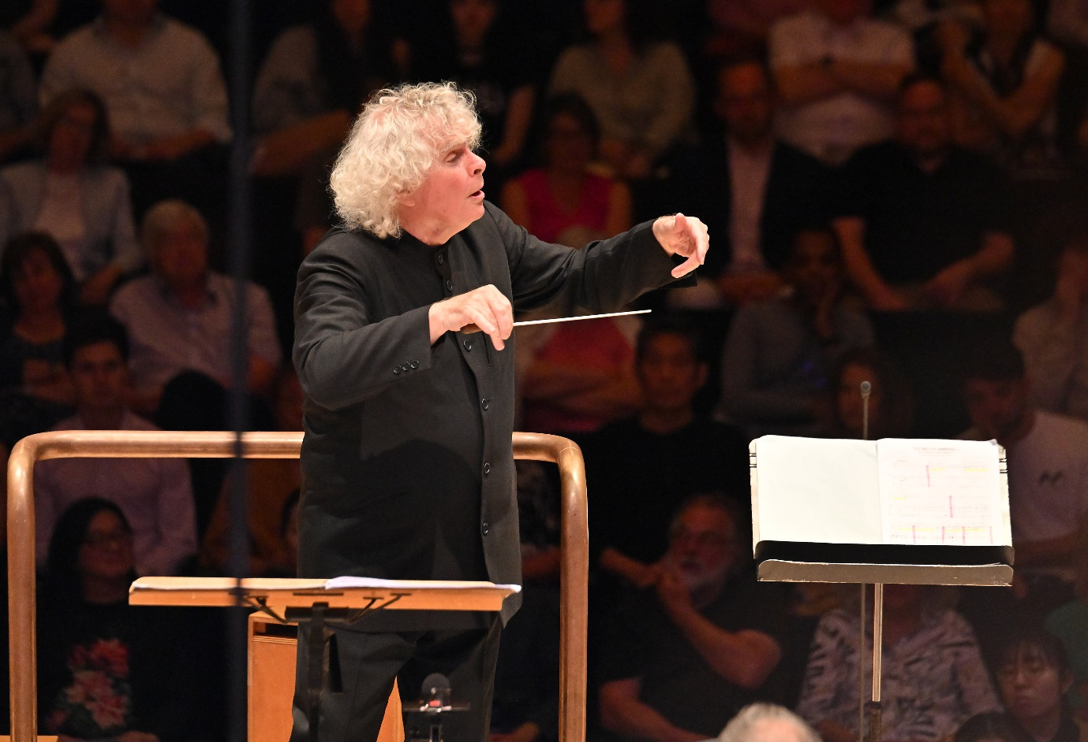

Sir Simon Rattle was born in Liverpool and studied at the Royal Academy of Music. From 1980 to 1998, he was Principal Conductor and Artistic Adviser of the City of Birmingham Symphony Orchestra and was appointed Music Director in 1990. In 2002 he took up the position of Artistic Director and Chief Conductor of the Berlin Philharmonic, where he remained until the end of the 2017/18 season. Sir Simon was appointed Music Director of the London Symphony Orchestra in September 2017, a position he remained in until the 2023/24 season, when he became Conductor Emeritus. That same season, Sir Simon took up the position of Chief Conductor with the Symphonieorchester des Bayerischen Rundfunks in Munich. He is a Principal Artist of the Orchestra of the Age of Enlightenment and Founding Patron of Birmingham Contemporary Music Group.

Sir Simon has made over 70 recordings for EMI record label (now Warner Classics) and has received numerous prestigious international awards for his recordings on various labels. His most recent recordings include Berlioz’s *The Damnation of Faust*, Helen Grime’s *Woven Space*, Debussy’s *Pelléas et Mélisande*, Turnage’s *Remembering* and Beethoven’s *Christ on the Mount of Olives*, which were all released by the LSO’s own record label, LSO Live.

Sir Simon regularly tours within Europe, the United States and Asia, and has longstanding relationships with world-leading orchestras. He regularly conducts the Staatskapelle Berlin, Berlin Philharmonic, Chamber Orchestra of Europe and the Czech Philharmonic. He has conducted opera productions at the Metropolitan Opera, Wiener Staatsoper, Deutsche Staatsoper Berlin and at the Festival d’Aix en Provence.

Music education is of supreme importance to   
Sir Simon. In 2019 Sir Simon announced the creation of the LSO East London Academy, developed by the LSO in partnership with ten East London boroughs. This free programme aims to identify and develop the potential of young East Londoners between the ages of 11 and 18 who show exceptional musical talent. His partnership with the Berlin Philiharmonic broke new ground with the education programme Zukunft@Bphil. He and the Berlin Philharmonic were appointed International UNICEF Ambassadors in 2004, the first time this honour has been conferred on an artistic ensemble.

Sir Simon was awarded a knighthood by Her Late Majesty Queen Elizabeth II in 1994 and received the Order of Merit in 2014. He received the Order of Merit in Berlin in 2018. In 2019 he was given the Freedom of the City of London.

# Agneta Eichenholz

## Soprano

## Jenůfa

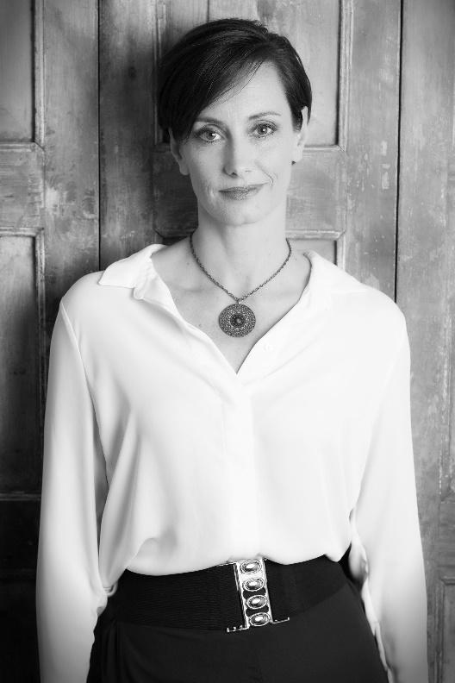

Swedish soprano Agneta Eichenholz made her breakthrough in 2009 with her debut at the Royal Opera House, Covent Garden, in the title role of Alban Berg’s *Lulu*. Engagements since have included performances at Opernhaus Zürich, Royal Opera Stockholm, Teatro Real Madrid, Komische und Deutsche Oper Berlin, Liceu Barcelona, Antwerpen, Rome, Theater Basel, Staatsoper Hamburg, Copenhagen and Gothenburg.

Her extensive repertoire includes roles such as Daphne (Strauss), Alcina (Handel), Circe (Gluck’s *Telemaco*), Fiordiligi (Mozart’s *Così fan tutte*), Konstanze (Mozart’s *Die Entführung aus dem Serail*, Elettra (Mozart’s *Idomeneo*), Vitellia and Violetta (Verdi’s *La traviata*), Gilda (Verdi’s *Rigoletto*), Juliette (Gounod’s *Roméo et Juliette*), Norina (Donizetti’s *Don Pasquale*), Sophie Scholl (Zimmerman’s *White Rose*), Cordelia (Reimann’s *Lear*), Eva (Die Meistersinger von Nürnberg) and Zdenka (Strauss’ *Arabella*), plus concert repertoire.

Recent and future engagements include her return to the Theater an der Wien as Ellen Page (Britten’s *Peter Grimes*), her debut as Emilia Marty (Janáček’s *The Makropulos Affair*) in Malmö, singing Jenůfa in Seville and at the Flamish Opera Antwerpen, and a production of Cosi fan tutte at the Théâtre du Chatelet, Paris.

Katarina Karnéus

Mezzo-soprano

## Kostelnička

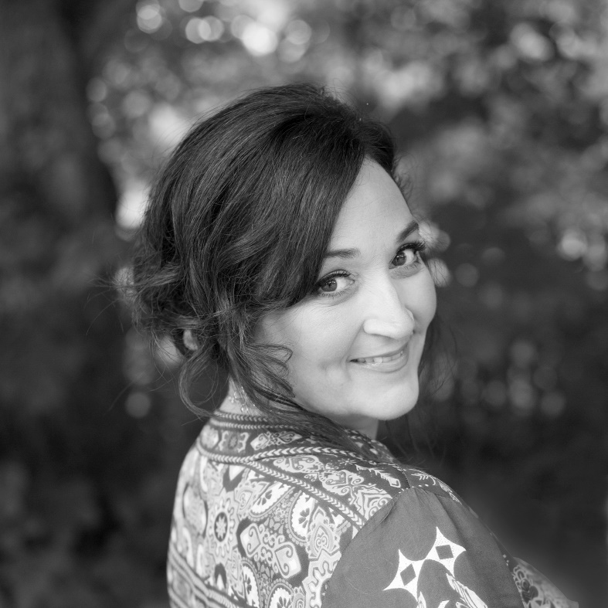

Swedish mezzo-soprano Katarina Karnéus is a member of the Gothenburg Opera and an international ambassador for the company. She was recently presented with the Litteris et Artibus medal by HM the King of Sweden. A former winner of the BBC Cardiff Singer of the Year Award, she has performed for international opera companies including the Metropolitan Opera, New York; The Royal Opera House, Covent Garden; the Bavarian State Opera; and the Opéra national de Paris. She has sung with orchestras including the Berlin Philharmonic, Vienna Symphony Orchestra, Cleveland Orchestra and NDR Symphony Orchestra, and at festivals including the BBC Proms, Edinburgh and Salzburg. Her recordings range from Sibelius and Grieg songs to Mahler’s Symphony No 8, under Michael Tilson Thomas.

Recent and future engagements include Kundry (Wagner’s *Parsifal*) for Opera North, Brangäne (Wagner’s *Tristan and Isolde*) in Luxembourg and Auckland, Herodias (Strauss’ *Salome*) for Royal Swedish Opera, Nicklausse (Offenbach’s *The Tales of Hoffmann*) and Donna Elvira (Mozart’s *Don Giovanni*) for Gothenburg Opera, and concerts with the Helsinki Philharmonic Orchestra and the Gothenburg Symphony Orchestra.

Nicky Spence

Tenor

## Števa

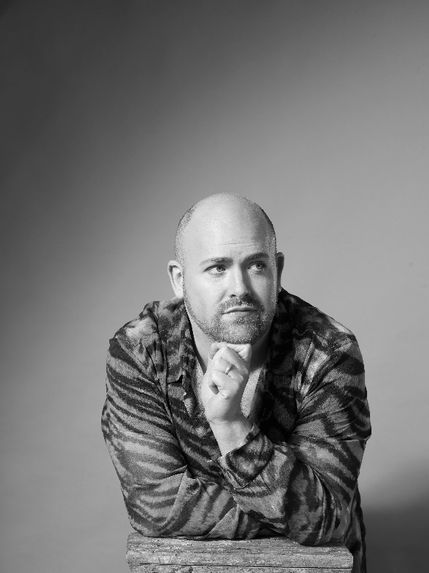

Scottish tenor Nicky Spence was awarded an OBE in His Majesty The King’s Birthday Honours in 2023 and named Personality of the Year by *BBC Music Magazine* in 2022. He has won special acclaim for his interpretations of Janáček and Heldentenor roles.

Recent engagements include Siegmund (Wagner’s *Die Walküre*) for English National Opera; the title   
role of Wagner’s *Parsifal* with the Hallé Orchestra; Laca (Janáček’s *Jenůfa*) for The Royal Opera House, Covent Garden; Erik (Wagner’s *The Flying Dutchman*) for Grange Park Opera; Albert Gregor (Janáček’s *The Makropulos Affair*) for the Berlin State Opera; Tichon (Janáček’s *Katya Kabanova*) for Glyndebourne Festival; and his role debut as Loge (Wagner’s *Das Rheingold*) for La Monnaie, Brussels. Forthcoming engagements include his debut at the Gran Teatre del Liceu, Barcelona, and returns to The Royal Opera House, the Opéra national de Paris and the Glyndebourne Festival.

Passionately dedicated to bringing as many people as possible to classical music, Nicky Spence hosts ENO’s new podcast, *Opera Actually*, and recently presented *Anyone can sing* and *Sing while you’re winning* for Sky Arts. His recordings include an award-winning disc of Janáček’s *The Diary of One Who Disappeared*.

Aleš Briscein

Tenor

Laca

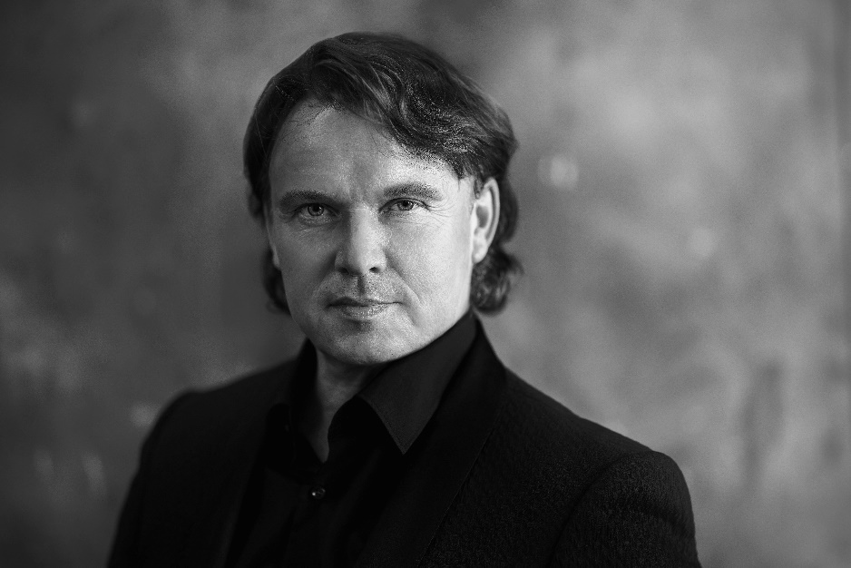

Czech tenor Aleš Briscein’s recent engagements include Erik (Wagner’s *The Flying Dutchman*) and Fritz (Schreker’s *Der ferne Klang*) in Prague, Boris (Janáček’s *Katya Kabanova*) in Geneva and Paul (Korngold’s *Die tote Stadt*) in Auckland.

Other career highlights have included Anatole (Prokofiev’s *War and Peace*) in Geneva; Albert Gregor (Janáček’s *The Makropulos Case*) in Geneva and at the Deutsche Oper Berlin and the BBC Proms; King’s Son (Humperdinck’s *Königskinder*) and the title role in Smetana’s *Dalibor* in Frankfurt; Paul (*Die tote Stadt*) for the Komische Oper Berlin and the Semperoper Dresden; Števa (Janáček’s *Jenůfa*) and Filka Morozov (Janáček’s *From the House of the Dead*) for the Bavarian State Opera; Sergei (Shostakovich’s *Lady Macbeth of Mtsensk*) in Ostrava; Lensky (Tchaikovsky’s *Eugene Onegin*) at the Komische Oper Berlin; Skuratov (*From the House of the Dead*) for the Savonlinna Opera Festival; and the title role in Wagner’s *Lohengrin* at the Tyrolean Festival in Erl.

He also performs widely in concert, in repertoire including Beethoven’s Missa Solemnis and Ninth Symphony, Mahler’s Eighth Symphony and Janáček’s *Glagolitic Mass*.

# **Carole Wilson**

## Mezzo-soprano

## Grandmother Buryjovka

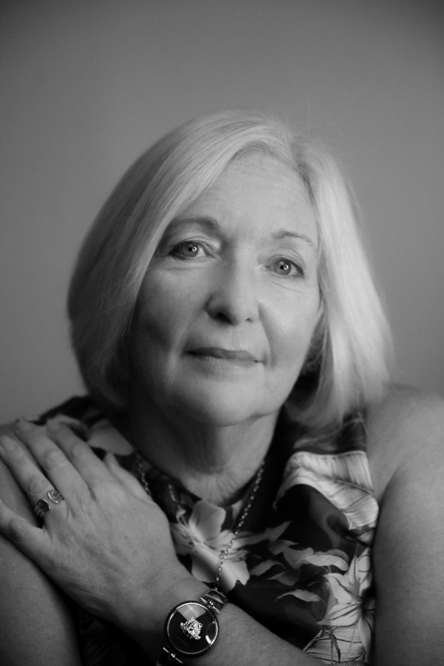

British mezzo-soprano Carole Wilson sings regularly for The Royal Opera House, Covent Garden, where roles have included Aksinya (Shostakovich’s *Lady Macbeth of Mtsensk*), Marthe (Gounod’s *Faust*) and White Queen (Gerald Barry’s *Alice’s Adventures Underground*). For La Monnaie, Brussels, she has recently performed Grandmother Buryjovka, Ježibaba (Dvořák’s *Rusalka*), Gertrude (Gounod’s *Roméo et Juliette*), Annina (Verdi’s *La traviata*), Mrs Lovett (Sondheim’s *Sweeney Todd*) and Babarikha (Rimsky-Korsakov’s *The Tale of Tsar Saltan*).

Other recent appearances have included Mother Goose (Stravinsky’s *The Rake’s Progress*) for Glyndebourne Festival, Auntie (Britten’s *Peter Grimes*) for the Deutsche Oper am Rhein and Opéra de Monte Carlo, Annina (Strauss’ *Der Rosenkavalier*) at the Baden Baden Festival, Bobylicka (Rimsky-Korsakov’s *Snegurochka*) for Opéra national de Paris and Witch (Humperdinck’s *Hansel and Gretel*) for Opéra national de Lorraine.

She has sung in concert with orchestras including the Berlin Philharmonic, Vienna Philharmonic and Royal Concertgebouw Orchestra, and with conductors including Semyon Bychkov, Andrew Davis, Adam Fischer, Sir Antonio Pappano and   
Sir Simon Rattle.

Jan Martiník

## Bass

## Foreman / Mayor

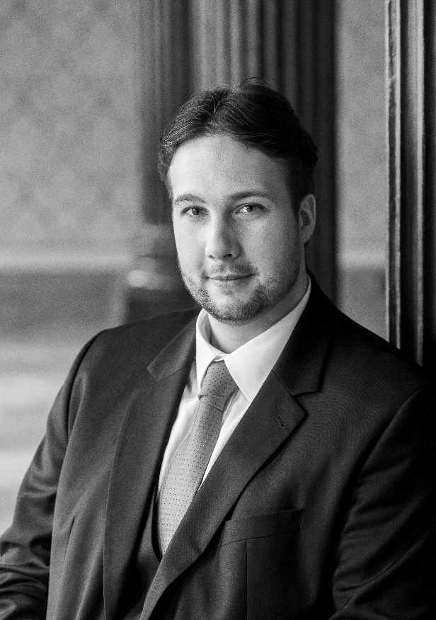

Czech opera singer Jan Martiník has won several awards during his career, including the BBC Cardiff Singer of the World Song Prize in 2009.

Martiník has been a soloist at Berlin State Opera for almost 10 years. Recent engagements in Berlin include Starek, Sacristan (Puccini’s *Tosca*), Dr Kolenatý (Janáček’s *The Makropulos Affair*), Zuniga (Bizet’s *Carmen*), Voice (*Idomeneo*), Daland (Wagner’s *The Flying Dutchman*) and Innkeeper (Peter Eötvös’ *Sleepless*).

Recent concert engagements include Janáček’s Glagolitic Mass in Tokyo and Vienna, Beethoven’s Ninth Symphony at the Prague Spring Festival, and the Water Sprite (Dvořák’s *Rusalka*) in a semi-staged concert with the Czech Philharmonic conducted by Semyon Bychkov. He regularly performs with orchestras including the London Symphony Orchestra, Bamberger Symphoniker, BBC Symphony Orchestra, and others.

His recordings include *Winterreise* by Franz Schubert and Dvořák’s Biblical Songs (2020, Decca) with the Czech Philharmonic. With the LSO and Sir Simon Rattle, he recorded Parson/Badger in Janáček’s *The Cunning Little Vixen*, which was nominated for a Grammy in 2020.

Hanna Hipp

## Mezzo-soprano

## Mayor’s Wife

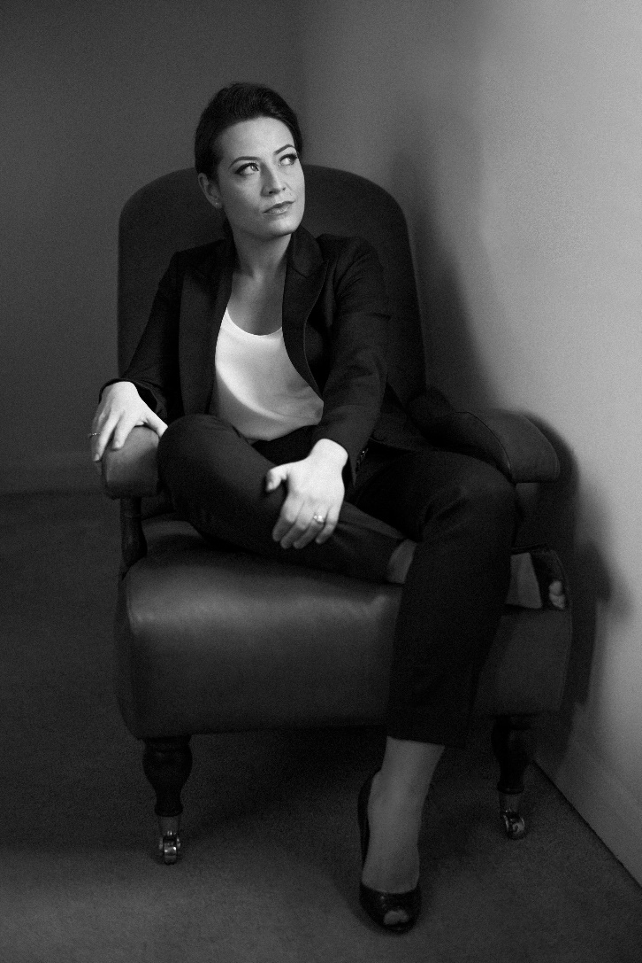

Polish mezzo-soprano Hanna Hipp is a former Jette Parker Young Artist at The Royal Opera House, Covent Garden. In the 2022/23 season she sang in Szymanowski’s *Stabat Mater* with the LSO under Sir Simon Rattle at the Barbican and the Edinburgh Festival. She performs internationally at leading opera houses and concert venues.

Recent opera engagements include Federico García Lorca (Golijov’s *Ainadamar*) for Welsh National Opera, Offred (Ruders’ *The Handmaid’s Tale*) for the Royal Danish Theatre, Composer (Strauss’ *Ariadne auf Naxos*) for Glyndebourne Festival and Opera North, Octavian (Strauss’ *Der Rosenkavalier*) for Garsington Festival, Dorabella (Mozart’s *Così fan tutte*) for Seattle Opera, English National Opera and New Zealand Opera, and Cherubino (Mozart’s *The Marriage of Figaro*) for The Royal Opera House, Covent Garden.

Recent concert appearances include Beethoven’s Ninth Symphony at the Vienna Konzerthaus and with the Orchestre de la Suisse Romande in Geneva, Mahler’s Symphony No 3 with the Royal Philharmonic Orchestra and the Page of Herodias (Strauss’ *Salome*) at the Edinburgh Festival.

Evelin Novak

## Soprano

## Karolka

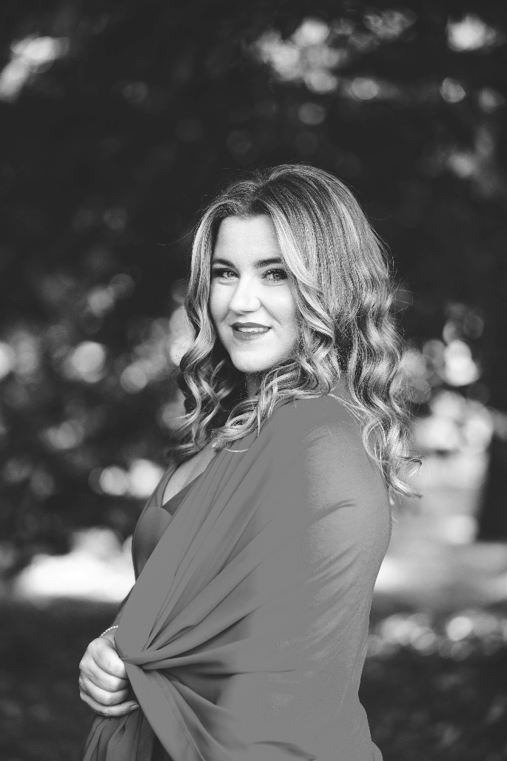

Croatian soprano Evelin Novak is a member of the Berlin State Opera, where she has sung roles such as Drusilla (Monteverdi’s *L’incoronazione di Poppea*), Susanna (Mozart’s *The Marriage of Figaro*), Donna Anna (Mozart’s *Don Giovanni*), Fiordiligi (Mozart’s *Così fan tutte*), Pamina (Mozart’s *The Magic Flute*), Marzelline (Beethoven’s *Fidelio*), Agathe (Weber’s *Der Freischütz*), Frau Fluth (Nicolai’s *The Merry Wives of Windsor*), Violetta Valéry (Verdi’s *La traviata*), Eurydice (Offenbach’s *Orphée aux enfers*), Woglinde (Wagner’s *Der Ring des Nibelungen*), Gretel (Humperdinck’s *Hansel and Gretel*), Mimì   
(Puccini’s *La bohème*) and Jenny Hill (Weill’s *Rise and Fall of the City of Mahagonny*).

Other appearances include Pamina, Gretel, Marzelline and Naiad (Strauss’ *Ariadne auf Naxos*) for the Semperoper Dresden, Micaëla (Bizet’s *Carmen*) for the Liceu, Barcelona, Susanna for Hamburg State Opera and Mimì for the Cologne Opera. In 2023 she made her Bayreuth Festival debut as Woglinde (Wagner’s *Der Ring des Nibelungen*) and as   
First Flowermaiden (Wagner’s *Parsifal*). She works regularly with conductors including Daniel Barenboim, Christian Thielemann, Sir Simon Rattle and Simone Young.

Claire Barnett-Jones

Mezzo-soprano

## Herdswoman / Barena

# Claire Barnett-Jones

British mezzo-soprano Claire Barnett-Jones is fast becoming one of the most sought-after singers on the operatic stage and the concert platform, having been awarded the Dame Joan Sutherland Audience Prize at the 2021 BBC Cardiff Singer of the Year Competition. Recent career highlights have included her debut at the Bayreuth Festival as Waltraute (Wagner’s *Die Walküre*) and Second Norn (Wagner’s *Götterdämmerung*); her French operatic debut as Ježibaba (Dvořák’s *Rusalka*) in a new production by Stefano Poda for the Théâtre National du Capitole de Toulouse; her role and company debuts as Fricka (*Die Walküre*) at the Tiroler Festspiele Erl in Austria; and her BBC Proms debut with a solo recital as part of the 2022 Proms at Birmingham.

In the 2023/24 season Claire makes her company debut with Dutch National Opera singing the role of The Government in the world premiere of Ellen Reid’s *The Shell Trial*, returns to Oper Frankfurt as Mescalina (Ligeti’s *Le grand macabre*) and sings Second Norn (*Götterdämmerung*) with the London Philharmonic Orchestra, conducted by Vladimir Jurowski.

Erika Baikoff

## Soprano

## Jano

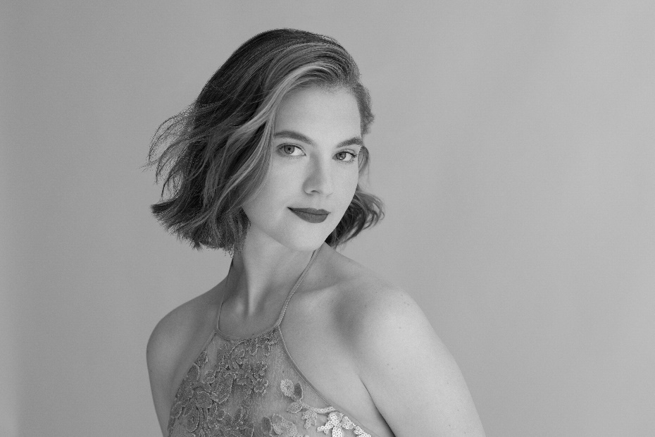

Russian-American soprano Erika Baikoff studied at Princeton University and the Guildhall School of Music & Drama. She is a former member of the Lyon National Opera Studio, and of the Metropolitan Opera’s Lindemann Young Artist Development Program, as part of which she sang Xenia (Mussorgsky’s *Boris Godunov*) and Barbarina (Mozart’s *The Marriage of Figaro*) at the Metropolitan Opera, New York.

During the 2022/23 season she returned to the Metropolitan Opera as a guest artist, and also made role debuts as Woglinde (Wagner’s *Das Rheingold*) at the Baden-Baden Festspiele under Yannick Nézet-Séguin and as Anna (Verdi’s *Nabucco*) at the Graz Musikverein. Important concert appearances have included Mahler’s Fourth Symphony with the Lyon National Opera Orchestra and Ulster Orchestre under Daniele Rustioni and with the Taipei Music Academy under Kent Nagano. Her plans include Zerlina (Mozart’s *Don Giovanni*) for Houston Grand Opera, the four heroines in Offenbach’s *The Tales of Hoffmann* for Palm Beach Opera and multiple appearances at the Bavarian State Opera.

# Simon Halsey

## chorus master

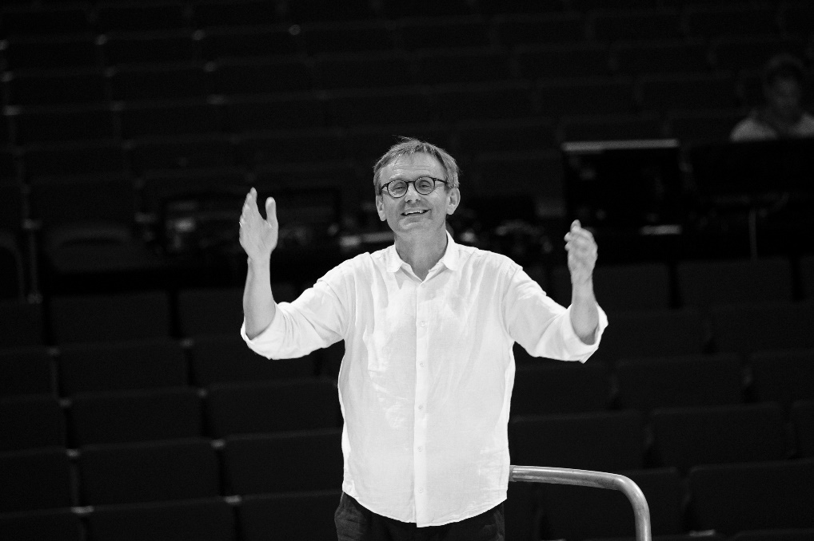

Simon Halsey holds positions as Chorus Director of the City of Birmingham Symphony Orchestra Chorus, Principal Guest Conductor and Choral Ambassador of Orfeó Català, Principal Guest Conductor at the WDR Rundfunkchor, Conductor Laureate of the Rundfunkchor Berlin, Choral Director Emeritus of the London Symphony Chorus, and Professor and Director of Choral Activities at University of Birmingham.

He is also a highly respected teacher and academic, nurturing the next generation of choral conductors on his post-graduate course in Birmingham and through masterclasses in Germany, the Netherlands, and the US. He holds four honorary doctorates from universities in the UK, and in 2011 Schott Music published his book and DVD on choral conducting, *Chorleitung: Vom Konzept zum Konzert*.

Halsey’s numerous awards include three Grammys for his recordings with the Rundfunkchor Berlin. He was made Commander of the British Empire in 2015, was awarded The Queen’s Medal for Music in 2014, and received the Officer’s Cross of the Order of Merit of the Federal Republic of Germany in 2011 in recognition of his outstanding contribution to choral music in Germany.

# London Symphony Chorus

The London Symphony Chorus was formed in 1966 to complement the work of the London Symphony Orchestra and is renowned internationally for its concerts and recordings with the Orchestra. The LSC has also worked with many leading international conductors and other major orchestras, including the Berlin Philharmonic, Vienna Philharmonic, Leipzig Gewandhaus, Los Angeles Philharmonic and New York Philharmonic; and has toured extensively throughout Europe and visited North America, Israel, Australia and South East Asia.

In the current season, the Chorus joins the LSO in anticipated performances of Felix Mendelssohn’s *Elijah* under LSO Chief Conductor Designate Sir Antonio Pappano, and reunites with Sir Simon Rattle in concert performances of *Jenůfa* (the latest in the LSO’s Leoš Janáček cycle). Further performances this season include Claude Debussy’s *Three Nocturnes* under Susanna Mälkki, Anton Bruckner’s *Te Deum* under Nathalie Stutzmann, Gustav Mahler’s Symphony No 3 under Michael Tilson Thomas, and Carl Orff’s *Carmina Burana* under Gianandrea Noseda.

Highlights of recent LSC seasons include a major European tour performing Ludwig van Beethoven’s Symphony No 9 and *Christ on the Mount of Olives* with Sir Simon Rattle and the LSO; the world premieres of Howard Goodall’s *Never to Forget* and Errollyn Wallen’s *After Winter* with Simon Halsey at the Spitalfields Festival in July 2021; Beethoven’s Symphony No 9 with the Orchestre Philharmonique in Monte-Carlo and Aix-en-Provence under Kazuki Yamada; a performance at the Barbican of Julian Anderson’s *Exiles* (an LSC/LSO co-commission); and appearances at the BBC Proms for Mahler Symphony No 2 and most recently Robert Schumann’s *Das Paradies und die Peri*, both under Sir Simon Rattle and with the LSO.

The Chorus is an independent charity run by its members. It is committed to excellence, to diversity, equity and inclusion, and the vocal development of its members. It engages actively in the musical life of London, seeking new members and audiences, and commissioning and performing new works.

# On Stage

Sopranos

Franziska Braeumer   
Carol Capper  
Laura Catala-Ubassy  
Esther Elbro  
Lucy Feldman  
Isobel Hammond  
Sophie Hill  
Sally Ho  
Denise Hoilette  
Alice Jones  
Ruth Knowles-Clark  
Luca Kocsmarsky  
Jasmine Krishnamurthy-Spencer  
Caddy Kroll  
Katy Lane  
Jane Morley  
Maggie Owen  
Carole Radford  
Liz Reeve  
Alison Ryan  
Emma Secher  
Deborah Staunton  
Jessica Villiers  
Lizzie Webb  
Eleri Williams  
Rachel Wilson

Altos

Kate Aitchison  
Enid Armstrong  
June Brawner  
Jo Buchan  
Sheila Cobourne  
Maggie Donnelly  
Lynn Eaton  
Linda Evans  
Amanda Freshwater  
Rachel Green  
Charlotte Hacking  
Yoko Harada  
Kate Harrison  
Catherine Hulme  
Elisabeth Iles  
Jill Jones  
Vanessa Knapp  
Gilly Lawson  
Anne Loveluck  
Jane Muir  
Caroline Mustill  
Helen Palmer  
Alison St Denis  
Lis Smith  
Erika Stasiuleviciute  
Snezy Valcheva

Tenors

Paul Allatt  
Matteo Anelli  
Erik Azzopardi  
Joaquim Badia  
Paul Beecham  
Philipp Boeing  
Oliver Burrows  
Kevin Cheng  
James David  
Michael Delany  
Colin Dunn  
Euchar Gravina  
Matt Journee  
Robert Kozak  
John Marks  
Davide Prezzi  
Chris Riley  
Mattia Romani  
Peter Sedgwick  
Malcolm Taylor  
Simon Wales  
James Warbis  
Robert Ward  
Leonard Wong

Basses

Roger Blitz  
Gavin Buchan  
Andy Chan  
Steve Chevis  
Harry Clarke  
Matthew Clarke  
Damian Day  
Robert Garbolinski  
Gerald Goh  
John Graham  
Owen Hanmer  
Anthony Howick  
Douglas Jones  
Alex Kidney  
Samuel Lea  
George Marshall  
Hugh McLeod  
Martin Nosek  
Jesus Sanchez Sanzo  
Rob Sanders Hewett  
Rod Stevens  
Gregory Storkan  
Richard Tannenbaum  
Gordon Thomson  
Robin Thurston  
Paweł Wysocki

# London Symphony Orchestra

## On Stage

**Leader**  
Benjamin Gilmore

**First Violins**  
Saskia Otto   
Clare Duckworth   
Ginette Decuyper   
Maxine Kwok   
William Melvin   
Stefano Mengoli  
Elizabeth Pigram   
Claire Parfitt   
Laurent Quénelle   
Harriet Rayfield   
Sylvain Vasseur   
Alix Lagasse   
Julia Rumley

**Second Violins**  
Thomas Norris  
Sarah Quinn  
Miya Väisänen   
Matthew Gardner   
Naoko Keatley   
Belinda McFarlane   
Iwona Muszynska   
Csilla Pogány   
Andrew Pollock   
Paul Robson   
Ricky Gore  
Lyrit Milgram

**Violas**  
Jane Atkins   
Gillianne Haddow  
Malcolm Johnston  
Matan Gilitchensky  
Steve Doman   
Thomas Beer  
Julia O’Riordan   
Sofia Silva Sousa   
Robert Turner   
Mizuho Ueyama   
Matan Gilitchensky

**Cellos**  
Rebecca Gilliver  
Laure Le Dantec   
Alastair Blayden  
Ève-Marie Caravassilis   
Daniel Gardner   
Amanda Truelove   
Joanna Twaddle   
Henry Hargreaves

**Double Basses**  
Graham Mitchell   
Patrick Laurence   
Thomas Goodman   
Joe Melvin   
Jani Pensola   
Simon Oliver   
Ben Griffiths

**Flutes**   
Gareth Davies  
Patricia Moynihan

Piccolo   
Sharon Williams

**Oboes**   
Olivier Stankiewicz  
Rosie Jenkins

Cor Anglais   
Romain Curt

**Clarinets**   
Sérgio Pires   
Chi-Yu Mo

**Bass Clarinet**   
Ferran Garcerà Perelló

**Bassoons**   
Rachel Gough  
Joost Bosdijk

**Contra Bassoon**   
Martin Field

**Horns**Timothy Jones  
Angela Barnes   
Diego Incertis Sánchez  
Jonathan Maloney

**Trumpets**   
Jason Evans  
Robin Totterdell

**Trombones**Peter Moore  
Jonathan Hollick

**Bass Trombone**   
Paul Milner

**Tuba**Ben Thomson

**Timpani**   
Patrick King

**Percussion**   
Neil Percy  
David Jackson

**Harp**Bryn Lewis