# Listening to America

## Sunday 3 March 7–9pm Barbican

**George Gershwin arr Don Rose** Overture: Let ’Em Eat Cake

**George Gershwin ed Timothy Freeze** Piano Concerto in F

*Interval*

**Roy Harris** Symphony No 3

**John Adams** Frenzy (world premiere)

**George Gershwin arr Don Rose** Overture: Strike Up the Band

**Sir Simon Rattle** conductor

**Kirill Gerstein** piano

**London Symphony Orchestra**

# Welcome

Welcome to this LSO concert. Tonight, Sir Simon Rattle, our Conductor Emeritus, celebrates American music with a programme spanning from the 1920s to the present day, including a new work written for Sir Simon and the LSO by John Adams, whom we are thrilled is with us this evening for the world premiere.

The LSO has had a long and successful history in America. We were the first European orchestra to tour there in 1912 – narrowly escaping the ill-fated Titanic – and since then, have returned more frequently than any other British orchestra. In recent years, we have enjoyed residencies in New York and Florida, as well as a major partnership with the Music Academy in Santa Barbara, California. Our years with American conductors André Previn, Leonard Bernstein and Michael Tilson Thomas have marked milestone moments for the Orchestra, and we continue to work with leading American artists both in London and abroad.

It is a pleasure to be joined this evening by pianist Kirill Gerstein, as part of his Spotlight Artist series with the Orchestra. Tonight he performs George Gershwin’s glistening Piano Concerto in F, a signature piece that brilliantly blends classical and jazz styles. We look forward to his forthcoming chamber music series at LSO St Luke’s, taking place in partnership with BBC Radio 3, on 30 and 31 May, and 12 July.

The concert is bookended by two musical theatre overtures, both written by Gershwin and arranged by Don Rose: Let ’Em Eat Cake and Strike Up the Band. After the interval, we hear Roy Harris’ Symphony No 3, a seminal American work from 1939 and the composer’s best-known piece. John Adams’ Frenzy follows, a ‘short symphony’ that musically explores the various meanings of the title.

This concert is generously supported by Cockayne Grants for the Arts – a donor advised fund of The London Community Foundation. It is being recorded for future broadcast by our partner Marquee TV, available from 28 March. We also look forward to performing this programme on tour for audiences in Bristol, Luxembourg and Paris over the next week.

We hope you enjoy this concert and that you can join us again soon. Next week we welcome back François-Xavier Roth, Principal Guest Conductor, who continues his ‘Beethoven and Modernism’ series. We perform Beethoven’s Symphonies Nos 2 and 8 alongside Unsuk Chin’s Piano Concerto, featuring Bertrand Chamayou as soloist in the first of his LSO Artist Portrait concerts at the Barbican. We hope to see you there.

**Dame Kathryn McDowell DBE DL  
Managing Director**

# Overture: Let ’Em Eat Cake

## George Gershwin (arr Don Rose)

1933

8 minutes

Programme note by Lucy Walker

George Gershwin was steeped in song from an early age. At the age of 15, he dropped out of school (the New York High School for Commerce) to work as a ‘song plugger’ for a music publisher in Tin Pan Alley. Alongside this he began writing his own songs, with ambitions to emulate Jerome Kern’s success on Broadway; within just three years his songs were appearing in Broadway shows. By the age of 20, he was writing musicals. Commerce’s loss was definitely Broadway’s gain.

Let ’Em Eat Cake (1933) was Gershwin’s penultimate stage work (only Porgy and Bess followed). It was a sequel to the Pulitzer Prize-winning Of Thee I Sing (1931) which, with Strike Up the Band (1927, revised 1930), formed a sub-genre of ‘political musicals’ satirising American and global politics. In Let ’Em Eat Cake, the heroes from Of Thee I Sing turn to ludicrous coups and countercoups, with the deposed President Wintergreen overturning the results of a presidential election, and forming a group of ‘blue-shirts’ (a clear reference to fascist brown and black shirt movements in Europe).

Both left- and right-wing politics are satirised in equal measure, and disagreements are fought out on a baseball diamond. Unlike Of Thee I Sing, however, Let ’Em Eat Cake flopped: even though audiences were feeling the hit of the Depression, they were finding reasons to be cheerful under the new presidency of Franklin D Roosevelt, and did not want to hear about the dangers of encroaching fascism.

The overture, however, has remained a popular concert work, reflecting the zany plot of the musical and the boundless, sometimes hectic, nature of Gershwin’s musical imagination. It begins with a discordant version of the US army bugle call to assemble, suggestive of crumbling military discipline. The hit song ‘Mine’ – an infectiously hip-swinging number – appears around three minutes in, and a section marked ‘Revolution’ in the score is the song ‘Blue, blue, blue’, a breezy commercial for selling the blue shirts. A recurrence of the jagged ‘call to assembly’ appears about halfway through, followed by a whistle-stop sequence of melodies leading to the boisterous finale.

# George Gershwin

## 1898 to 1937 (United States)

Composer profile by Sandra Burlingame

George Gershwin was one of the 20th century’s most revered composers. Despite his premature death at 38, his musical output was outstanding. By 1913 he was working as a pianist, and he became a staff composer for a publishing firm in 1917. His first hit was the song Swanee (1918), which became a huge success for Al Jolson when it was added to the show Sinbad in 1919.

There were many ‘firsts’ for Gershwin: he was the first to combine ‘serious’ and popular music in his jazz concerto, Rhapsody in Blue (1924); the first to score a Pulitzer Prize-winning musical, Of Thee I Sing (1931), which was one of the Gershwin brothers’ ‘serious’ musicals employing social satire; and the first to write an American opera, Porgy and Bess (1935), further distinguished by its all-Black cast, and hits such as ‘Summertime’. In 1926 his ‘Clap Yo’ Hands’ from the musical Oh, Kay! encouraged other composers to create feel-good religious songs in their musicals, and An American in Paris (1928) stands alone as an orchestral work.

Gershwin wrote for several of George White’s Scandals, an annual variety show which introduced songs such as I’ll Build a Stairway to Paradise and Somebody Loves Me. With his lyricist brother Ira, he produced many hit musicals: Lady Be Good (1924); Oh, Kay! (1926), in which Gertrude Lawrence introduced the song ‘Someone to Watch Over Me’; Funny Face (1927); Strike Up the Band (1930); and Girl Crazy (1930).

The Gershwins moved to Hollywood, where they wrote for several films, foremost among them the Fred Astaire and Ginger Rogers classic Shall We Dance? (1937). Gershwin was pictured on a commemorative postage stamp in 1973.

# Piano Concerto in F

## George Gershwin (ed Timothy Freeze)

1925

31 minutes

Allegro

Adagio – Andante con moto

Allegro agitato

Programme note by Lucy Walker

The conductor Walter Damrosch, blown away by Gershwin’s Rhapsody in Blue, commissioned this jazz-inspired Concerto in F in 1925. Gershwin later joked that he went straight out and bought a book about concertos. But in truth he was ahead of the game: around the time he wrote his early musicals, he began studying classical form, composing quartets and solo piano works. He was, nonetheless, nervous about presenting a definitively ‘classical’ work to the concert-going public, aware he was setting himself up to be compared to a centuries-old tradition.

To some extent, the critical response played into Gershwin’s fears, with one writer remarking that he had ‘committed an assault on the concert hall’, and others questioning if jazz had a place at all in classical music. For Damrosch, it was a question of whether it was done well enough. He wrote supportively after the premiere that ‘Various composers have been walking around jazz like a cat around a plate of soup, waiting for it to cool off so that they could enjoy it without burning their tongues.’ Compared to these timid ‘cats’, only Gershwin knew what he was doing.

Listening to it today, the need for such defensiveness or definition falls away because the Concerto is an exhilarating ride, especially in Tim Freeze’s exuberant, punchy edition (based as far as possible on Gershwin’s intentions). After the initial timpani and drum rolls, the first movement has two principal themes: the first, heard initially on the bassoon, is jaunty and rhythmic, while the second is a romantic, bluesy number kicked off by the solo piano. The opening rhythms of the first theme fuel much of the Charleston-like feel of most of the rest, while the piano’s sultry melody periodically bursts through in increasingly luscious orchestrations.

The slow movement has, as Gershwin put it, a ‘poetic nocturnal atmosphere’, ushered in by a beautiful solo trumpet melody, soulfully accompanied by clarinets and low strings. When the piano arrives, it takes on the ‘repeated note’ element of the opening melody and turns it into a sassy stroll across the keyboard. Gershwin drops in other elements of the opening melody across the solo and orchestral textures, gloriously so in an expansive central section. A solo flute gets the chance to show off its blues credentials at the end, a moment of repose before the finale, which starts as if the whole band has had a double espresso between movements. Gershwin’s own ability as a brilliant pianist can be heard across what he described as an ‘orgy of rhythms’, but the whole orchestra gets to join in the fireworks. Themes from the opening movement make a brief recurrence before the sparkling conclusion.

# Symphony No 3

## Roy Harris

1938–39

18 minutes

1. Tragic –
2. Lyrical –
3. Pastoral –
4. Fugue Dramatic –
5. Dramatic Tragic

Programme note by Lucy Walker

In a note to a recording of Roy Harris’ Symphony No 3, David Truslove writes that ‘‘Made in the USA’ is stamped onto every page.’ Composed in 1938–39, Symphony No 3 certainly stands apart from the ‘conventional’, European style of symphonies, which are often structured around a series of contrasting movements and a web of interlocking themes. Instead, Harris has written a single-movement symphony in five sections, which he outlined as ‘Tragic’, ‘Lyrical’, ‘Pastoral’, ‘Fugue Dramatic’ and ‘Dramatic Tragic’. Across the whole work, Harris’ themes announce themselves plainly, then form slabs of musical gestures, often played simultaneously with others. His music has been described as ‘rugged’, or ‘craggy’, and there is certainly something serious and forthright about his sound world, far from the melting sensuality of his French or Russian contemporaries. You would be hard-pressed to find any jazz elements here either, for Harris’ influences are the rich harmonies of the Renaissance, along with the open intervals and long-breathed melodies of American traditional music (think of Aaron Copland’s Fanfare for the Common Man, or even the theme tune to the TV show The West Wing).

The opening (‘Tragic’) is an extraordinary build from low strings, starting with a lengthy theme for cellos, amplified by violas. The strings are gradually joined by other low-voiced instruments, and when the violins enter, it is with their own, slow-moving melody (which will be heard again in the final minutes). A gentle solo flute heralds the short, sweet ‘Lyric’ section, during which the orchestral texture is opened up with a series of gently rocking figures in the woodwind and an increasingly beguiling violin melody. In the ‘Pastoral’, the strings (eventually dividing into 14 parts) provide a continuous background shimmer against a series of birdlike statements in the woodwind.

A passage of scurrying woodwind leads to the ‘Fugue’ section, where the strings play a punchy five-bar theme, followed up in the brass. Elements of this theme appear in fragments across the orchestra, interrupted by some heavyweight bangs from brass and timpani. The theme transforms, briefly, into a more expansive version, with waves of melody flowing across the entire ensemble before the powerful final section begins, once more with the timpani to the fore. The violin melody of the opening returns, a backdrop to the timpani and some insistent brass fanfares. The timpani then settles into a continuous, ominous pulsing until the end of this uncompromising, tough – craggy indeed – American symphony.

# Roy Harris

## 1898 to 1979 (United States)

Composer profile by Lucy Walker

If Roy Harris’ Symphony No 3 is a departure from European tradition, so too was his early career as a composer. He was born LeRoy Harris in 1898, into a farming family in Lincoln County, Oklahoma. Following a successful gambling win, Harris’ father Elmer moved the family to the San Gabriel Valley in California. Harris later recounted that he absorbed musical influences from his family’s love of folk song, and more abstract stimuli from the sparse landscape of rural California.

His musical education was sporadic until his mid-20s: he learned clarinet and piano at high school, and while at university, sought out teachers and mentors (during this period he was making his living as a farmer, and later as a delivery driver for a dairy company). Thanks to the useful contacts of his teacher Arthur Farwell, he was able to travel to Europe with the backing of a wealthy patron to study with Nadia Boulanger. He returned to the US in 1930 and began to receive significant orchestral commissions. He would go on to write at least 18 symphonies, including one for voices, as well as chamber, choral and band music. From the 1930s to the 1960s, he also taught at various US institutions such as the University of California and The Juilliard School.

While some of his later music fell short of his ambitions, Symphony No 3 achieved a rare popular as well as critical appeal: composer Nicolas Slonimsky reported in 1947 that ‘after a performance of Harris’ Third Symphony, the manager of a baseball team wrote him: ‘If I had pitchers who could pitch as strongly as you do in your Symphony, my worries would be over.’’ Outside composition, he was a keen advocate of American music of all kinds, and with his third wife Johana (a concert pianist) would arrange concerts and festivals across the country. He died aged 81 in 1979.

# Frenzy (world premiere)

## John Adams

2022

18 minutes

Programme note by John Adams

Frenzy is an 18-minute orchestral work that passes through the various figurative states of the term as defined in the Oxford English Dictionary: ‘agitation or disorder of the mind, likened to madness; a state of delirious fury, enthusiasm; a wild folly, distraction, a crazy notion, a mania for something.’ For me, ‘frenzy’ sums up the feeling, at times overwhelming, of contemplating the current world around us, especially as it is imagined in our daily doses of digital news and information, much of which we consume without regard to its subversive and subconscious influence on our mood.

One of the ‘crazy notions’ for me (and something as old as Joseph Haydn, but new to my work) is a mania for the development of unique melodic ideas, a technique for which the Germans have two vivid terms: Fortspinnung and Durchführung. Starting with a brief quote from a moment in my most recent opera, Antony and Cleopatra, I take the motivic material through an extended hall of mirrors, transforming it, twisting it, turning it, reshaping it, remodelling it. Sometimes the tiniest of rhythmic motifs take over, frenetically dominating the foreground and then receding, giving way to contrasting ideas.

Formally, Frenzy is also a kind of ‘short symphony’, encompassing in a relatively brief duration a variegated yet unified symphonic structure.

And, despite the title, the piece is not without moments of tranquillity and good humor, which I believe befits the work’s dedication to my long-time friend Simon Rattle, an incomparable musician, a deeply compassionate human and, as ever, an enthusiastic interpreter of my music.

# John Adams

## b 1947 (United States)

Composer profile by Jo Kirkbride

It is no exaggeration to suggest that John Adams has changed the landscape of contemporary music. He has — effortlessly, it seems — navigated a path between the staunch modernists that dominated the post-war era and the minimalists that brokered a return to tonality in the years that followed. Although he is more readily linked today with the likes of Steve Reich, Terry Riley and Philip Glass, his earlier music was just as indebted to the more acerbic influences of John Cage, Elliott Carter and even Arnold Schoenberg, all of whom were still dominating forces in contemporary composition as Adams graduated from Harvard in 1971.

It was when Adams moved to San Francisco a year later that everything changed. Almost overnight, his music mellowed. He found himself gravitating towards a more melodic, more tonal musical framework — one that drew on the jazz and rock he had grown up with at home, and which found a certain kinship in minimalism, while making space for deeper architectural integrity and richer harmonic detail.

His first major breakthrough came with his string septet Shaker Loops (1978), but it was his appointment as New Music Adviser to the San Francisco Symphony Orchestra that became the catalyst for a series of significant large-scale works: Harmonium (1980), Grand Pianola Music (1982) and Harmonielehre (1985). Each is united by Adams’ self-designated ‘large architectonic shapes’, their structural shifts and swells creating an intense and richly varied landscape that captures ‘both light and dark, serenity and turbulence’ – as opposed to the more flattened contours of traditional minimalism.

These stylistic, musical impetuses are coupled with a leaning towards difficult subjects: politics, terrorism and communism, to name but a few. His first opera, Nixon in China (1987), explores the clash of cultures in Chairman Mao’s historic meeting with President Richard Nixon. But then, his totemic dramas also sit side by side with the four-minute fanfare Short Ride in a Fast Machine (1986), which is nothing if not a riotous bundle of energy and joy. Few composers could segue between the two with such exceptional ease.

# Overture: Strike Up the Band

## George Gershwin (arr Don Rose)

1927

10 minutes

Programme note by Lucy Walker

Gershwin’s musical Strike Up the Band – the first in the ‘political trilogy’ which ended with Let ’Em Eat Cake – was originally composed in 1927, with lyrics by Ira Gershwin and the book by George S Kaufman. The collaborators were attempting something new in musical form, and Strike Up the Band’s anti-war, antibig business theme was certainly that (its absurd satire is similar to that of the Marx Brothers’ 1933 film Duck Soup). The plot features an American cheese manufacturer who convinces the US government to wage war on Switzerland over rising cheese tariffs. The government complies, banning all things Swiss along the way, such as watches or any copy of The Swiss Family Robinson.

While the creative team were proud of their innovation, and the musical included the famous song ‘The Man I Love’ borrowed from the earlier show Lady Be Good, audiences were less than thrilled. Strike Up the Band did not even manage to reach Broadway. The Gershwins and Kaufman, joined by writer Morrie Ryskind, decided to revise it in 1930. In this version, the authors softened the satire, replaced cheese with chocolate, had the whole story take place during a dream, and threw in a love story for good measure. With twelve new songs to boot, it was considerably more popular with audiences and ran on Broadway for 191 performances.

The rousing overture has, like that of Let ’Em Eat Cake, a military flavour with marching drums and slightly curdled trumpet fanfares. It is followed by a rapid succession of contagiously lyrical tunes, several of which became solo standards in later years. The yearning melody of ‘Soon’ appears early, followed by the strolling duet ‘I Mean to Say’ and the playful ‘How About A Boy’, somewhat resembling ‘Happy Days Are Here Again’. Some suitably mysterious ‘dream music’ appears midway, before a second version of ‘Soon’, this time played crooningly on the trombones. A clarinet cadenza heralds a sprightly version of ‘I’ve Got A Crush On You’. The quasi-military music returns, galloping towards the boisterously good-natured conclusion.

# Sir Simon Rattle

## Conductor Emeritus

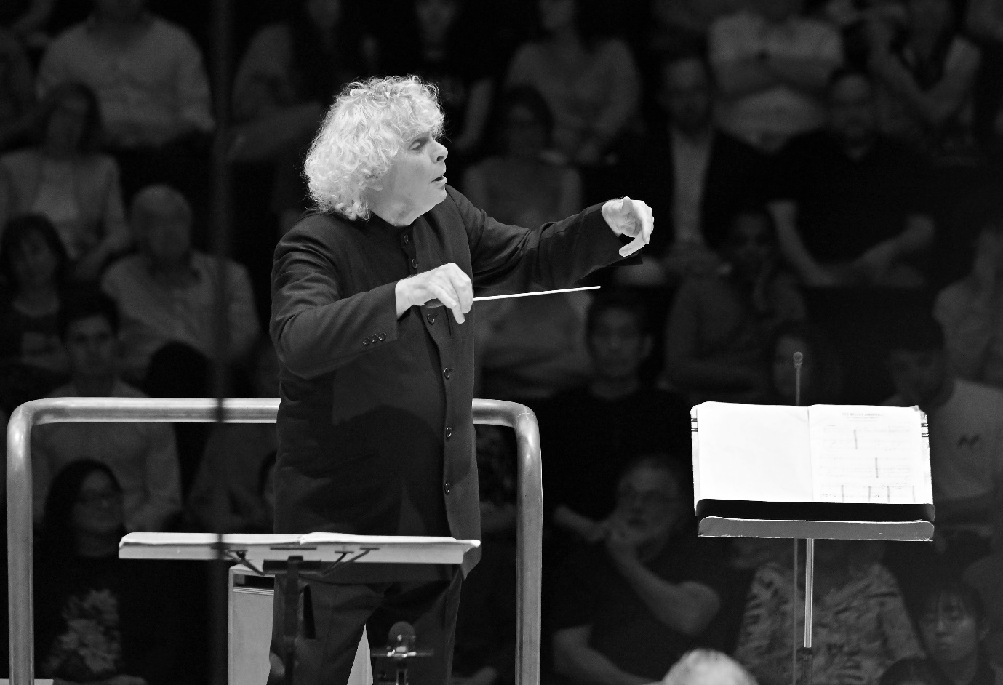

Sir Simon Rattle was born in Liverpool and studied at the Royal Academy of Music. From 1980 to 1998, he was Principal Conductor and Artistic Adviser of the City of Birmingham Symphony Orchestra and was appointed Music Director in 1990. In 2002 he took up the position of Artistic Director and Chief Conductor of the Berlin Philharmonic, where he remained until the end of the 2017/18 season. Sir Simon was appointed Music Director of the London Symphony Orchestra in September 2017, a position he remained in until the 2023/24 season, when he became Conductor Emeritus. That same season, Sir Simon took up the position of Chief Conductor with the Symphonieorchester des Bayerischen Rundfunks in Munich. He is a Principal Artist of the Orchestra of the Age of Enlightenment and Founding Patron of Birmingham Contemporary Music Group. In February Sir Simon was announced as the Principal Guest Conductor, Rafael Kubelik Chair, of the Czech Philharmonic Orchestra.

Sir Simon has made over 70 recordings for EMI record label (now Warner Classics) and has received numerous prestigious international awards for his recordings on various labels. His most recent recordings include Berlioz’s The Damnation of Faust, Helen Grime’s Woven Space, Debussy’s Pelléas et Mélisande, Turnage’s Remembering and Beethoven’s Christ on the Mount of Olives, which were all released by the LSO’s own record label, LSO Live.

Sir Simon regularly tours within Europe, the United States and Asia, and has long-standing relationships with world-leading orchestras. He regularly conducts the Staatskapelle Berlin, Berlin Philharmonic, Chamber Orchestra of Europe and the Czech Philharmonic. He has conducted opera productions at the Metropolitan Opera, Wiener Staatsoper, Deutsche Staatsoper Berlin and at the Festival d’Aix en Provence.

Music education is of supreme importance to Sir Simon. In 2019 Sir Simon announced the creation of the LSO East London Academy, developed by the LSO in partnership with ten East London boroughs. This free programme aims to identify and develop the potential of young East Londoners between the ages of 11 and 18 who show exceptional musical talent. His partnership with the Berlin Philharmonic broke new ground with the education programme Zukunft@Bphil. He and the Berlin Philharmonic were appointed International UNICEF Ambassadors in 2004, the first time this honour has been conferred on an artistic ensemble.

Sir Simon was awarded a knighthood by Her Late Majesty Queen Elizabeth II in 1994 and received the Order of Merit in 2014. He received the Order of Merit in Berlin in 2018. In 2019 he was given the Freedom of the City of London.

# Kirill Gerstein

## Piano

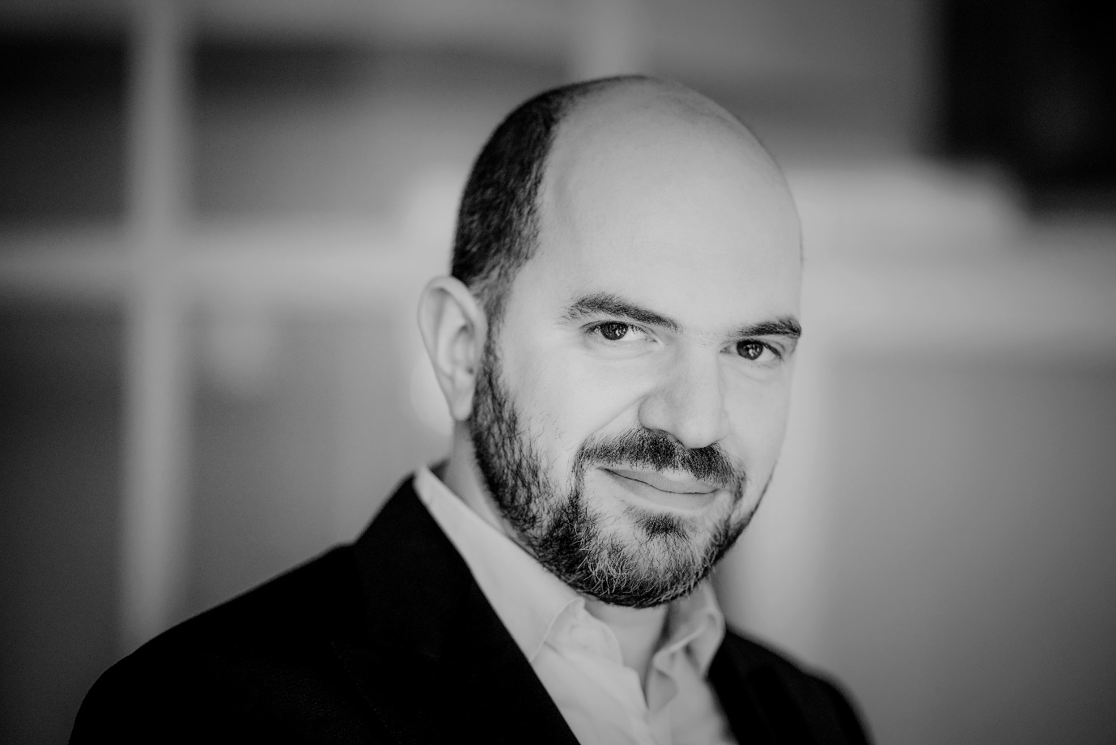

Pianist Kirill Gerstein’s repertoire ranges from Johann Sebastian Bach to Thomas Adès. His playing is distinguished by a ferocious technique and discerning intelligence, matched with an energetic, imaginative musical presence that places him at the top of his profession.

Born in the former Soviet Union, Gerstein is an American citizen based in Berlin. His career is similarly international, with worldwide performances ranging from concerts with the Chicago and Boston Orchestras, the Leipzig Gewandhaus, Royal Concertgebouw, Vienna and Berlin Philharmonics, London Symphony Orchestra and the Bavarian Radio Symphony Orchestra (BRSO) to recitals in London, Berlin, Vienna, Paris and New York. Gerstein is also in demand for the breadth of his musical influences which, in recent seasons, has led to residencies with the Bavarian Radio Symphony Orchestra (BRSO), London’s Wigmore Hall, the Festival d’Aix-en-Provence and the London Symphony Orchestra.

Gerstein’s forthcoming release on myrios classics will be a double album of music by Claude Debussy and Komitas. He first collaborated with the label in 2010 and through the partnership has been able to realise many projects. Deutsche Grammophon’s 2020 release of the world premiere performance of Adès’ Concerto for Piano and Orchestra, written for Gerstein, with the Boston Symphony Orchestra, won a 2020 Gramophone Award and was nominated for three Grammy Awards. He released his Rachmaninoff 150 recording in 2023 as a tribute to the mark the composer’s 150th year, featuring his performance of the Second Piano Concerto with the Berlin Philharmonic and Kirill Petrenko, recorded live on Berlin’s Waldbühne stage.

Gerstein is Professor of Piano at Berlin’s Hanns Eisler Hochschule and is on the faculty of the Kronberg Academy. Under the auspices of the Kronberg Academy, his series of free and open online seminars entitled Kirill Gerstein invites is now into its fifth season, featuring conversations with musicians, artists and thinkers who have included Ai Weiwei, Iván Fischer, Deborah Borda, Sir Antonio Pappano, Kaija Saariaho and Joshua Redman.

Gerstein was born in Voronezh in Russia in 1979. He studied jazz and classical piano at the Berklee College of Music in Boston (their youngest student), completed his undergraduate and graduate degrees in classical piano with Solomon Mikowsky at New York’s Manhattan School of Music and went on to further studies with Dmitri Bashkirov in Madrid and Ferenc Rados in Budapest. Gerstein is the sixth recipient of the prestigious Gilmore Artist Award, First Prize winner at the tenth Arthur Rubinstein Competition and an Avery Fisher Career Grant holder. In May 2021, he was awarded an Honorary Doctor of Musical Arts degree from the Manhattan School of Music.

# London Symphony Orchestra

## On Stage

**Leader**Benjamin Gilmore

**First Violins**Andrej Power

Clare Duckworth

Ginette Decuyper

Maxine Kwok

William Melvin

Stefano Mengoli

Claire Parfitt

Laurent Quénelle

Harriet Rayfield

Caroline Frenkel

Polina Makhina

Hilary Jane Parker

Shoshanah Sievers

Second Violins

Thomas Norris

Miya Väisänen

David Ballesteros

Matthew Gardner

Naoko Keatley

Alix Lagasse

Belinda McFarlane

Iwona Muszynska

Csilla Pogány

Andrew Pollock

Paul Robson

Doretta Balkizas

Ricky Gore

Violas

Eivind Ringstad

Gillianne Haddow

Anna Bastow

Germán Clavijo

Thomas Beer

Steve Doman

Robert Turner

Mizuho Ueyama

Matan Gilitchensky

Elisabeth Varlow

Cellos

David Cohen

Laure Le Dantec

Alastair Blayden

Ève-Marie Caravassilis

Daniel Gardner

Amanda Truelove

Salvador Bolón

Silvestrs Kalnins

Ghislaine McMullin

Joanna Twaddle

Double Basses

Rodrigo Moro Martín

Patrick Laurence

Thomas Goodman

Joe Melvin

Jani Pensola

Ruohua Li

Hugh Sparrow

Adam Wynter

Flutes

Gareth Davies

Imogen Royce

Piccolo

Sharon Williams

Oboes

Olivier Stankiewicz

Rosie Jenkins

Cor Anglais

Drake Gritton

Clarinets

Sérgio Pires

Chi-Yu Mo

Andrew Harper

## Bass Clarinet

Ferran Garcerà Perelló

Bassoons

Daniel Jemison

Joost Bosdijk

## Contra Bassoon

Martin Field

Horns

Timothy Jones

Diego Incertis Sánchez

Angela Barnes

Olivia Gandee

Jonathan Maloney

Trumpets

James Fountain

Jon Holland

Adam Wright

Toby Street

## Trombones

Matthew Gee

Jonathan Hollick

Bass Trombone

Paul Milner

## Tubas

Ben Thomson

Adrian Miotti

## Timpani

Nigel Thomas

Patrick King

## Percussion

Neil Percy

David Jackson

Sam Walton

Tom Edwards

Harps

Bryn Lewis

Lucy Wakeford

Piano

Elizabeth Burley

## Celeste

Ian Tindale