# Mozart and Bruckner

## Thursday 8 February 2024 7–9.30pm Barbican

**Wolfgang Amadeus Mozart** Piano Concerto No 22 K482  
*Interval*  
**Anton Bruckner** Symphony No 7 (ed Benjamin-Gunnar Cohrs, Urtext Edition)

**Nathalie Stutzmann** conductor

**Leif Ove Andsnes** piano  
**London Symphony Orchestra**

# Welcome

A warm welcome to this LSO concert with Nathalie Stutzmann, who was last with us in November 2022. Tonight, in a concert of Anton Bruckner and Wolfgang Amadeus Mozart, we hear pillars of the repertoire that she is particularly keen to conduct with the LSO.

We are delighted to welcome pianist Leif Ove Andsnes, a long-standing friend of the Orchestra. He performed Ludwig van Beethoven’s ‘Emperor’ Concerto with us at the start of the month and tonight returns to the works of Mozart, with the much loved Piano Concerto No 22 K482.

After the interval we hear Bruckner’s visionary Symphony No 7, in this, the 200th year of his birth. Tonight’s performance is of the Urtext edition by the late Benjamin-Gunnar Cohrs, whose inspired editions of Bruckner’s symphonies we have performed multiple times in recent years, and whose passing we were saddened to hear of in November last year.

I hope you enjoy the concert and that you will be able to join us again soon. On Sunday, Nathalie Stutzmann continues her focus on Bruckner, with a performance of his Ninth Symphony, followed by his choral work *Te Deum*. For the latter, we welcome soloists Christina Nilsson, Anna Stéphany, Robin Tritschler and Alexander Tsymbalyuk, and the London Symphony Chorus.

**Dame Kathryn McDowell DBE DL  
Managing Director**

# Piano Concerto No 22 in E-flat major K482

## Wolfgang Amadeus Mozart

1 Allegro   
2 Andante  
3 Allegro

Programme note by Lucy Walker

Halfway through the 1984 film *Amadeus*, we see Wolfgang Amadeus Mozart playing and conducting one of his piano concertos at an open-air concert, with Emperor Joseph II in the audience. Meanwhile, his nemesis Antonio Salieri, having bribed Mozart’s maid to sneak him into the family apartment, is roaming the beautifully styled rooms, eaten up with envy at Mozart’s success and wondering how he managed to fund such a lavish lifestyle. The music playing throughout both sequences is the joyous finale to the Piano Concerto No 22 K482, appropriate both in its effortless invention, and to it having been written in 1785, during one of Mozart’s most successful periods. He composed three piano concertos that year (compared to the previous year’s six) and they were immensely popular with the public. The effervescently melodic No 22 is famously known as the ‘queenliest’ of them all.

The Concerto opens with a drum-roll style theme, which one might expect would dominate the whole introduction. However, after a few iterations, Mozart treats the audience to at least another three musical ideas in rapid succession. The ensemble gives way to the piano which – not to be outdone – introduces yet another melody and, after a nod to the ‘drum-roll’ theme, two more. Such abundance of material serves the entire movement, with both piano and orchestra picking and choosing from their opening melodies, and the soloist riffing further on them in the cadenza.

The beautiful Andante is, in touching contrast, sombre and muted, in a melancholy C minor. It is mostly in a theme and variation structure, with the long opening melody providing the material for decoration and interplay across the orchestra. Yet in between are two elegant interludes, showcasing the rich sonority of the woodwind section, which, for the first time in Mozart’s piano concertos, includes clarinets.

Woodwind is at the fore in the outrageously high-spirited finale, described by the musicologist and composer Arthur Hutchings as having a ‘won’t be going home until morning’ spirit. The catchy opening theme alternates with a series of tunes, all inventively deployed across the orchestra. The solo piano has as much of a workout as in the first movement, with some strong competition, in particular from the solo flute. Brief solo passages form the bridge between the bustling opening and closing material and a central, more peaceful serenade. As the music builds towards the conclusion, Mozart cannot resist playfully throwing in a few bars of yet another musical idea only seconds before the end.

# Wolfgang Amadeus Mozart

## 1756 to 1791 (Austria)

Composer profile by Jessica Duchen

Wolfgang Amadeus Mozart was one of the most extraordinary child prodigy musicians known to history. He was born in Salzburg, son of the violinist and teacher Leopold Mozart. Wolfgang’s sister Anna Maria, or ‘Nannerl’, was reputedly as talented as he was. The proud Leopold toured them both around the royal courts of Europe to display their skills, beginning what perhaps inevitably developed into a somewhat toxic father-son relationship.

Mozart’s early adulthood was further stamped by trauma when he travelled to Paris with his mother in 1778, in an attempt to establish a career there: the trip ended in tragedy when his mother died. His move to Vienna in 1781 was an act of rebellion against his father’s insistence that he should stay home and provide income for the family. Instead, Mozart married Constanze Weber and soon gained a foothold in the imperial capital, initially with some support from the Emperor. A series of subscription concerts, for which he wrote numerous symphonies and piano concertos, set him on a stellar path. The year 1786 saw the premiere of his opera *The Marriage of Figaro*, the first of three inspired collaborations with the librettist Lorenzo da Ponte.

The Austro-Turkish War, however, heralded a period of reduced prosperity in which the aristocracy was less able to support artistic work. Mozart’s debts accumulated, his health began to fail and when a mysterious visitor (now known to be Count Franz von Walsegg) commissioned a Requiem from him, Mozart, according to Constanze, became convinced he was writing his own requiem. Nevertheless, he continued to compose prolifically in his final months, writing the Clarinet Concerto and his two final operas, *La clemenza di Tito* and *The Magic Flute*. He died on 5 December 1791, aged 35.

# Symphony No 7 in E major

## Anton Bruckner

1 Allegro moderato  
2 Adagio: Sehr feierlich und sehr langsam   
3 Scherzo: Sehr schnell. Trio: Etwas langsamer  
4 Finale: Bewegt, doch nicht schnell

Programme note by Kate Hopkins

Few composers have experienced as long and arduous a journey to fame as Anton Bruckner. For years his poverty forced him to concentrate on his careers as teacher and organist. In 1868, he moved from Linz to Vienna, hoping at last to establish himself as a composer. But for more than a decade, he struggled. His earnings came almost exclusively from his demanding teaching jobs. The premiere of his Third Symphony in 1877 was a fiasco that attracted a vicious review from the prominent critic Eduard Hanslick, and while the much-revised Fourth Symphony had a positive reception in 1881, the Fifth and Sixth Symphonies were not performed in full until the 1890s.

The composer’s feelings are clear from the dedication of hischoral *Te Deum* (1881–84): ‘to God […] for having brought me through so much anguish in Vienna’. Nevertheless, on 23 September 1881, less than a month after completing his Sixth Symphony, he began the Seventh. Over the next two years, he often played extracts from this work-in-progress to friends, who were struck by its beauty. Early in 1884, his ex-pupils Joseph Schalk and Ferdinand Löwe took a piano duet version of the completed score to Arthur Nikisch, Principal Conductor of the Leipzig Opera. Nikisch was profoundly impressed, declaring that ‘since Beethoven there has been nothing that could even approach it’. He agreed to conduct the premiere with the Leipzig Gewandhaus Orchestra.

This performance, which took place in Leipzig on 30 December 1884, was a triumph: one critic asked,‘How is it possible that he [Bruckner] could remain so long unknown to us?’ The 1885 Munich premiere was equally successful; and after the Vienna one in 1886, even the snide Hanslick reported that the composer had received multiple ovations between movements. Bruckner’s Seventh Symphony remains his best-loved work. Like all his symphonies, it exists in multiple editions: tonight’s performance is of the Urtext by Benjamin-Gunnar Cohrs, which includes the percussion omitted in Robert Haas’ 1944 edition.

The Allegro moderato opens with high string tremolos and a lyrical cello melody, which Bruckner claimed he first heard in a dream played to him by his former mentor Ignaz von Dorn. Two further themes follow: a reflective one for oboe and clarinet, and a livelier one for strings, supported by woodwind and brass, that has a dance-like quality. The movement is notable for its textural variety – from chamber-like episodes to robust, full-orchestral passages – and for its gathering momentum and dramatic pauses. The movement’s radiant conclusion is an ingenious transformation of its opening.

The Adagio commemorates the composer’s friendship with Richard Wagner. Bruckner wrote how one day he ‘felt very sad … The thought had crossed my mind that before long the Master would die, and then the C-sharp minor theme of the Adagio came to me.’ This pleading melody, which also features in his contemporaneous *Te Deum*, contrasts with a consoling subsidiary theme for strings and woodwind. Towards the movement’s end, an expanded version of the principal theme builds to a majestic climax crowned with a dramatic cymbal clash; some believe this depicts Bruckner’s reaction to his friend’s death in February 1883. A quartet of Wagner tubas – an instrument specially created for Wagner’s *Der Ring des Nibelungen* – play an extensive role in the coda ending, which Bruckner termed ‘funeral music for the Master’.

The remaining movements are shorter and more light-hearted. The Scherzo is a rustic dance that pays tribute to the composer’s youthful experiences as a violinist in village dance bands. The outer sections feature a bright-toned trumpet solo with lively string accompaniment and long crescendos. The central Trio is contrastingly gentle and song-like. The Finale, like the Allegro moderato, has three main themes: a leaping violin figure, a calm violin and viola chorale accompanied by pizzicato (plucked) lower strings, and a forceful descending theme dominated by the brass. Bruckner develops all three with great ingenuity as the movement progresses. The closing bars recall both the conclusion of the Allegro moderato and the very opening of the work, and end the symphony in a mood of exaltation.

Nathalie Stutzmann: “The music of Wagner has always been essential to me, and I cannot ignore that the Seventh Symphony includes Bruckner’s own tribute to Wagner; the Adagio written when Wagner was in very poor health and entering his final months. This intense connection between Bruckner and Wagner, and my relationship with Wagner’s music, gives this Symphony a particular place within me.”

A chorale is a hymn-like melody, usually sung in four-part harmony. Chorales are especially associated with the German Lutheran church.

# Anton Bruckner

## 1824 to 1896 (Austria)

Composer profile by Kate Hopkins

The Austrian composer, organist and teacher Anton Bruckner was a late bloomer who composed all his major works after the age of 39.

Born in Ansfelden in Upper Austria, he studied violin and organ from a young age with his father, the village schoolmaster. After his father’s death in 1837, Bruckner became a chorister at the monastery-school of St Florian. His family’s poverty made a musical career impossible; instead, he trained as a school teacher. Following positions in Windhaag and Kronstorf, he returned to St Florian, where he taught from 1845 and was organist from 1848.

In 1863, Bruckner first heard the music of Richard Wagner, which had a major effect on his own work. He met the composer two years later at the premiere of the latter’s opera *Tristan and Isolde*, and they formed a friendship that endured until Wagner’s death in 1883.

In 1868 Bruckner moved to Vienna, taking up a post at the Conservatory (and, from 1875, also teaching at the University of Vienna). During the next 28 years, he composed most of his greatest works; these included Symphonies Nos 3 to 9, the String Quintet and the *Te Deum*.

For a number of years, he struggled to get his orchestral music performed, particularly after the disastrous 1877 premiere of the Third Symphony. Only after the 1884 premiere of the Seventh Symphony in Leipzig did he receive the acclaim he deserved. He continued to compose – and to revise his works numerous times – until his death from heart failure on 11 October 1896. He is buried in the crypt of St Florian.

Bruckner’s best-known works are his Symphonies Nos 3 to 9. Although each of them has a distinctive character, all have features in common. Other than the unfinished Ninth Symphony, they all comprise an extensive opening movement that explores three contrasting themes, a lyrical slow movement, an energetic folk-like Scherzo (more muted in the Sixth Symphony) and a large-scale finale that usually recalls earlier music. The symphonies’ massive structures have led them to be nicknamed ‘cathedrals of sound’.

# Nathalie Stutzmann

## Conductor

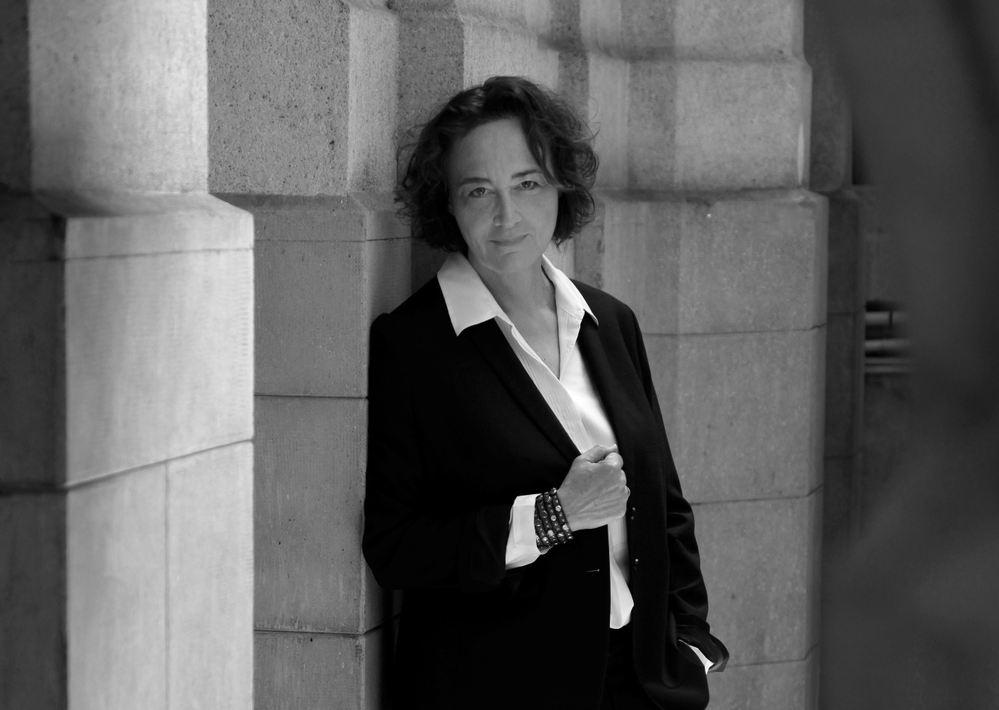

Nathalie Stutzmann is the Music Director of the Atlanta Symphony Orchestra and the second woman in history to lead a major US orchestra. She is also Principal Guest Conductor of the Philadelphia Orchestra.

Stutzmann made her spectacular debut at the 2023 Bayreuth Festival with Wagner’s *Tannhäuser*; she was awarded ‘Best Conductor’ in the 2024 Oper! Awards for this production, with *Oper Magazin* describing her as a true possessor of ‘the Bayreuth gene’. The 2022/23 season also saw her acclaimed debut at the Metropolitan Opera with productions of both Mozart’s *The Magic Flute* and *Don Giovanni*.

During the 2023/24 season, she leads the Atlanta Symphony in twelve programmes spanning some of her favourite core repertoire from Beethoven, Schumann, Brahms and Ravel through to the large symphonic forces of Mahler, Strauss and Tchaikovsky, along with a Bruckner festival marking the composer’s 200th anniversary and a West Coast tour. With the Philadelphia Orchestra she returns to New York for her much anticipated Carnegie Hall debut.

As a guest conductor, Stutzmann makes her debut with the Swedish Radio Symphony Orchestra and returns to the London Symphony Orchestra for Bruckner’s *Te Deum* and his Symphonies Nos 7 and 9. She conducts Wagner’s *The Flying Dutchman* for the Teatro Regio Torino and returns to Bayreuth in the summer of 2024. Throughout the season, Stutzmann will have a strong presence at the Philharmonie de Paris, where she will appear with the Orchestre de Paris and the Orchestre du Capitole de Toulouse, and also chair the jury for the La Maestra Conducting Competition.

She was awarded the 2023 Opus Klassik ‘Concerto Recording of the Year’ for her recording of Glière and Mosolov harp concertos with Xavier de Maistre and the WDR Sinfonieorchester. The year 2022 saw the release of the complete Beethoven Piano Concertos recorded with Haochen Zhang and the Philadelphia Orchestra. *Gramophone* praised it as ‘a brilliant collaboration that I urge you to not miss’ and *Classics Today* as a ‘modern reference version’. Stutzmann is an exclusive recording artist for Warner Classics/Erato.

She started her studies at a very young age in piano, bassoon and cello and studied conducting with the legendary Finnish teacher Jorma Panula.As one of today’s most esteemed contraltos, she has made more than 80 recordings and received the most prestigious awards. Recognised for her significant contribution to the arts, Stutzmann was named ‘Chevalier de la Légion d’Honneur’ – France’s highest honour – and ‘Commandeur dans l’Ordre des Arts et des Lettres’ by the French government.

# Leif Ove Andsnes

## Piano

Leif Ove Andsnes sitting at a piano with his hand resting on his forehead. In grayscale.

With his commanding technique and searching interpretations, the celebrated Norwegian pianist Leif Ove Andsnes has won acclaim worldwide, playing concertos and recitals in the world’s leading concert halls and orchestras. An avid chamber musician, he is the founding director of the Rosendal Chamber Music Festival, co-artistic director of the Risør Festival of Chamber Music for nearly two decades and served as music director of California’s Ojai Music Festival in 2012. He was inducted into the Gramophone Hall of Fame in July 2013, and has received honorary doctorates from New York’s Juilliard School and the universities of Bergen and Oslo.

In 2023/24, Andsnes performs Beethoven’s ‘Emperor’ Concerto with orchestras including the London Symphony Orchestra, New York Philharmonic and New World Symphony, as well as on a Japanese tour with the NHK Symphony. Other upcoming highlights include Rachmaninoff’s Third Piano Concerto with the Philadelphia Orchestra, Pittsburgh Symphony, Danish National Symphony and Orchestre de Paris. He also embarks on high-profile solo recital tours of Japan and Europe, before joining the Dover Quartet for Brahms and Dohnányi piano quintets on a five-city North American tour, bookended by dates at the Kennedy Center and Carnegie’s Zankel Hall. *Leif Ove Andsnes: The Complete Warner Classics Edition 1990–2010*, a 36-CD retrospective, was released in October 2023.

Andsnes’ discography comprises more than 50 titles, spanning repertoire from the Baroque to the present day, and has been recognised with eleven Grammy nominations, seven *Gramophone* Awards and many other international prizes. His recordings of Grieg’s Piano Concerto with the Berlin Philharmonic and of Mozart’s Piano Concertos Nos 9 and 18 were both named ‘Best CD of the Year’ by *The* *New York Times*. His Sony Classical series *A Beethoven Journey* and *Mozart Momentum 1785/86* were honoured with multiple *Gramophone* Awards, Belgium’s Prix Caecilia and *BBC Music Magazine*’s ‘Recording of the Year’. Andsnes’ other accolades include the Royal Philharmonic Society’s Instrumentalist Award, the Gilmore Artist Award, and Norway’s Peer Gynt Prize and Commander of the Royal Norwegian Order of St Olav. He was the first Scandinavian to curate Carnegie Hall’s ‘Perspectives’ series and has been Pianist-in-Residence of the Berlin Philharmonic, Artist-in-Residence of the New York Philharmonic and the subject of a previous LSO Artist Portrait series.

Andsnes was born in Karmøy, Norway, in 1970, and studied at the Bergen Music Conservatory. He is currently an Artistic Adviser for the Prof Jirí Hlinka Piano Academy in Bergen, where he lives with his partner and their three children.

# London Symphony Orchestra

## On Stage

**Leader**  
Benjamin Gilmore

**First Violins**  
Jérôme Benhaim   
Clare Duckworth   
Ginette Decuyper   
Maxine Kwok   
William Melvin  
Stefano Mengoli   
Claire Parfitt   
Elizabeth Pigram  
Laurent Quénelle   
Harriet Rayfield  
Sylvain Vasseur   
Julian Azkoul   
Dániel Mészöly   
Olwen Miles *  
Bridget O’Donnell  
Patrick Savage

**Second Violins**  
Olatz Ruiz de Gordejuela   
Sarah Quinn  
Miya Väisänen   
Matthew Gardner   
Naoko Keatley   
Iwona Muszynska   
Csilla Pogány   
Andrew Pollock   
Paul Robson   
Eleanor Fagg   
Ricky Gore   
Aleem Kandour  
Polina Makhina *  
Jan Regulski

**Violas**  
Eivind Ringstad   
Gillianne Haddow  
Malcolm Johnston  
Matan Gilitchensky   
Anna Bastow   
Thomas Beer  
Germán Clavijo   
Julia O’Riordan   
Sofia Silva Sousa   
Mizuho Ueyama   
Stephanie Edmundson  
Vanessa Hristova   
Matthias Wiesner

**Cellos**Rebecca Gilliver  
Laure Le Dantec   
Alastair Blayden  
Ève-Marie Caravassilis   
Daniel Gardner   
Amanda Truelove   
Anna Garde   
Henry Hargreaves  
Ken Ichinose  
Joanna Twaddle

**Double Basses**  
Burak Marlali   
Patrick Laurence   
Thomas Goodman   
Joe Melvin   
Josie Ellis   
Chaemun Im  
Ruohua Li   
Simon Oliver   
Adam Wynter

**Flutes**   
Gareth Davies  
Liselotte Schricke

**Oboes**   
Olivier Stankiewicz  
Rosie Jenkins

**Clarinets**   
Oliver Janes  
Chi-Yu Mo

**Bassoons**   
Rachel Gough  
Joost Bosdijk

**Horns**  
Timothy Jones  
Angela Barnes   
Norberto López García   
Kathryn Saunders   
Duncan Fuller

**Wagner Tubas**  
Diego Incertis Sánchez   
Olivia Gandee   
Richard Bissill  
Jonathan Maloney

**Trumpets**   
James Fountain  
Robin Totterdell   
Katie Smith   
Kaitlin Wild

**Trombones**   
Peter Moore  
Jonathan Hollick   
Gemma Riley

**Bass Trombone**   
Paul Milner

**Tuba**   
Ben Thomson

**Timpani**   
Nigel Thomas

**Percussion**   
Neil Percy  
David Jackson