# Spanish Connections: Nash Ensemble

## Thursday 8 February 1–2.05pm Jerwood Hall, LSO St Luke’s

**Joaquín Turina** Scène andalouse

**Maurice Ravel** Violin Sonata No 1, ‘Posthume’

**Enrique Granados** The Maiden and the Nightingale

**Joaquín Turina** Piano Trio No 1 Nash Ensemble

Recorded for future broadcast on BBC Radio 3

# Scène andalouse

## Joaquín Turina

1. Crépuscule du soir (Twilight)
2. À la fenêtre (At the Window)

1912

12 minutes

Joaquín Turina grew up in Seville, Spain. In 1905 he moved to Paris to study at the Schola Cantorum with Vincent d’Indy. His early compositions were in the French Romantic tradition, but a meeting with his compatriots and fellow-composers Manuel de Falla and Isaac Albéniz encouraged him to turn for inspiration to the music of his homeland. He wrote Scène andalouse in 1912, the year before his return to Spain.

It is a homage to his native Andalusia, scored for the unusual combination of piano, solo viola and string quartet. In ‘Crépuscule du soir’, the viola player imitates the serenade of a street musician, with guitar-like pizzicato (plucked) accompaniment from the quartet’s lower strings. ‘À la fenêtre’ depicts a conversation between two lovers. It is notable for its textural variety and is alternately tender and passionate.

## Violin Sonata No 1 in A minor, ‘Posthume’

## Maurice Ravel

1897

11 minutes

# The Maiden and the Nightingale

## Enrique Granados

1911

7 minutes

‘The Maiden and the Nightingale’ is the fourth piece in Enrique Granados’s 1911 piano suite Goyescas. This work was inspired by Francisco Goya’s paintings, acquatints and etchings of majos and majas: 19th-century lower-class Spanish men and women known for their flamboyant dress and behaviour.

Granados intended Goyescas to show ‘rhythm, colour and life distinctly Spanish: the note of sentiment as suddenly amorous and passionate as it is dramatic and tragic’. ‘The Maiden and the Nightingale’ is a set of pensive variations on a Valencian folk melody that Granados had heard a young girl sing. The piece ends in a superb pianistic evocation of the nightingale’s song.

# Piano Trio No 1

## Joaquín Turina

1. Lento – Fugue (à l’inverse) – Allegro moderato
2. Thème et Variations
3. Sonate: Allegro

1926

21 minutes

Turina wrote his first piano trio in 1926, dedicating it to Her Royal Highness L’Infante Doña Isabel de Borbón. It was first performed in London the following year. The piece combines aspects of the ‘learned style’ the composer had absorbed at Paris’ Schola Cantorum with elements of Spanish folk music.

The first movement is a homage to the Baroque form of Prelude and Fugue, immortalised by Johann Sebastian Bach in his Well-Tempered Clavier. The prelude is mournful, with sighing figures in the strings, and the fugue is notable for its elaborate piano writing. The variations in the second movement are all based on dances from different regions of Spain, including the muñeira (miller’s dance) from Galicia, and the zortziko from the Basque region, the Aragonese jota and the soleá from Turina’s native Andalusia.

The sonata-form finale has two principal themes, the first energetic and jubilant, the second expansive and lyrical. Its final section includes a reminiscence of the opening movement, and brings the work to a majestic conclusion.

# Nash Ensemble

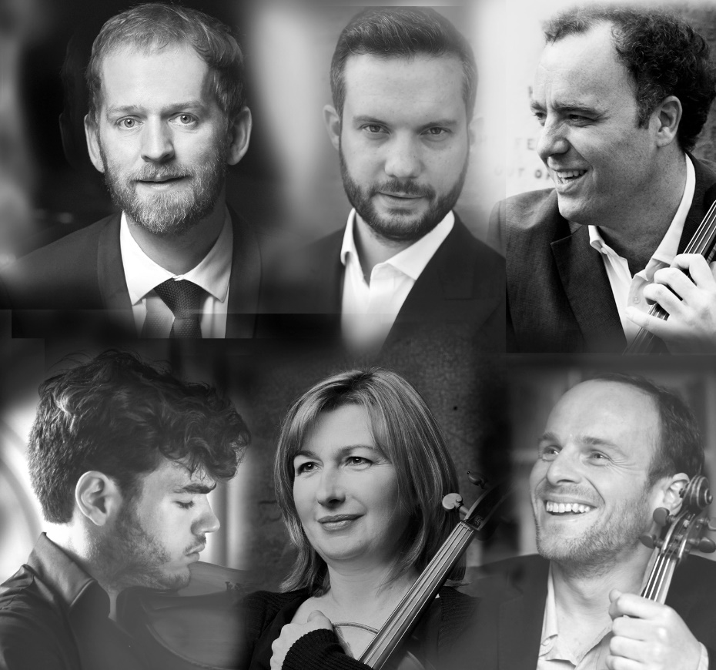

**Amelia Freedman CBE** artistic director

**Alasdair Beatson** piano

**Timothy Ridout** viola

**Benjamin Nabarro** violin

**Jonathan Stone** violin

**Rachel Roberts** viola

**Adrian Brendel** cello

The Nash Ensemble, Resident Chamber Ensemble at Wigmore Hall since 2010, is acclaimed for its adventurous programming and virtuoso performances. It presents works from Haydn to the avant-garde, and is a major contributor towards the recognition and promotion of contemporary composers. The group have premiered over 300 new works by 225 different composers of which 215 have been especially commissioned.

An impressive collection of recordings illustrates the same varied and colourful combination of classical masterpieces, little-known neglected gems and important contemporary works. Contemporary recordings receiving much acclaim include chamber works by Harrison Birtwistle and Julian Anderson. Notable recordings for Hyperion include a series of works by British composers of the first half of the 20th century, including those by Benjamin Britten, Arnold Bax, Frank Bridge and Vaughan Williams. Other recordings include Mozart and Beethoven string quintets; chamber works by Schumann and Saint-Saëns; works by Czech composers incarcerated in the Theresienstadt concentration camp between 1941 and 1945; and a CD of Bruch’s string quintets and octet which was nominated for a *Gramophone* award.

Recent highlights have included concerts in Turkey, France, Belgium, Germany, Switzerland and Italy. The Ensemble broadcasts regularly for the BBC including appearances at the BBC Proms.