Jörg Widmann and Mahler’s Fifth Symphony

Sunday 24 March 2024 7–9.30pm
Barbican

Jörg Widmann Towards Paradise (Labyrinth VI) (UK premiere)
Interval
Gustav Mahler Symphony No 5

Daniel Harding conductor
Håkan Hardenberger trumpet
London Symphony Orchestra

Welcome
Tonight’s LSO concert is conducted by Daniel Harding, who was LSO Principal Guest Conductor from 2007 to 2017, and with whom we have had the pleasure of working regularly since, including most recently in October 2021.
Over the years we have enjoyed many rewarding collaborations with trumpeter Håkan Hardenberger, and we are delighted to be joined by him again for this concert. Tonight he performs the UK premiere of Jörg Widmann’s Towards Paradise (Labyrinth VI), a trumpet concerto written for and dedicated to him.
After the interval, we hear Gustav Mahler’s Symphony No 5, a profound work which continues to inspire listeners as one of the composer’s most deeply personal statements.
I hope that you enjoy this concert and that you will be able to join us again soon. At the beginning of April, François-Xavier Roth, Principal Guest Conductor, returns to conduct our annual LSO Futures concert. The concert features world premieres commissioned through the LSO Panufnik Composers Scheme, and the UK premiere of Nachtergebung, a cello concerto composed by Donghoon Shin, alumnus of the LSO Panufnik Composers Scheme, and performed by Rebecca Gilliver, LSO Principal Cello. There is more Mahler to come in May, as Michael Tilson Thomas, Conductor Laureate, conducts two performances of Mahler’s Third Symphony, for which we welcome the Sopranos and Altos of the London Symphony Chorus, the Tiffin Boys’ Choir and mezzo-soprano Alice Coote. We hope to see you there.
Dame Kathryn McDowell DBE DL
Managing Director

Towards Paradise (Labyrinth VI)

Jörg Widmann
2021
37 minutes
Programme note by Jo Kirkbride

For a composer so invested in reinvention, whose catalogue is marked by its wilful disconnection over stylistic cohesion, Jörg Widmann has a surprising interest in cycles. ‘I’ll often deliberately write something completely opposite to the previous composition,’ he has said. ‘It is important to me that I am always renewing myself.’ And yet, scattered across his diverse output are pockets of works that take a deep dive into a particular theme or style: a series of string quartets inspired by Ludwig van Beethoven, a handful of studies on the theme of ‘light’, and an open-ended Labyrinth cycle that has been evolving and accumulating since 2005.
The first Labyrinth, for 48 string instruments, began as a meditation on Widmann’s own maze-like composition process, with the myriad of ideas and possibilities that present themselves along the way: ‘A melodic thread is introduced, but soon gets lost: the labyrinth walker seeking an exit is soon completely on his own.’ However, his trumpet concerto Towards Paradise, the sixth instalment in the Labyrinth series, takes this theme in a new direction. It was conceived as a partner piece for his solo trumpet piece ad absurdum, which was composed nearly 20 years earlier. ‘After my hypertrophic virtuoso concert piece ad absurdum 20 years ago, I now felt the urge to compose a large-scale, angelic lyrical trumpet concerto,’ Widmann explains. The score of Towards Paradise is itself labyrinthine in its ‘wide spectrum of psychological and tonal zones’, but it also manifests the idea of taking a different turn in the maze, of following a different route to reach a different conclusion.
In ad absurdum, Widmann had deliberately composed a work that ‘begins at a finishing point’, a piece so fast and so virtuosic that it ‘verges on the unplayable’. Towards Paradise is its foil. It begins in darkness and reaches out into the void, the lone trumpeter positioned off-stage and calling out questioningly into the gloom, as though this were the beginning of time itself. In this barren and unfamiliar landscape, the soloist appears restless and uncertain. They strike up a dialogue with this instrument and then that, constantly repositioning themselves in search of a unity not yet found. However, as the maze builds in three-dimensional space all around us, moments of exquisite, ethereal beauty begin to emerge. The ‘wild and craggy orchestral abysses’ fall away and we are led out into the open, where the soloist finds themselves alone once more. As Widmann says: ‘Aren’t we all searching for paradise … at least in music?’

Jörg Widmann

b 1973
Composer profile by Jo Kirkbride
Jörg Widmann’s multifaceted career – as equal parts composer, clarinettist and conductor – says much about how his mind works. He is restless, inquisitive, and always in search of the novel and the new. As a result, it is almost impossible to characterise his output, which ranges from the experimental and the extreme to the tonal and the familiar. ‘When a composer or a painter does the same thing all their life, at some point it’s called their style. That has never interested me,’ he explains. ‘Surprise and freedom: these are the concepts that shape my artistic thinking.’
Widmann began writing music at a young age (‘I remember an early piano waltz in F major. The first two bars were wonderful, what came after that, not so much’) and composed his first opera at the age of eleven. Studies in composition with Hans Werner Henze and Heiner Goebbels followed, alongside postgraduate studies in clarinet at the Juilliard School – his determination to pursue both disciplines never wavering. His youthful Fantasie for solo clarinet (1993) was one of his first works to marry the two, pushing his instrument to its limits with a series of extended techniques and multiphonics.
This desire to explore the whole instrument would become a common thread across an otherwise shapeshifting output. His Second Violin Concerto (2018), composed for his sister Carolin, is an homage to a childhood spent exploring the world of music together: ‘I composed at night and left notes with questions for her at breakfast … we developed sounds together that didn’t exist before.’ And yet, his recent Kantate (2023), which was composed in honour of J S Bach’s appointment in Leipzig, and Schumannliebe (2023), a re-composition of Robert Schumann’s song cycle Dichterliebe, reveal another side to Widmann: a composer indebted to tradition, unafraid to use the past as a springboard to the future.

Symphony No 5

Gustav Mahler
1902, rev 1904–11
70 minutes
Part 1
- Trauermarsch (with measured tread. Strict. Like a procession)
- Stürmisch bewegt, mit größter Vehemenz (Stormy. With utmost vehemence)
Part 2
- Scherzo: Kräftig, nicht zu schnell (Vigorous, not too fast)
Part 3
- Adagietto: Sehr langsam (Very slow)
- Rondo-Finale: Allegro

Programme note by Stephen Johnson

When Gustav Mahler started work on his Fifth Symphony in the summer of 1901, he must have felt that he had survived an emotional assault course. In February, after a near-fatal haemorrhage and a dangerous operation, he had resigned his post as conductor of the Vienna Philharmonic Orchestra. His relationship with the musicians had been uneasy at best – not all of them appreciated his intensely demanding style of rehearsal – and some of the press (especially the city’s vocal anti-Semitic newspapers and journals) had been poisonous. Still, leaving such a prestigious and lucrative post was a wrench.
At about the same time, Gustav met his future wife, Alma Schindler, and fell passionately in love. That, at least, was a hopeful development, but it was emotionally challenging. Right from the start there were tensions in their relationship, which Mahler chose to ignore – to his cost, as he eventually found. Some composers seek escape from the trials of their personal life in their music, but Mahler was the kind of artist whose life and work are inextricably, often painfully interlinked. Unsurprisingly, the Fifth Symphony bears the imprint of Mahler’s recent experiences throughout its complex five-movement structure.
At the same time, the Fifth Symphony marked a new departure for Mahler. Up until then, all his symphonies had either contained sung texts or come with detailed explanatory programmes. The Fifth has neither. Instead, we are expected to interpret the music directly, for ourselves, without any explicit help from the composer. One of the problems with programmes, he had come to realise, was that people would take them literally, and then go on to assume that the music had been explained for them. Listening was also a creative experience: it went beyond ‘real’ events and feelings to another, more mysterious world – a world beyond simple sequence in time and space.

FIRST MOVEMENT
Mahler does, however, give us a substantial clue to the possible meaning of the first movement. Entitled ‘Funeral March’, it opens with an ominous trumpet fanfare, then the full orchestra thunders in with an unmistakable funereal tread. Shuddering string trills and deep, rasping horn notes evoke Death in full grotesque pomp.
Then comes a more intriguing pointer: the quieter march theme that follows (strings alone) is clearly related to Mahler’s song ‘Der Tamboursg’sell’ (The Drummer Lad), which tells of a young deserter facing execution. Here, perhaps, is another face of Death: not grand, but pitiful and desolate.

SECOND MOVEMENT
The much faster second movement has the character of an urgent personal struggle. The shrill three-note woodwind figure near the start comes to embody the idea of striving. Several times, aspiration falls back into sad rumination and echoes of the ‘Funeral March’. At last the striving culminates in a radiant brass hymn.
Is the answer to death to be found in religious consolation – faith? But the affirmation collapses under its own weight, and the movement quickly fades into darkness.

THIRD MOVEMENT
Now comes a surprise. The Scherzo bursts onto the scene with a wildly elated horn fanfare. The character is unmistakably Viennese – a kind of manic waltz. Perhaps some of Mahler’s feelings about his adopted Viennese home went into this movement. Certainly there are passages where the gaiety sounds forced, even downright crazy. Mahler himself wondered what people would say ‘to this primeval music, this foaming, roaring, raging sea of sound, to these dancing stars, to these breath-taking iridescent and flashing breakers?’

FOURTH MOVEMENT
Now comes the famous Adagietto, for strings and harp alone, and another profound change of mood. Mahler clearly intended this movement as a kind of love song without words to his future wife, Alma. There is another significant clue here. At the movement’s final climax, Mahler invokes one of his greatest songs, ‘Ich bin der Welt abhanden gekommen’ (I Am Lost to the World), from his Rückert Lieder. The poem ends with the words ‘I live alone in my heaven, in my love, in my song’; Mahler quotes the violin phrase that accompanies ‘in my love, in my song’ at the very end of the Adagietto.

FIFTH MOVEMENT
So human rather than divine, love provides the true turning point in the Fifth Symphony – just as Mahler believed it had done for him in 1901. The finale is a vigorous, joyous contrapuntal • display – genuine joy this time, it seems, not the Scherzo’s manic elation. Even motifs from the Adagietto are drawn into the bustling textures.
Finally, after a long and exciting build-up, the second movement’s brass chorale returns in full splendour, now firmly anchored in D major, the Symphony’s ultimate home key: the triumph of faith, hope and, above all, of love? Not everyone finds this ending convincing; significantly, Alma Mahler had her doubts from the start. But one can hear it either way – as a ringing affirmation or as forced triumphalism – and it still stirs. For all his apparent late Romanticism, Mahler was also a very modern composer: even in his most positive statements, there is room for doubt.

Gustav Mahler

1860 (Bohemia) to 1911 (Austria)
Composer profile by Stephen Johnson

Gustav Mahler’s sense of being an outsider, coupled with a penetrating, restless intelligence, made him an acutely self-conscious searcher after truth. For Mahler, the purpose of art was, in Shakespeare’s famous phrase, to ‘hold the mirror up to nature’ in all its bewildering richness. The symphony, he told Jean Sibelius, ‘must be like the world. It must embrace everything’. Mahler’s symphonies can seem almost over-full of intense emotions and ideas: love and hate, joy in life and terror of death, the beauty of nature, innocence and bitter experience. Similar themes can also be found in his marvellous songs and song cycles, though there the intensity is, if anything, even more sharply focused.
Mahler was born the second of 14 children. His parents were apparently ill-matched (Mahler remembered violent scenes), and young Gustav grew up dreamy and introspective, seeking comfort in nature rather than human company. Death was a presence from early on: six of his siblings died in infancy. This, no doubt, partly explains the obsession with mortality in Mahler’s music. Few of his major works do not feature a funeral march: in fact, his first composition (at age ten) was a Funeral March with Polka – exactly the kind of extreme juxtaposition found in his mature works. For most of his life, Mahler supported himself by conducting, but this was no mere means to an end. His evident talent and energetic, disciplined commitment led to successive appointments in Prague, Leipzig, Budapest, Hamburg and climactically, in 1897, at the Vienna Court Opera. In the midst of this hugely demanding schedule, Mahler composed whenever he could, usually during his summer holidays. The rate at which he composed during these brief periods – when most of his massive symphonies were written – is astonishing. His workload in no way decreased after his marriage to the charismatic and intelligent Alma Schindler in 1902.
Many today have good cause to be grateful to Mahler for his singleminded devotion to his art. His music can take us to the edge of the abyss, then sing us the sweetest songs of consolation. If we allow ourselves to make this journey with him, we may find that we too are the better for it.

Daniel Harding

Conductor

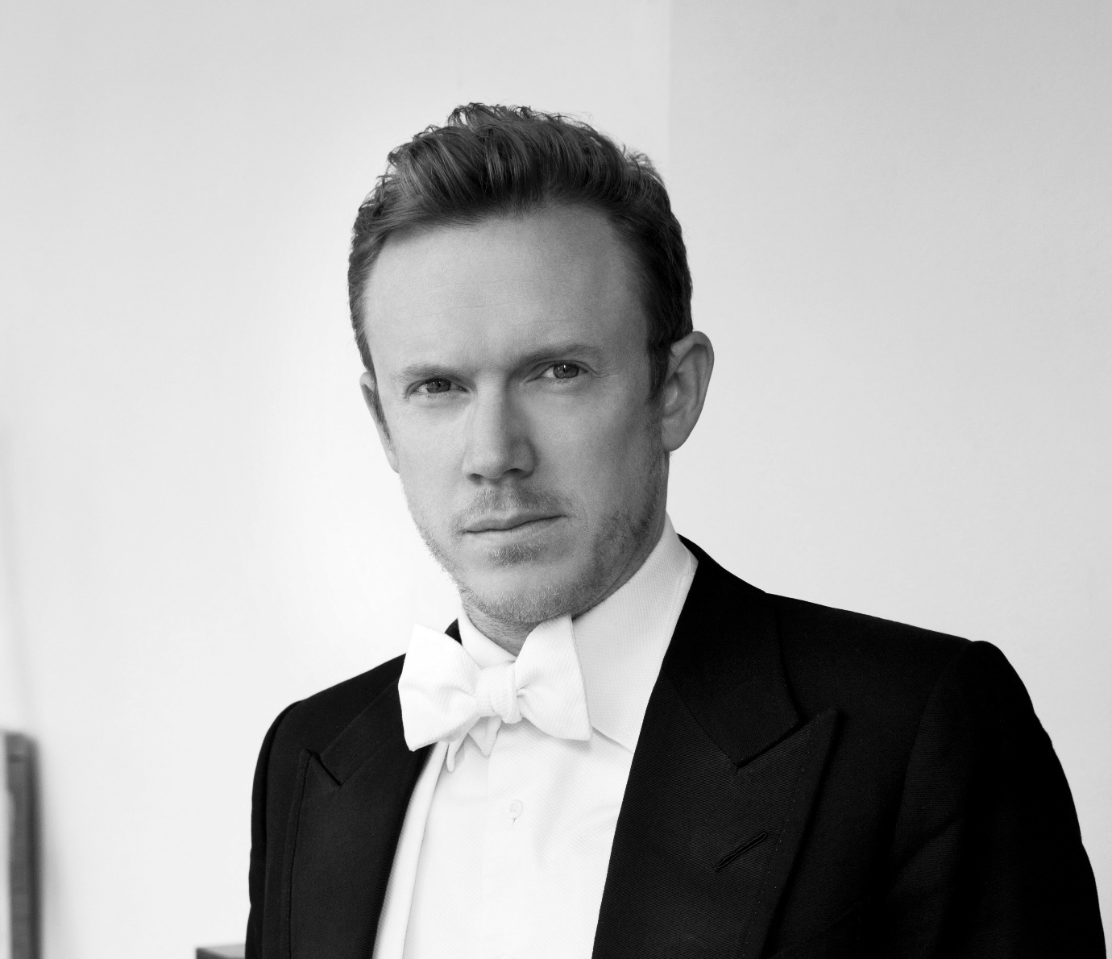
Daniel Harding is the Music and Artistic Director of the Swedish Radio Symphony Orchestra. He was Music Director of the Orchestre de Paris from 2016 to 2019 and Principal Guest Conductor of the London Symphony Orchestra from 2007 to 2017.
He holds the lifetime title of Conductor Laureate of the Mahler Chamber Orchestra, with whom he has worked for over 20 years. In 2024 he will take up the position of Music Director of the Youth Music Culture, The Greater Bay Area (YMCG) for a five-year term, and will also take up the position of Music Director of the Orchestra and Chorus of the Accademia Nazionale di Santa Cecilia.
He works regularly with the LSO, Berlin Philharmonic, Vienna Philharmonic, Royal Concertgebouw Orchestra, Symphonieorchester des Bayerischen Rundfunks, Dresden Staatskapelle and the Orchestra Filarmonica della Scala. In the US, he has appeared with the Boston Symphony Orchestra, Cleveland Orchestra, Chicago Symphony Orchestra, Los Angeles Philharmonic, New York Philharmonic and the San Francisco Symphony.
His recordings of Mahler’s Symphony No 10 with the Vienna Philharmonic and Carl Orff’s Carmina Burana with the Symphonieorchester des Bayerischen Rundfunks, both for Deutsche Grammophon, received widespread critical acclaim. For Virgin/EMI he has recorded Mahler’s Symphony No 4 with the Mahler Chamber Orchestra and Brahms’ Symphonies Nos 3 and 4 with the Deutsche Kammerphilharmonie Bremen; Billy Budd with the London Symphony Orchestra (winner of a Grammy Award for best opera recording); Don Giovanni and The Turn of the Screw (awarded the Choc de l’Année 2002, the Grand Prix de l’Académie Charles Cros and a Gramophone Award) with the Mahler Chamber Orchestra; works by Witold Lutosławski with Solveig Kringelborn and the Norwegian Chamber Orchestra; and works by Britten with Ian Bostridge and the Britten Sinfonia (awarded the Choc de l’Année in 1998). For BR Klassik he has released critically acclaimed recordings of Schumann’s Szenen aus Goethes Faust, Mahler’s Symphony No 6 and Holst’s The Planets. His performances of Mahler’s Symphony No 1 and Beethoven’s Violin Concerto with Frank Peter Zimmermann are available on the Berlin Philharmonic label. His latest recordings with the Swedish Radio Symphony Orchestra for Harmonia Mundi include The Wagner Project with Matthias Goerne, Mahler’s Symphonies Nos 5 and 9, Brahms’ German Requiem and a Britten disc.
In 2002 Harding was awarded the title Chevalier de l’Ordre des Arts et des Lettres by the French Government, and in 2017 he was nominated to the position Officier des Arts et des Lettres. In 2012, he was elected a member of The Royal Swedish Academy of Music. In 2021, he was awarded a CBE in the New Year Honours. He is a qualified airline pilot.

Håkan Hardenberger

Trumpet
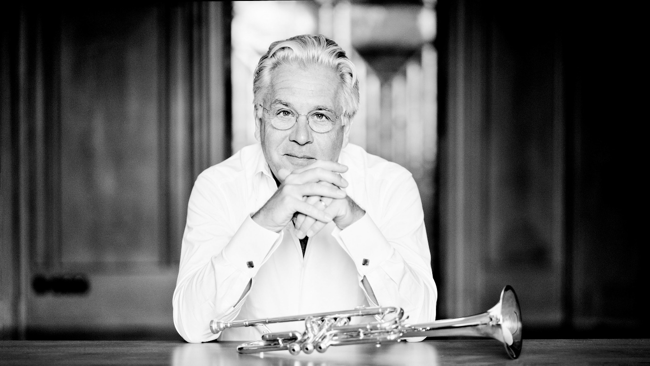
During his 40-year career as one of the world’s most prominent trumpet soloists, Håkan Hardenberger has not only pushed the boundaries of what can be achieved with the instrument, but also inspired countless composers and fellow musicians to explore unknown musical territories with him.
Hardenberger performs regularly with orchestras including the LSO, Berlin Philharmonic, Vienna Philharmonic, Leipzig Gewandhaus Orchestra, Symphonieorchester des Bayerischen Rundfunks, Royal Concertgebouw Orchestra, Boston Symphony Orchestra and NHK Symphony Orchestra. He works with conductors including Marin Alsop, Alan Gilbert, Daniel Harding, Susanna Mälkki, Ingo Metzmacher, Andris Nelsons, Sakari Oramo, Sir Simon Rattle, François-Xavier Roth, Jukka-Pekka Saraste and John Storgårds. Composers such as Sir Harrison Birtwistle, Brett Dean, Helen Grime, H K Gruber, Hans Werner Henze, Betsy Jolas, György Ligeti, Olga Neuwirth, Tōru Takemitsu, Mark-Anthony Turnage, Rolf Wallin and Jörg Widmann have written new works for him.
As well as performing Jörg Widmann’s Towards Paradise with the LSO and Daniel Harding, notable engagements in the 2023/24 season include the Swedish and Finnish premieres of the same work with the Royal Stockholm Philharmonic Orchestra and Andris Nelsons, and the Helsinki Philharmonic Orchestra and Dima Slobodeniouk. He will also perform Towards Paradise with the Mozarteumorchester Salzburg, NDR Radiophilharmonie and Symphonieorchester des Bayerischen Rundfunks, under Widmann. In addition, he continues his collaborations with the Royal College of Music and Grafenegg Festival Academy.
Hardenberger’s recent 60th birthday season featured the world premieres of Widmann’s Towards Paradise, co-commissioned by the Leipzig Gewandhaus Orchestra and the Boston Symphony Orchestra, and Helen Grime’s night-sky-blue, cocommissioned by the Koussevitzky Foundation, Library of Congress, London Symphony Orchestra and Boston Symphony Orchestra. In 2023 he performed Betsy Jolas’ Histoires vraies with Sir Simon Rattle and the LSO in London and Paris.
Hardenberger performs with pianist Roland Pöntinen and percussionist Colin Currie. With the latter, he released a recording of duo works by composers including Brett Dean and André Jolivet. His recent discography includes French trumpet concertos by Jolivet, Schmitt and Tomasi, as well as Jolas’ Onze Lieder (BIS). He has also recorded for Philips, Deutsche Grammophon, Decca and EMI.
Born in Malmö, Sweden, Hardenberger began studying the trumpet at the age of eight with Bo Nilsson in Malmö, and continued his studies at the Paris Conservatoire with Pierre Thibaud and in Los Angeles with Thomas Stevens. He is a professor at the Malmö Conservatoire. From 2016 to 2018 he was the Artistic Director of the Malmö Chamber Music Festival.

London Symphony Orchestra

On Stage
Leader
Benjamin Gilmore
First Violins
Ying Xue
Clare Duckworth
Ginette Decuyper
Maxine Kwok
William Melvin
Stefano Mengoli
Claire Parfitt
Laurent Quénelle
Caroline Frenkel
Mitzi Gardner
Sofia Gomez Alberto
Grace Lee
Alexandra Lomeiko
Dániel Mészöly
Magdalena Riedl
Kate Suthers

Second Violins
Phoebe Gardner
Sarah Quinn
Miya Väisänen
Naoko Keatley
Alix Lagasse
Belinda McFarlane
Iwona Muszynska
Csilla Pogány
Andrew Pollock
Helena Buckie
Eleanor Fagg
Juan Gonzalez Hernandez
Aleem Kandour
Erzsebet Racz

Violas
Jano Lisboa
Malcolm Johnston
Anna Bastow
Mizuho Ueyama
Steve Doman
Julia O’Riordan
Sofia Silva Sousa
Errika Collins
Stephanie Edmundson
Nathalie Green-Buckley
Philip Hall
Hattie Quick
Elisabeth Varlow

Cellos
David Cohen
Laure Le Dantec
Alastair Blayden
Anna Garde
Ève-Marie Caravassilis
Judith Fleet
Silvestrs Kalnins
Ghislaine McMullin
Miwa Rosso
Joanna Twaddle

Double Basses
Enno Senft
Thomas Goodman
Patrick Laurence
Joe Melvin
Chaemun Im
Jani Pensola
Hugh Sparrow
Adam Wynter

Flutes
Gareth Davies
Liselotte Schricke

Piccolos
Sharon Williams
Patricia Moynihan

Oboes
Juliana Koch
Rosie Jenkins

Cor Anglais
Thomas Davey

Clarinets
Sérgio Pires
Chi-Yu Mo

Bass Clarinet
Martino Moruzzi

Contrabass Clarinet
Sarah Watts

Bassoons
Daniel Jemison
Joost Bosdijk

Contra Bassoon
Martin Field

Horns
Timothy Jones
Diego Incertis Sánchez
Jonathan Maloney
Benjamin Jacks
Max Garrard
Mark Alder Bennett
Amadea Dazeley-Gaist

Trumpets
James Fountain
Thomas Nielsen
Adam Wright
Katie Smith
Toby Street

Trombones
Helen Vollam
Jonathan Hollick

Bass Trombone
Paul Milner

Tuba
Adrian Miotti

Timpani
Patrick King

Percussion
Neil Percy
David Jackson
Sam Walton
Matthew Farthing
Jacob Brown

Harps
Bryn Lewis
Anneke Hodnett

Celeste
Elizabeth Burley

Accordion
Ian Watson

