LSO St Luke’s


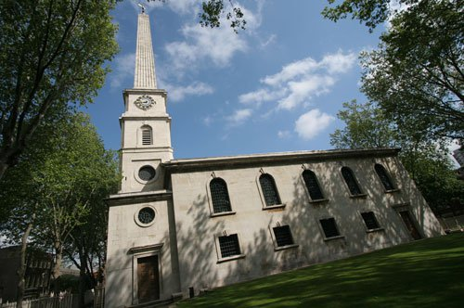
Access Guide

LSO St Luke's
161 Old Street
London EC1V 9NG

For further information, please visit
lso.co.uk/your-visit/accessibility/accessibility-lso-st-lukes/
Call us on +44 (0)20 7490 3939 or email lso.stlukes@lso.co.uk

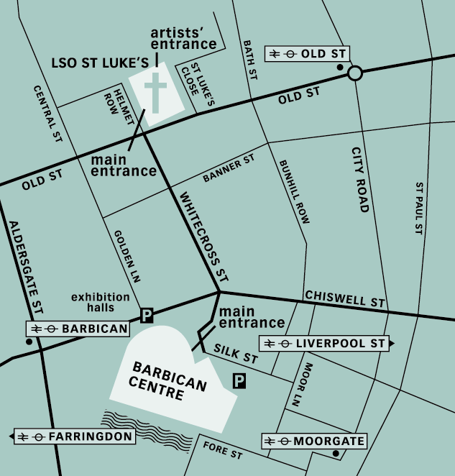
Accessibility at LSO St Luke’s

LSO St Luke’s is committed to being as accessible as possible while hosting a diverse range of music events for all ages. We welcome everyone to our building and events, working as hard as we can to remove any barriers to having a venue accessible to all.

Located in the heart of London on Old Street, EC1V, LSO St Luke's is a beautiful venue available to hire for rehearsals, recordings and chamber music performances, as well as a wide variety of corporate and private events.

At Our Events

If you would like more advice about visiting LSO St Luke’s with a disability or concern that is not covered in this guide, please get in touch with a member of staff via phone or email. We endeavour to make the building and our events accessible to everyone.

Building Layout

LSO St Luke's is built on three levels:

Balcony Level:
Balcony audience seating

Ground Floor:
Main Entrance
Jerwood Hall (Stage & Stalls)

Lower Ground:
Hawksmoor Space (Bar)
Front of house toilets






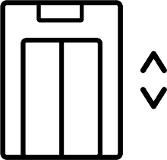

Lifts
Lifts give access to all levels and ramps give access to all external and internal doors.

From the Main Entrance, automatic doors provide a route to the lift, which goes up to Balcony level or down to Lower Ground level. Automatic doors give full access to the public areas of both levels.

Audience Seating

The auditorium has two levels, stalls (Ground) and balcony.

In the stalls, concert seating comprises of both flat-level seating and a tiered seating bank.

The balcony has a single row of seats that wrap around the auditorium. Some of the fixed seating can be removed to make three wheelchair positions available.




Toilets

All toilets can be found on the Lower Ground level. LSO St Luke's has two accessible Front of House toilets, one of which also has an adult hoist and changing table. We also have gender neutral and baby changing facilities on site.

LSO St Luke’s recognises that not all disabilities are visible, and anyone is entitled to use these facilities if they feel they require them.



In The Event of a Fire

Fire escapes can be found on the ground level at the top of each staircase.

Please note that in the event of a fire, all staircases within LSO St Luke’s are spiral.

Our Fire Evacuation procedure for those on the Ground Floor level involves guiding patrons out of the building in the order of wheelchair users, non-disabled personnel, and then those who identify as ambulant disabled.
For those on the Balcony or Lower Ground level, our Fire Evacuation procedure involves firstly guiding non-disabled personnel followed by those who identify as ambulant disabled towards the ground floor to evacuate and then guiding those in a wheelchair to the evacuation point.


Vision

If you would like a copy or a programme with larger print, then please contact us beforehand. LSO St Luke’s provide larger print copies of programmes for our free Lunchtime Concerts with Discovery. Stewards are on hand to assist any visitor with programme reading before and during concerts.

Some performances may contain strobe or strobe-like lighting effects, which will be made clear on the day of the event via signage.



Hearing

LSO St Luke's has a hearing loop and sound enhancement devices available on site.

Our Hearing Loop points can be found at the box office desk at our main entrance, and at the bar, located in the Hawksmoor Space.

Our personal sound-enhancement receivers are used with our infra-red systems in the Jerwood Hall. They can be used with or without a hearing aid, by connecting to a microphone in the Jerwood Hall, and amplifying the sound. These can be collected from the main entrance for concerts, or on request from a member of LSO St Luke's staff for other events.

Please note that these do not assist with 1:1 conversations.

We have two types, in ears, which are all disinfected before and after use, and stand-alone units, which patrons can plug their own headphones into.

Please telephone in advance to if you have any questions or concerns.



Assistance Dogs & Service Animals

If you would like your dog/service animal to remain with you in the auditorium, please mention this when booking a ticket to ensure you are provided with a seat with enough space.

In the unlikely event of an evacuation, your service animal should guide you to the nearest exit and assembly point at the corner of Mitchell Street and St Luke’s Close.

Doors usually open 1 hour prior to the start of a concert. If you or another visitor has access requirements that mean you need extra time to get to your seat, please ask one of our stewards for assistance.

For dog refuse areas, there is a park or green space on either the north or south of the building. The South Churchyard is open to the public 24/7 and is often used for walking dogs.

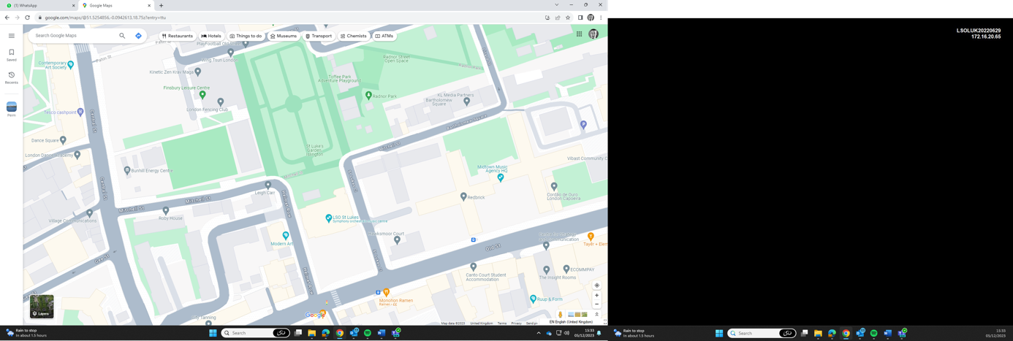
Highlighted areas are public parks which can be used as dog walking.

Both churchyard and park are open to the public 24/7



The Bar
Our bar is located within the Hawksmoor Space on the Lower Ground floor, and is open for concerts, most public events, and on request for private events. We serve hot and cold drinks, and a selection of snacks and alcoholic beverages.

The bar is closed outside of event hours, and visitors must be in possession of a ticket or event invitation to access the café.


Cloakroom
LSO St Luke’s advises that all visitors always keep their belongings with them, as we do not have a cloakroom for most events. If you need information about where to store bags while you’re at an event, please visit our website.

If you require further information, please email lso.stlukes@lso.co.uk in advance.



Re-admittance
During concerts at LSO St Luke’s latecomers or guests needing re-admittance can often be let into the hall during pauses. Certain events or performances may prohibit re-admittance or latecomers, so please ask one of our stewards for assistance.



Families & Babies

Whilst most of our events are suitable for families, if you are unsure of whether an event is suitable, please contact us at lso.stlukes@lso.co.uk or call us on 0207 490 3939.

Please note: Our changing facilities are at standing height, and therefore not accessible for those in a wheelchair.

Travelling to LSO St Luke's
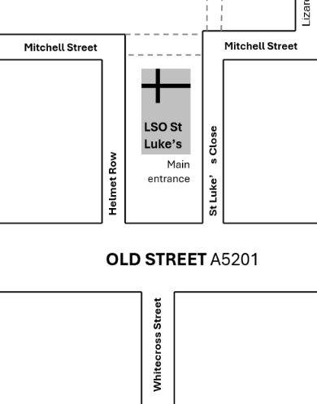
Arriving at LSO St Luke’s from Old Street

Enter the LSO St Luke’s churchyard near the crossing opposite the end of Whitecross Street and follow the step-free path towards the Main Entrance.

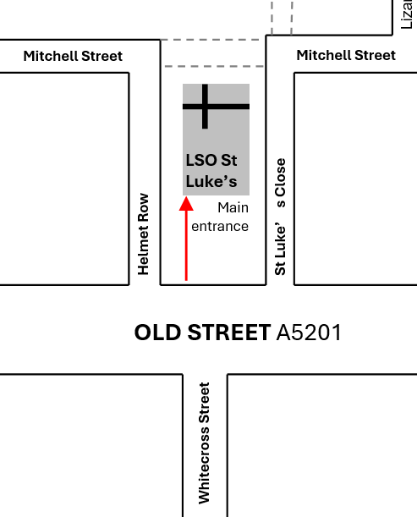
Arriving at LSO St Luke's from Mitchell Street

Enter the LSO St Luke's churchyard from Mitchell Street directly behind the Centre. There are convenient setting-down points at the top of either Helmet Row or St Luke's Close.

Our Southwest Entrance is fully ramped. Doors usually open 1 hour before the start of a concert (it advisable to check in advance.)


Cars and Parking

Drivers should be aware that LSO St Luke’s and the surrounding area is within the Congestion Charge zone and ULEZ, meaning most vehicles are subject to a daily charge. Blue Badge holders are eligible for a full exemption from the Congestion Zone, but not necessarily from the ULEZ. LSO St Luke’s encourages visitors to use public transport wherever possible.

More information regarding the ULEZ can be found below, and if you are reading this digitally, the below URL will also link to the website tfl.gov.uk/modes/driving/ultra-low-emission-zone/ulez-expansion-support-for-disabled-people.

LSO St Luke’s has private parking on Mitchell Street at the rear of the building. Spaces are accessible via bollards on either end of the street, which are controlled by LSO St Luke’s staff. Please note that access to this parking is very limited. If a patron would like to park, they must call to arrange this prior to the event. Vehicles are left at the owners’ risk and must leave by 11 pm.

The red arrows on the map indicate a one-way system. If the driver would like to park on Mitchell Street private parking, they must either arrive via Central Street or follow the route along Bath Street, onto Radnor Street, down Lizard Street and right onto Mitchell Street. Larger vans are encouraged to arrive through the Central Street route.

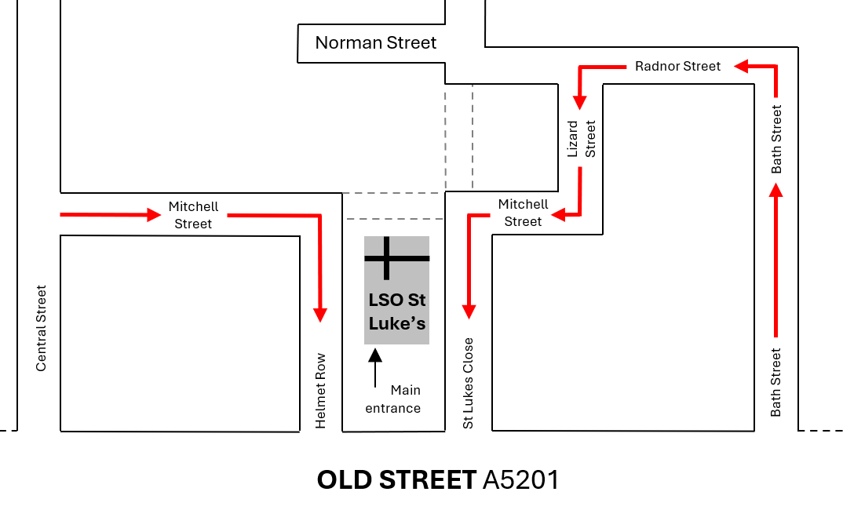
There are also Pay & Display parking spaces available on Helmet Row, opposite the side gate of LSO St Luke’s.

Parking hours:
Monday to Friday 8.30 am – 6.30 pm
Saturday 8.30 am – 1.30 pm

Short stay tariff is between £7.05 and £7.55 / hour and the maximum stay is for 2 hours.

Alternatively, cars parked on Helmet Row must possess a Resident permit or Business permit.
St Luke’s Close and Mitchell Street (on either side of the LSO St Luke’s bollards) is Residential Parking only.

Other nearby Pay & Display spaces are located on Central Street, Norman Street and Ironmonger Row, Gee Street and Bastwick Street.



Blue Badge and Dedicated Disabled Permit Parking Places

The Blue Badge Disabled parking scheme is fully recognised in Islington. Blue badge holders may park in the following places:

- On yellow lines (without loading restrictions) for up to three hours, providing the clock card is displayed and set to your time of arrival.
- In resident and Pay & Display bays for an unlimited time.
- In designated Disabled bays for an unlimited time
(please note: there are a few Disabled bays with time restrictions, please check parking signs).

The nearest Blue Badge parking bays are located on Seward Street, Gee Street, Wyclif Street, St John’s Lane, Moreland Street, Tabernacle Street and Bonhill Street.

More information on Disabled parking in the Islington area, and if you are reading this digitally, the below URL will also link to the website: www.islington.gov.uk/parking/where-to-park/parking-for-disabled-people.


Motorbikes and bicycles

Motorbikes can be left on Mitchell Street, but not within the church yard. Cyclists are encouraged to use cycle hoops on the corner of Mitchell Street and Helmet Row. Cyclists are asked to not chain bikes to the railings.



Taxis

Setting-down points for taxis are on Helmet Row, St Luke’s Close or Mitchell Street (via bollards). The postcode for all three locations is EC1V 9NG. If you are reading this digitally, the company name will also link to their website:

0343 222 7777 – Dial-a-Ride (TFL)
020 3051 7480 – Radio Taxis
020 8204 4444– London Radio Cars
020 7387 8888 – Addison Lee

It is also possible to hail Black Cabs along Old Street. Ask a member of staff if you need taxi information on the day of an event.

Travelling via Public Transport

Transport for London (including accessibility):
0343 222 1234

Transport for London – Booking for Assisted Travel:
0343 222 2000

The below map indicates the nearest stations. The red arrows denote the National Rail, with the yellow arrows showing the TFL Underground stations.
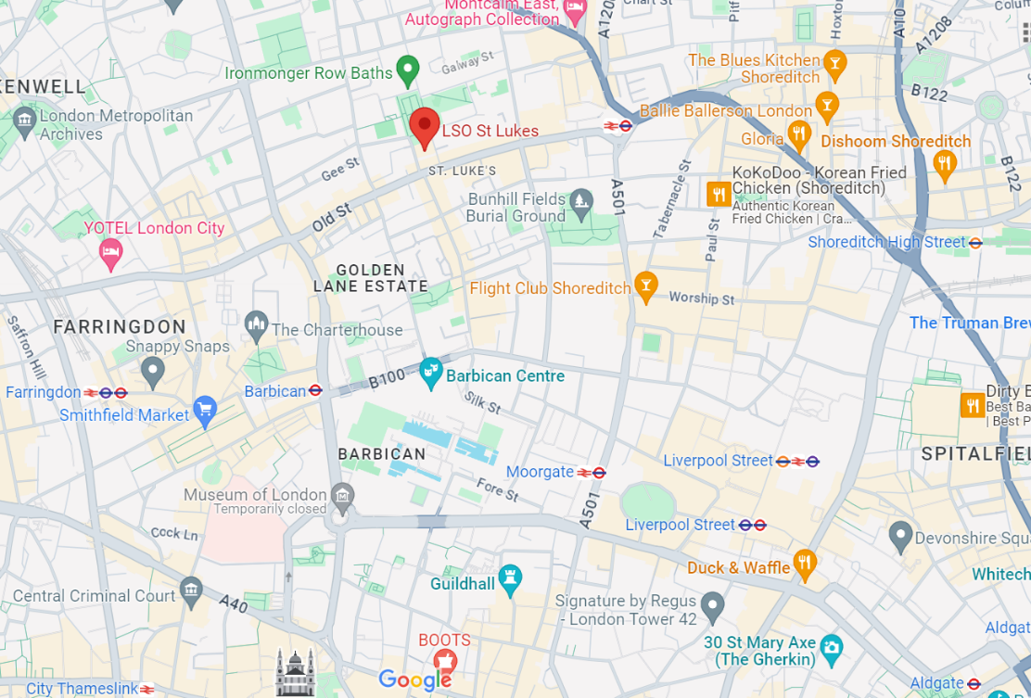

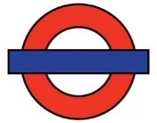

Underground

Old Street (322m) and Barbican (0.5 miles) underground stations are not wheelchair accessible.

The nearest underground stations to LSO St Luke's which are accessible using means other than escalators or stairs are:

- Moorgate Station (0.6 miles) has recently become step free thanks to the Elizabeth Line (please note that not all exit/entrances are step free
- Liverpool Street Station (0.8 miles) (Hammersmith & City, Circle, Metropolitan and Overground lines)
- Farringdon (0.7 miles) (Hammersmith & City, Circle and Metropolitan, and Elizabeth lines)
- Bank (1 mile) (DLR only)
- Caledonian Road & Barnsbury (2 miles) (Piccadilly Line)
- Waterloo (2.1 miles) (Jubilee Line only)
- London Bridge (1.6 miles) (Jubilee and Northern Lines)



National Rail stations

Old Street, Moorgate and Barbican stations are not wheelchair accessible. The nearest National Rail stations to LSO St Luke's which are wheelchair accessible are:

- Farringdon Station (0.7 miles)
(call 020 7222 1234)
Farringdon has a manual boarding ramp and lift.
- Liverpool Street Station (0.8 miles)
(call +44 (0)20 7295 2789)
Liverpool Street has a manual boarding ramp, accessible lift and toilet and a taxi rank.
- Waterloo Station (2.1 miles)
(call +44 (0)20 7922 4500, 48 hours in advance)
Waterloo has an accessible lift and toilet and a taxi rank.
- King's Cross St. Pancras (1.6 miles)
(call +44 (0)20 7922 9091)
This station has a platforms with designated level access boarding points, access via lift(s), an accessible toilet and taxi rank.
- Euston (2.1 miles)
(call +44 (0)20 7922 6482, 48 hours in advance)
Euston has a car park with 4 blue badge bays, a manual boarding ramp, accessible toilet and taxi rank.



Buses (all low floor with wheelchair access)

H: St Luke’s Music Education Centre (52 ft)
55 towards Oxford Circus
243 towards Waterloo Station via Stoke Newington (24 hour service).

J: St Luke’s Music Education Centre (308 ft)
55 towards Leyton
243 towards Wood Green (24 hour service).

E: Old Street Roundabout (0.3 miles)
43 towards Friern Barnet (24 hour service).
135 towards Old Street Station
205 towards Paddington (for Paddington, Marylebone, Euston, Kings Cross and Liverpool Street Stations).
214 towards Highgate Village

C: Old Street Station (0.4 miles)
43 towards London Bridge Station via Highbury & Bank (24 hour service).
205 towards Bow Church (for Paddington, Marylebone, Euston, Kings Cross and Liverpool Street Stations).
214 towards Moorgate

M: City Road / Leonard Street (0.3 miles)
21 towards Lewisham, Shopping Centre
43 towards London Bridge
76 or 141 towards Waterloo
214 or 271 towards Moorgate, Finsbury Square

N: Old Street Station (0.4 miles)
21 towards Newington Green
43 towards Friern Barnet
76 towards Tottenham Hale Bus Station
141 towards Palmers Green, North Circular Road
214 or 271 towards Highgate Village

Contact
To Old Street Station

The office open hours for LSO St Luke’s are from 10am to 4pm. During this time, you will be able to phone to speak to a member of our staff or arrange for a site visit or meeting.



Phone:

General Enquiries: 0207 490 3939
Ticket Enquiries (Barbican Box Office): 0207 870 2500

If you are unsure which number you need for your enquiry, please phone the general line and we can direct you to the right person. All tickets for concerts at LSO St Luke’s can be purchased via Barbican Box Office, with limited amounts of tickets available on the door for certain performances.



Email:

lso.stlukes@lso.co.uk
tickets@barbican.org.uk



Price concessions

Those with accessibilities requirements may be entitled to discounted tickets, subject to availability.



Advance booking

To ensure the best choice of suitable seats, please book in advance where possible. This also enables us to send your tickets to you before the day, time permitting.

The Advance Box Office at the Barbican Centre is open 10am–9pm Mon–Sat (from 12 noon Sunday/bank holidays).

It is located at the Silk Street main entrance where there are automatic doors, step-free access, and accessible counter.

LSO St Luke’s
161 Old Street
London
EC1V 9NG


lso.co.uk/about-us/lso-st-lukes/

