Relaxed Friday Lunchtime Concert
LSO Discovery

Date: Friday 27 February 2026 12.30pm

Location: LSO St Luke’s
Programme:
Joseph Haydn
First movement from String Quartet in C Major No 2
Rebecca Clarke
Poem
Béla Bartók
Fourth movement from String Quartet No 4
Ludwig van Beethoven
Fifth movement from String Quartet No 13

Players:
William Melvin violin
Thomas Norris violin
Steve Doman viola
Laure Le Dantec cello
Rachel Leach presenter
First movement from String Quartet in C Major No 2
Joseph Haydn (1732–1809)

Known as ‘the father of Classical music’, Haydn ‘invented’ the symphony and revolutionised the string quartet as well as transforming many older techniques and forms. He also taught both Mozart and Beethoven and generously promoted their careers at the expense of his own. This is a movement from a set of six string quartets written in 1772. Haydn was at this point established and famous and working for the wealthy Esterházy family. Their estate was far from Vienna and isolated, so Haydn devoted himself to composing, innovating and pushing the boundaries of the string quartet format. In this movement for example, we hear more equality between the parts, solos for each instrument and a conversational style. Haydn’s String Quartet in C Major No 2 influenced all who followed and 250 years later, composers still look to him for inspiration.

Note by Rachel Leach

Poem
Rebecca Clarke (1886–1979)
Rebecca Clarke was an English composer and violist who is now increasingly regarded as one of the most important British composers of the interwar years. Clarke should have been a pioneer: one the of first women to study composition at the Royal College of Music, one of the first female professional orchestral musicians and one of the first female viola soloists, but she had trouble accepting her role and took long breaks from composing and performing throughout her life. This single movement is one of only two short pieces she wrote for string quartet. It was written in 1926 and then forgotten about. At this point in her life, Rebecca was 40, and she was working as a viola player in several ensembles. Clarke described the viola as a ‘forgotten instrument with its own personal tone’. She gives it a large role in this calm, reflective piece.
Note by Rachel Leach

Fourth movement from String Quartet No 4

Béla Bartók (1881–1945)
Bartók was a Hungarian composer and pianist with a passion for folk music. He was preoccupied with the string quartet throughout his long career. He wrote six quartets in all, the first was one of his first successes and the sixth his last. As a set, the quartets show his compositional development from Romanticism to experimentation to deep lyricism at the end of his life. This one, from 1928, was written in Budapest. It features five movements and a lot of unusual or ‘extended’ playing techniques. Movement four is played pizzicato – ie the strings are plucked rather than bowed. Bartók invented a type of pizzicato that is named after him and has a dramatic and slightly shocking sound. You will hear it throughout this piece.
Note by Rachel Leach

Fifth movement from String Quartet No 13
Ludwig van Beethoven (1770–1827)
Beethoven was in appearance and manner a very unlikely genius. He was often dirty, dishevelled, rude, aggressive, unpredictable and eccentric, but his music re-wrote the rulebook. Beethoven radically developed and transformed every genre he wrote in. At age 28 he began to go deaf. Soon could only communicate through the use of a notebook and he heard his greatest works by imagining the sounds in his head. This quartet was one of the final pieces he wrote and he did not live to see a performance of it. It is extremely unusual because the full quartet features six movements instead of the usual four and this one, number 5, is the second slow movement. It's called ‘cavatina’ which just means ‘little song’ and it is considered to be one of Beethoven’s finest slow pieces. He said he had ‘tears of melancholy’ as he wrote it and that no other piece had made such an impression on him.
Note by Rachel Leach

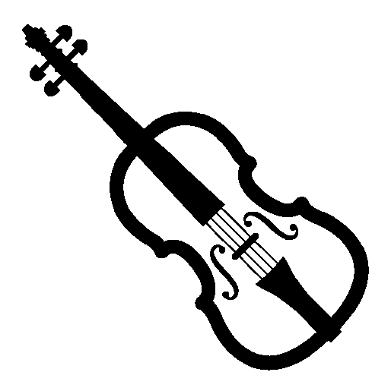
About the Artists
William Melvin
violin
Born in 1988, William Melvin graduated from the Royal Academy of Music in 2011 and 2012, having studied with Marianne Thorsen and Erich Gruenberg. During his time at RAM, William was a prize winner in the Wolfe Wolfinson competition and the Winifred Small Violin Prize, and toured with the RAM soloists, RAM Symphony and Julliard orchestras. He participated in masterclasses with world renowned violinists such as Thomas Brandis, Peter Schoeman and Maxim Vengerov.
As the Leader of the Bernadel Quartet, William has performed in all the major UK chamber music halls including Wigmore Hall, Colston Hall, St Martin-in-the-Fields and Kings Place. He has participated on prestigious courses and masterclasses such as IMS Prussia Cove, West Cork Chamber music festival and Britten-Pears Young Artists Programme. He has appeared as soloist in St Johns’ Smith Square, Cadogan Hall, The Amaryllis Fleming Concert Hall and LSO St Luke’s performing Mozart’s Violin Concerto in G, Mendelssohn E minor Concerto, Brahms’ Double Concerto and Saint-Saëns Concerto in B minor.

Thomas Norris
violin
Thomas Norris graduated from London’s Guildhall School of Music & Drama in 1994, and went on to study in Banff, Canada before joining the Winnipeg Symphony Orchestra as Principal Second Violin. Since returning to London, Tom has been a violinist of the LSO.
Tom has collaborated with countless musicians, ranging from the Schubert Ensemble to Roger Daltrey and The Who. He has recorded with Nanci Griffith, Elvis Costello and Andrea Bocelli. He has collaborated with Manu Delago and Living Room in London.
Tom is a member of the Puertas Quartet, formed in 2009, which was critics’ choice in the Strad magazine for its recording of music by Ravel and Tchaikovsky. Tom is also a singer, songwriter and composer, writing for TV and film. He released his debut album, Edge Of The World, in 2009.

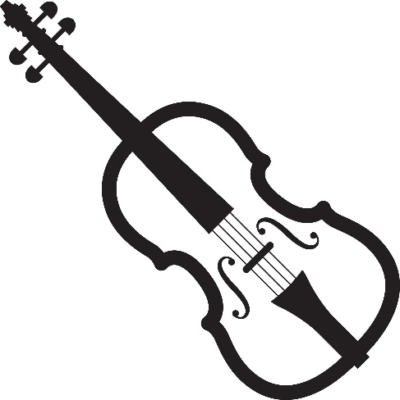
Steve Doman
viola
Steve Doman was a prize winner at the Lionel Tertis International Viola Competition 2016. He has performed as Guest Principal Viola with the BBC National Orchestra of Wales, Bournemouth Symphony, Royal Philharmonic Concert Orchestra, Manchester Camerata, Royal Ballet Sinfonia and English National Ballet. He is an experienced chamber musician and has given concerts at the Bath, Cheltenham and Schleswig Holstein international music festivals.
Steve has a passion for education work and has worked with LSO Discovery since 2008. Originally from Bath, Steve was a music scholar at Wells Cathedral School before studying at the Guildhall School of Music & Drama and the Royal Academy of Music. He also pursued further studies in Finland and the US. In his free time, he enjoys being outdoors and is passionate about all aspects of nature … almost as passionate as he is about food.
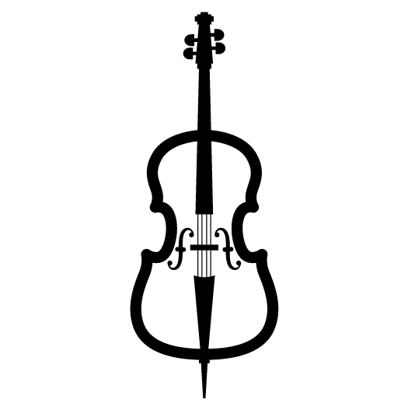
Laure Le Dantec
cello
Laure Le Dantec was seven when she started playing the cello. After studying with Marc Coppey and Raphael Pidoux at the Conservatoire Supérieur de Paris, she began studies at the Paris Conservatoire at the age of 16. There, she spent five years learning with Jéröme Pernoo and passed her Masters Diploma with the highest distinction.
Already very interested in symphonic repertoire, Laure moved to Amsterdam to be part of the Royal Concertgebouw Orchestra Academy for the 2014/15 season, and the year after travelled to Berlin, where she performed with the Berlin Radio Symphony Orchestra for one year. During this time, she continued her studies and started a second Masters course at the Hanns Eisler Musikhochschule with Troels Svane.
Laure is also passionate about chamber music and plays in ensembles of all sorts with the Camerata RCO, formed by players in the Royal Concertgebouw Orchestra of Amsterdam, and performing in festivals in Italy, Spain, France, Netherlands, Russia, Colombia, Canada and even Hawaii.

Rachel Leach
presenter
Rachel Leach was born in Sheffield. She studied composition, and her music has been recorded by NMC and published by Faber. She has won several awards, including the RPS award for best education project 2009 for One Day, Two Dawns, with English Touring Opera (ETO).
Rachel has worked within the education departments of most of the UK’s orchestras and opera companies. The majority of her work is for the London Symphony Orchestra and the London Philharmonic Orchestra. Rachel has written well over 20 pieces for LSO Discovery and 15 community operas, including seven for English Touring Opera.
Increasingly in-demand as a concert presenter, as well as presenting the LSO Discovery Free Friday Lunchtime Concert series, she regularly presents children’s concerts and pre-concert events for the LSO, LPO, Philharmonia Orchestra, Scottish Chamber Orchestra, Royal College of Music and Royal Northern Sinfonia.
Angie Newman
^{BSL interpreter}
Angie Newman has worked extensively across music and deaf education for many years. Her knowledge and expertise in these areas, combined with her skills as both a British Sign Language interpreter and a musician, enable her to make music more accessible to young deaf people and adults, bridging the worlds of deafness and music, something she feels passionate about.
She has worked for six successive years with the BBC, interpreting family Proms, including CBeebies Proms. She works with a variety of leading orchestras in the UK, including the London Symphony Orchestra, London Philharmonic Orchestra, Philharmonia Orchestra and many others, interpreting for their education and community programmes. Angie loves to relax by walking, cycling, playing the piano and violin, and practising yoga.

Thank you for joining us for this Relaxed Lunchtime Performance.
Please let us know what you thought of the concert by completing a short survey. We would love to hear your thoughts.



Next Relaxed Free Lunchtime Concert: LSO Musicians
Friday 8 May 2026 12.30pm
LSO St Luke's

Our next relaxed performance will take place back in LSO St Luke's Jerwood Hall in early May. We look forward to seeing you there!

Guildhall School Orchestral Artistry Musicians
Mark Withers presenter

